# Worksheet 1 Communication methods

**Task 1**

1. (a) Darren’s rather old printer is connected via a cable to his computer. He wants to move the printer to the other side of the room and searches the Internet for a longer cable. He finds suitable several cables like the one below.

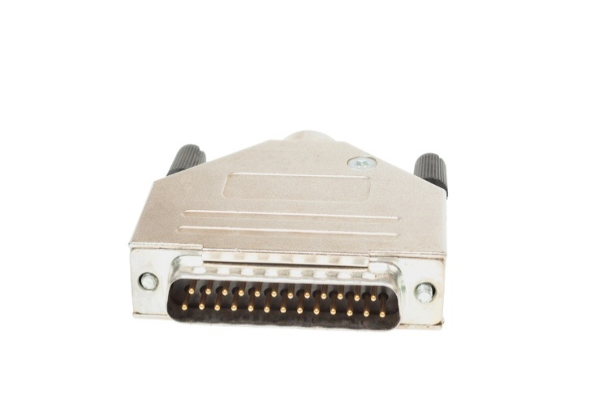

However, he cannot find one that is longer than 1.8m. Why not?

What should he do? [2]

(b) Explain why serial transmission is often faster than parallel transmission. [4]

(c) Where or when is parallel transmission used? [2]

**Task 2**

3. (a) Label Figure 1 and Figure 2 to show which type of transmission is shown in each.

**Figure 1:** ___________________ data transmission [1]

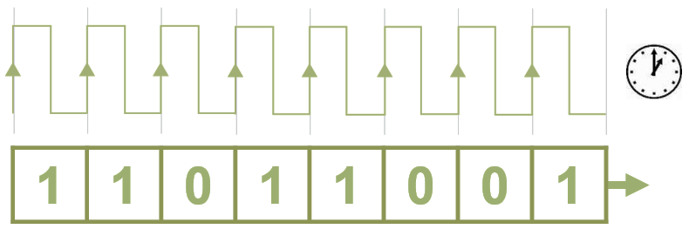

**Figure 2:** ___________________ data transmission [1]

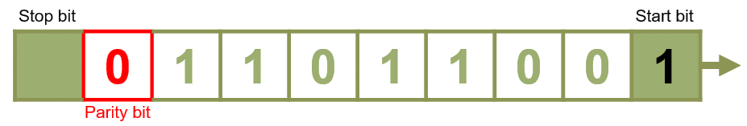

(b) Explain what the start and stop bits are used for. [1]

(c) What is the purpose of the parity bit? Explain the difference between **odd** and **even** parity systems. [2]

(d) Complete the following table: [4]

|  |  |  |  |
| --- | --- | --- | --- |
| **7 data bits** | **Count of 1 bits** | **8 bits including parity** | |
| **Even** | **Odd** |
| 0000000 |  |  |  |
| 1011000 |  |  |  |
| 0011110 |  |  |  |
| 1111111 |  |  |  |

(e) Explain why synchronous transmission is faster than asynchronous transmission. [1]

4. (a) Define **bit rate** and **baud rate**. [2]

(b) Explain why the baud rate is always less than or equal to the bit rate but never greater. [2]

5. Test the bandwidth of your computer on a speed test site, e.g.

<http://speedtest.zoominternet.net/>

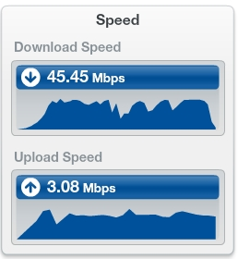

Why do you think upload speed is so much slower than download speed? [1]