Name: Class:

Task 1

A small summer festival has a capacity for 1000 people at their venue. They allow groups of people in and once each group has been admitted they enter the number onto the computer. If the number of people in the venue is more than 1000 they won’t admit any more people.

The algorithm they use is as follows.

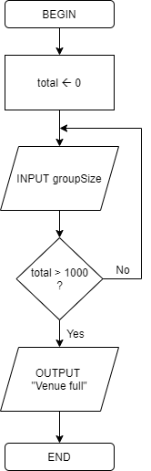

(a) Describe any problems with the algorithm.

(b) Draw a new flowchart to amend the algorithm and fix the problems you found.

|  |
| --- |
|  |

Task 2

This task is based on the cycle race algorithm given in the presentation.

A cycle race has around 10 competitors. At the end of the race, each competitor’s time (in seconds) is entered to a program. The program automatically calculates the fastest time.

The pseudocode for the algorithm in the program is given below.

fastestTime 🡨 0  
firstInput 🡨 TRUE  
moreTimes 🡨 TRUE  
  
WHILE moreTimes DO  
 INPUT time  
 IF time = -1  
 THEN  
 moreTimes 🡨 FALSE  
 ELSE  
 IF firstInput  
 THEN  
 fastestTime 🡨 time  
 firstInput 🡨 FALSE  
 ELSE  
 IF time < fastestTime  
 THEN  
 fastestTime 🡨 time  
 ENDIF  
 ENDIF  
 ENDIF  
ENDWHILE  
  
OUTPUT fastestTime

Draw a flowchart of the same algorithm.

|  |
| --- |
|  |

Task 3

The following program written in pseudocode is for a joke generator that tells random jokes.

The user will be given the first part of the joke. Whatever they enter, the answer will then be displayed.

The function math.ceil(*number*) will round up *number*.

(a) Write a program in pseudocode for the joke generator. You may wish to use the following three jokes in the joke generator, or create your own.

|  |
| --- |
|  |

(b) Write a program in a programming language for the joke generator.

Be aware that you may need to use a library to generate random numbers or round up a number.

|  |
| --- |
|  |