# Worksheet 5: Sampling sound

1. Look at the sound wave below and record the samples in the table beneath it. The first two are done for you. You can only plot a sample at an intersection. Use a ‘best-fit’ approach.

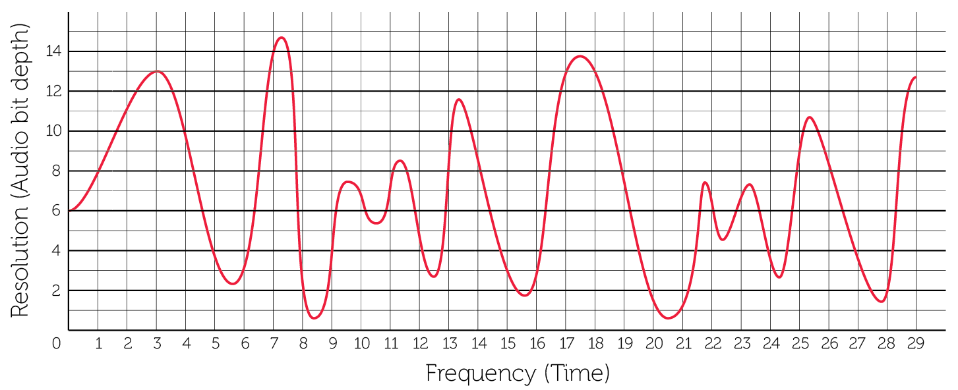

|  |  |  |  |  |  |  |  |  |  |  |  |  |  |  |
| --- | --- | --- | --- | --- | --- | --- | --- | --- | --- | --- | --- | --- | --- | --- |
| 0 | 1 | 2 | 3 | 4 | 5 | 6 | 7 | 8 | 9 | 10 | 11 | 12 | 13 | 14 |
| **6** | **8** |  |  |  |  |  |  |  |  |  |  |  |  |  |
| 15 | 16 | 17 | 18 | 19 | 20 | 21 | 22 | 23 | 24 | 25 | 26 | 27 | 28 | 29 |
|  |  |  |  |  |  |  |  |  |  |  |  |  |  |  |

1. Replot all of your figures on to the graph below and create a bar chart from the points. The first two points have been drawn for you.

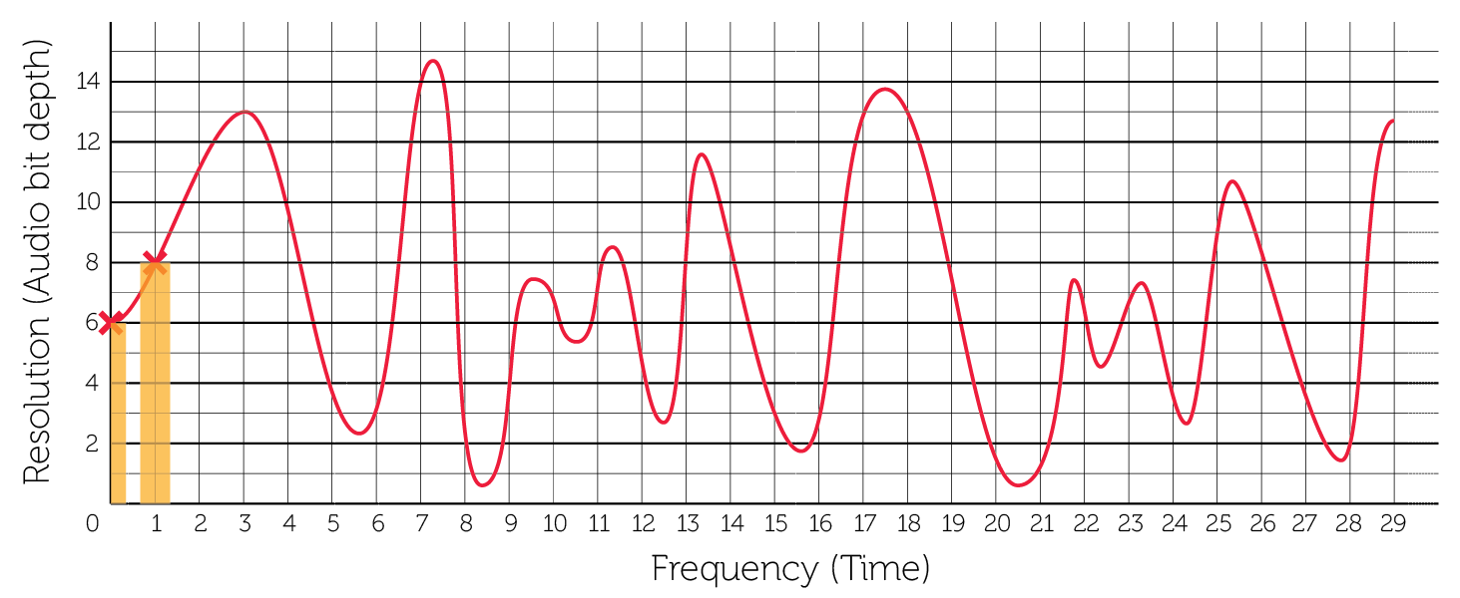

1. How accurately does this represent the original sound wave? Where are there inaccuracies in the digital reproduction of the wave?
2. What would you need to do in order to improve the accuracy of the recording?
3. In reality, each of the measurements on the Y axis would be given a binary value and that would be recorded in the audio data file. Using Table 1 below write out the binary values for each of the first ten samples given in Table 2. There are 16 sampling points on the Y axis so a minimum of four bits must be used in order to provide enough different bit patterns for each sampling point.

|  |  |
| --- | --- |
| **Y** | **Bit value** |
| 1 | 0001 |
| 2 | 0010 |
| 3 | 0011 |
| 4 | 0100 |
| 5 | 0101 |
| 6 | 0110 |
| 7 | 0111 |
| 8 | 1000 |
| 9 | 1001 |
| 10 | 1010 |
| 11 | 1011 |
| 12 | 1100 |
| 13 | 1101 |
| 14 | 1110 |
| 15 | 1111 |

*Table 1*

|  |  |  |  |  |  |  |  |  |  |  |
| --- | --- | --- | --- | --- | --- | --- | --- | --- | --- | --- |
| **Sample** | 0 | 1 | 2 | 3 | 4 | 5 | 6 | 7 | 8 | 9 |
| **Value** | 6 | 8 | 11 | 13 | 10 | 4 | 6 | 14 | 2 | 4 |
| **Binary value** | 0110 | 1000 |  |  |  |  |  |  |  |  |

*Table 2*

The Binary Values in the third row above represent the data that would be stored to recreate this very short sound file of 10 samples.

1. What would be the file size in bytes of the 10 samples in Question 5?

The **resolution** is the accuracy with which the wave height is measured – the higher the **resolution**, the more accurate the measurement at a particular sample point.

1. What would the file size of samples in question 3 become if you increased the resolution to allow for 256 different points on the Y axis?
2. How would this affect the quality of the recording?
3. The **sampling frequency** is the frequency with which the measurements are taken – a higher **sampling frequency** means measurements are taken more often within the same period of time. How would this affect the quality of the recording?
4. Explain the relationship between the quality of playback and the file size.