Homework 4 Subroutines

1. A set of Christmas tree lights consists of three separate strings of lights wound together.

The lights can be set to flash at one of two speeds, FAST and SLOW.

When the switch is set to FAST, the lights on each string turn on for half a second and then off for one second. Only one set of lights is lit at a time.

When the switch is set to SLOW, the lights on each string turn on for one second and then off for two seconds. Only one set of lights is lit at a time.

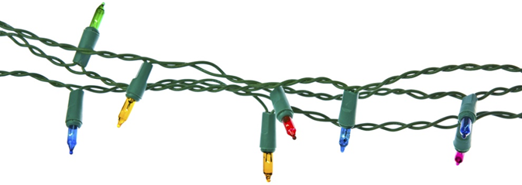

In Homework 2, you drew a flowchart representing the SLOW sequence, shown on   
the next page.

(a) Alter the first statement of the flowchart to turn this sequence into a   
subroutine, **SUB SlowFlash**. [1]

(b) What changes would you need to make to the subroutine   
Sub SlowFlash, to create Sub FastFlash? [3]

(b) Write a flowchart which starts with a decision box, to test whether the switch is set to FAST or SLOW. It then calls either **SUB SlowFlash** or a similar subroutine named **SUB FastFlash**. (You do not need to draw the flowchart for SUB FastFlash.) [6]

[Total 10 marks]

Set 1 ON

Delay 1

Set 1 OFF

SET 2 ON

Delay 1

Set 2 OFF

Set 3 ON

Delay 1

Set 3 OFF

Set 1 ON

Start