# Worksheet 5 Querying a database

**Task 1: Create a query using the AND logical operator**

1. Open **Films2.accdb** or your own version of the Films database.
2. From the menu, select **Create, Query Design**
3. In the Show Table dialogue box, select **tblFilm**, click **Add** and then close the box.
4. The Query window opens with **TblFilm** in the top half of the window, and the query grid in the bottom half of the window.
5. Drag the fields one at a time from the table onto the Query grid. Alternatively, double-click the field names one at a time. You can adjust the column widths in the query grid by double-clicking the boundary between each column header.

Your query should look something like this:

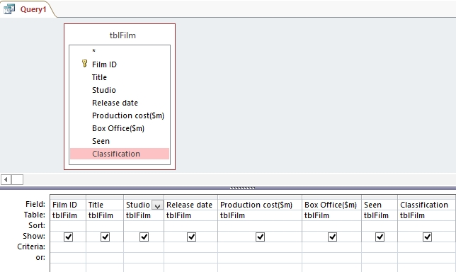

1. In the **Show:** row of the query grid, uncheck the field **Seen**. This field will not now appear in the Answer table when the query is run.
2. In the **Criteria**: row, enter **>250** in the **Production cost($m)** column and **“U”** in the **Classification** column.
3. Save the query, naming it **QryProductionOver250**.
4. Select **Design** from the menu and the click **Run** (next to the **View** button at the left hand end).

The results table will appear:

C:\Users\Pat\AppData\Roaming\PixelMetrics\CaptureWiz\Temp\1.png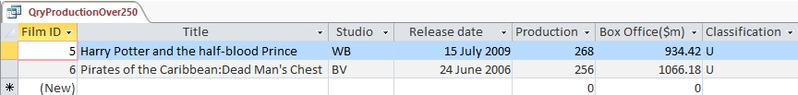

**Task 2: Using the logical operator OR in a query**

1. The table **tblFilm** has the following records:

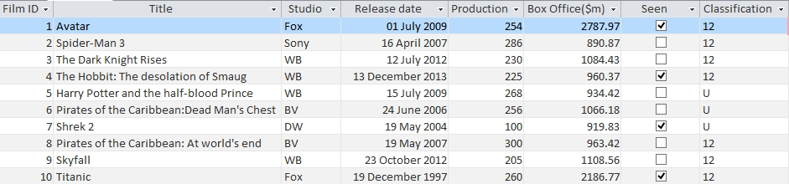

Write down the Film ID that will be found by the following query:

(Studio = “Fox”) OR (Studio = “BV”)

1. Now create a new query in Access to check out the accuracy of your answer.

Tip: Your query grid should look something like this:

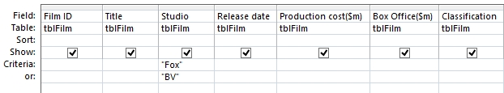

You can alternatively write the criteria on one line as: “Fox” OR “BV”

Save your query as **qryStudio**.

Close the database.

**Task 3: Writing queries**

Open the database **Paintings1** and look at tblPainting.

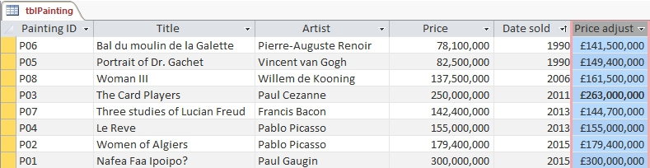

(a) Write a query which will find all paintings sold before 2010 for more than $100,000.

(b) Implement your query in Access. Which paintings were listed in the Results table?

(c) Which records will be displayed when the following query is run?

(Artist = “Pablo Picasso” OR Artist = “Paul Gaugin”) AND (Price < 160,000,000)

(d) Implement the query in Access and check your answer is correct.