Answers

Task 1

Exploring and learning about space can be a very expensive project costing   
billions of pounds.

A poll is carried out in which people were asked whether they thought that   
money spent in this way was well spent, or not. The results are summarised   
in the table below.

|  |  |
| --- | --- |
| Money well spent | 180 |
| Money not well spent | 150 |
| Not sure | 30 |

(a) How many people were questioned in the poll?

**360 people**

(b) What percentage of people thought that the money was well spent?

× 100 = **50%**

(c) What is the ratio of the number of people who thought the was money well spent to the number of people who thought the money was not well spent? Express your ratio in its simplest form.

180 : 150 in its simplest form is **6 : 5**

(d) Construct a bar chart below to show the findings. Remember to label the axis.

Task 2

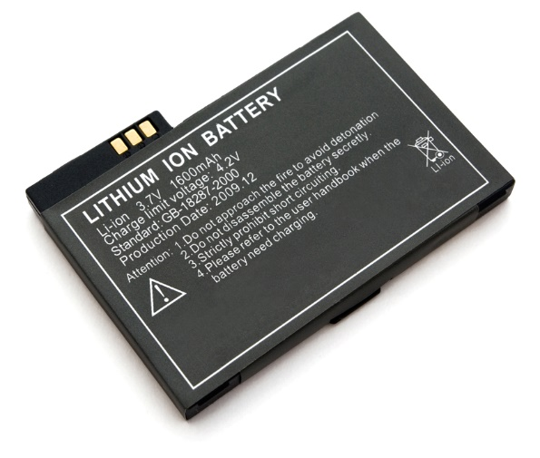The table below gives the weight of lithium metal used to make a range of different products, by a high-tech industry.

|  |  |  |
| --- | --- | --- |
| Material | Mass per year (tonnes) | Percentage of total |
| Batteries | 117 | 39% |
| Glass and ceramics | 93 | 31% |
| Lubricating grease | 21 | 7% |
| Casting products | 15 | 5% |
| Air treatments | 9 | 3% |
| Polymers | 12 | 4% |
| Other | 33 | 11% |

(a) Work out the percentage of the total lithium metal used for each product and add your finding to the table above.

(b) Using your answers from part (a), construct a pie chart of this data.

Task 3

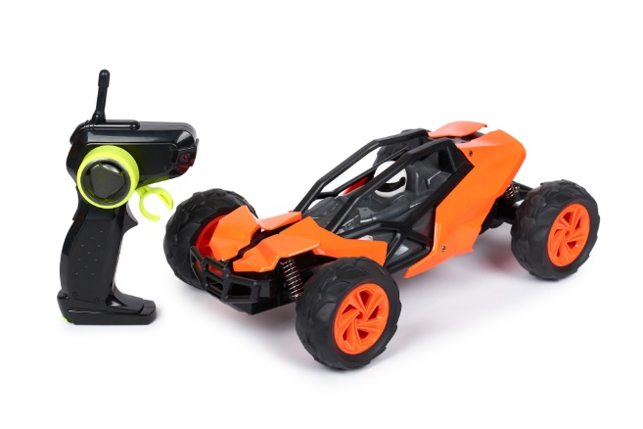The following table shows how the speed of a student’s 3D printed prototype radio-controlled car varies with time along a straight test track.

|  |  |
| --- | --- |
| Time in seconds | Speed in metres  per second |
| 0 | 0.0 |
| 1 | 0.3 |
| 2 | 1.0 |
| 3 | 2.0 |
| 4 | 2.9 |
| 5 | 3.2 |
| 6 | 3.2 |
| 7 | 3.2 |

(a) Plot a graph in the space below, to show the speed of the car on the vertical axis, against time on the horizontal axis.

(b) After what time is the car moving at half its maximum speed?

Approximately **2.5** seconds

(c) Explain what happens to the speed of the car from the start up to 7 seconds.

The speed of the car starts at 0 metres per second, and then it starts to increase its speed as it accelerates. Between 2 and 4 seconds, its acceleration is constant until it approaches its maximum speed of 3.2 metres per second.