Name: Class:

Task 1

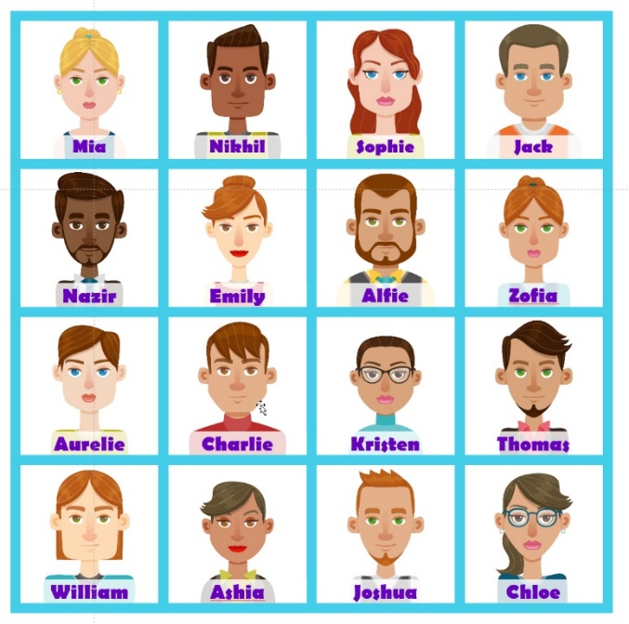

Work with a partner.

(a) For each partner, choose one of the people in the set of pictures, but don’t tell your partner.

(b) Now ask your partner **four** questions to find the person they have selected. Write your questions below.

Question 1:

Question 2:

Question 3:

Question 4:

(c) Did you find the person they selected?

□ Yes □ No

(d) Make a Boolean expression for the person who you were looking for.

Task 2

Shade the Venn diagrams to show the Boolean expression on the left.

|  |  |
| --- | --- |
| **Boolean Expression** | **Venn diagram** |
| Show people who like:  **Tea AND Coffee** | **ξ** |
| Show people whose preference is for:  **NOT (Tea OR Coffee)** |  |
| Show people whose preference is for:  **NOT Tea AND Coffee** |  |

Task 3

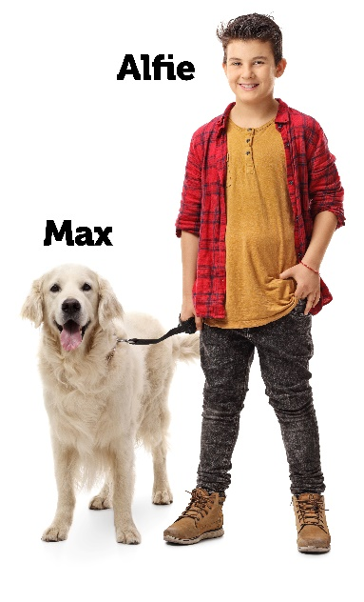

For each of the questions below, make deductions and conclusions for the photo above:

(a) Is Max a pet?

1. Pets have four legs

2.

3.

(b) Is Alfie a human?

1. Humans have two legs

2.

3.

(c) Are they going for a walk?

1. When a dog is connected to a lead and a human is connected to a lead they are going for a walk

2.

3.

4.

5.

6.

Task 4

1. Five ferrets took part in a race at a local fete. The following details are known about the race.

* Zippy finished either 1st or 3rd
* Flip finished faster than Musk
* The smallest difference in finishing times was between Flip and Lightning
* The largest difference in finishing times was between Lightning and Tornado

In what order did the ferrets finish in? You may like to work in pairs to solve this.

|  |  |  |  |  |
| --- | --- | --- | --- | --- |
| **1st (Fastest)** | **2nd** | **3rd** | **4th** | **5th (Slowest)** |
|  |  |  |  |  |

2. Use the following statements to solve who is in which carriage of a train [4]

* Jimmy is further towards the back of the train than Sandy
* Mo is at the front of the train
* Beth is closer to Mo than she is to Jimmy
* Beth is in a carriage adjacent to Sandy

|  |  |  |  |
| --- | --- | --- | --- |
| **Carriage A (Front)** | **Carriage B** | **Carriage C** | **Carriage D (back)** |
|  |  |  |  |