Name: Class:

Task 1

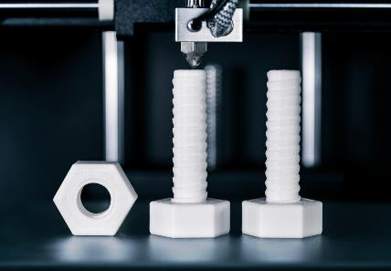1. The picture shows nylon filament being 3D printed in to nuts and bolts.

Nylon has a density of 1.15 g cm-3. A cube of 2 cm length is needed for each nut and bolt.

(a) Calculate the volume of the cube, in m3. Give your answer in standard form.

(b) Calculate the mass of the cube in grams.

(c) Calculate the mass of the cube in kg. Give your answer in standard form.

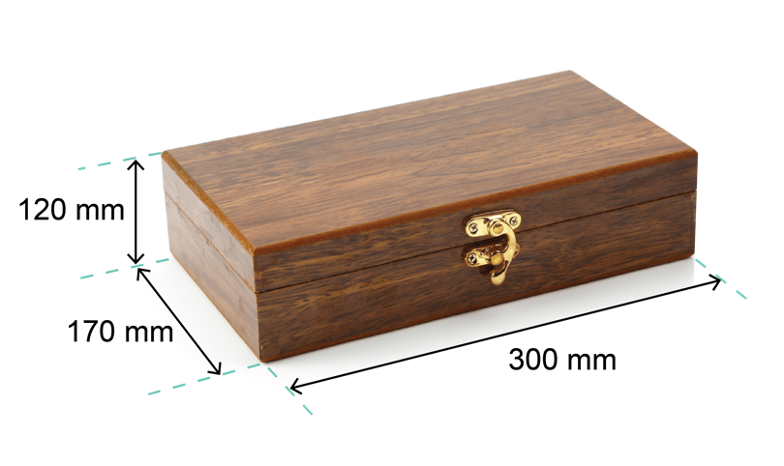Task 2

The picture shows a wooden jewellery box that a student has made.

The actual dimensions of the box are given.

(a) Calculate the surface area of the box.

(b) Calculate the volume of the box.

A student produces an accurate drawing of the jewellery box using a scale of 1 : 5.

(c) Calculate the dimensions of the box in the scale drawing.

(d) Calculate the surface area of the box of the scale drawing.

(e) Calculate the ratio of the areas of the scale drawing to the actual box.  
Give your answer in the simplest whole number ratio.

(f) What observations can be made about the answer to part (e) given the scale ratio   
is 1 : 5?

(g) Using the answer to part (f), deduce the ratio of the volumes of the scale box to the actual box.

(h) The student discovers that the volume of the original box it too small for its desired use.  
He would like to increase the volume of the actual box by 50%.

Calculate the new dimensions of the box. Give the new dimensions to 1 d.p.

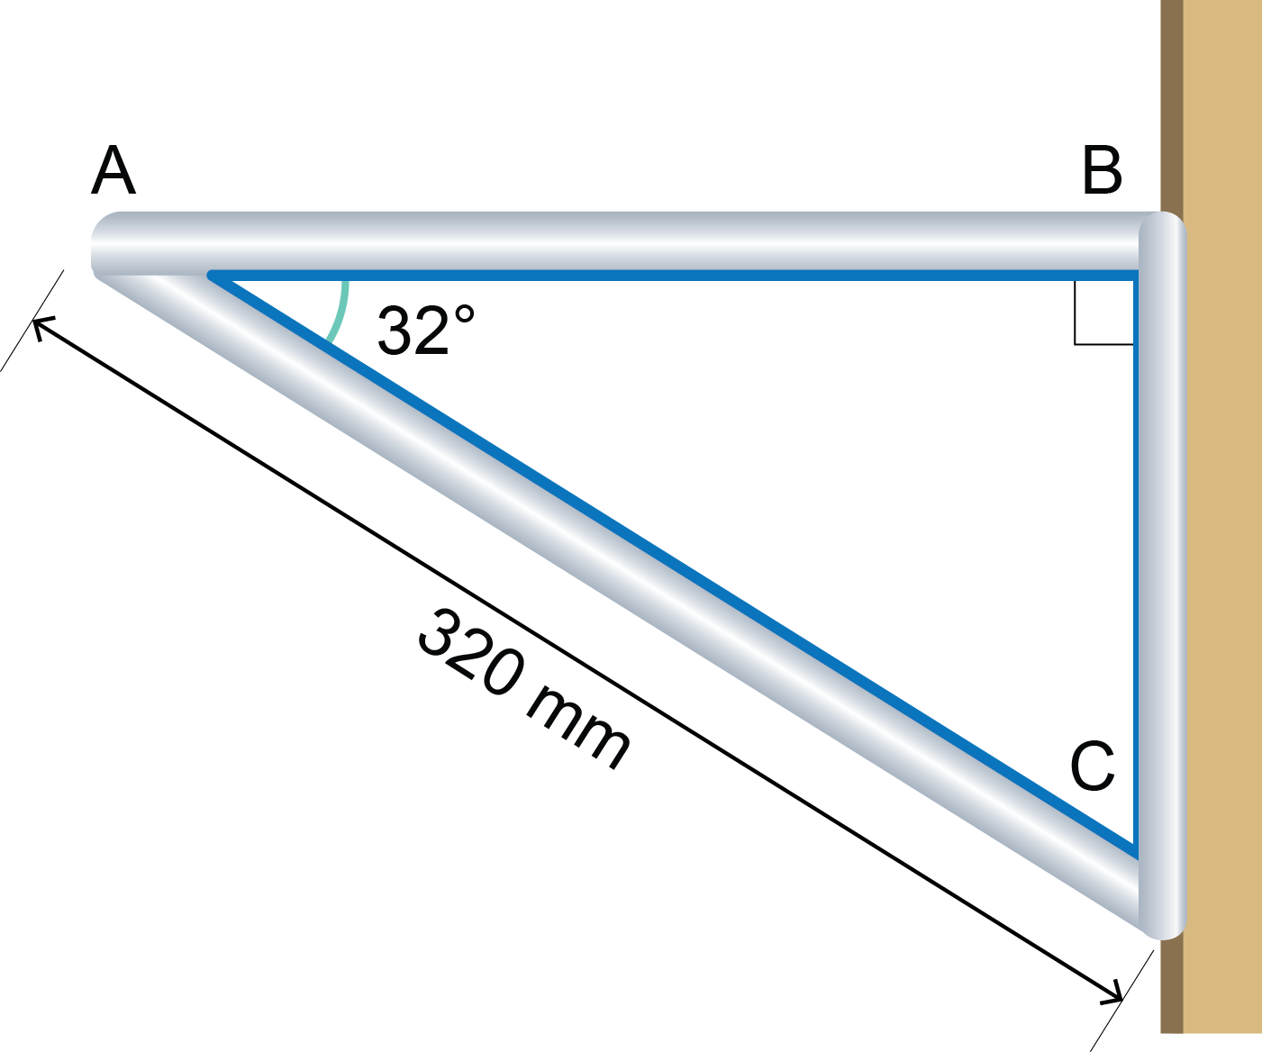Task 3

The picture shows a shelf bracket fixed to a vertical wall.

The bracket is made of solid aluminium tubing of diameter 16 mm.

(a) Calculate, using trigonometry:

C

i) Length AB. Give your answer to 1 d.p.

ii) Length BC. Give your answer to 1 d.p.

(b) Work out the total length of all three sides of the bracket.

(c) The density of aluminium is 2.70 g cm-3.

Work out the mass of aluminium tubing needed to make the bracket if all three sides were made from the same material.

Give your answer to 1 d.p.

Task 4

1. The bar graph gives the mass of plastic pollution produced by different manufacturing   
sectors in 2017.

(a) Use the bar graph to calculate the percentage of plastic waste produced by the following industrial sectors:

Give all answers to 2 d.p.

i) electronics

ii) packaging

(b) Use the data in the bar graph to construct a pie chart below.

2. Clothing designers and manufacturers need to know relevant anthropometric data when designing specific items of clothing.

This table shows some anthropometric data for a sample of 900 people used by a company making gloves, socks and shoes.

|  |  |  |  |
| --- | --- | --- | --- |
| **Parameter** | **Percentile** | | |
| **5th** | **50th** | **95th** |
| **Age (years)** | 20.2 | 25.2 | 29.6 |
| **Foot breadth (cm)** | 7.6 | 8.6 | 9.4 |
| **Foot length (cm)** | 23.9 | 26.3 | 27.8 |
| **Foot height (cm)** | 5.1 | 5.8 | 6.6 |
| **Hand breadth (cm)** | 8.7 | 9.5 | 10.1 |
| **Hand length (cm)** | 18.4 | 19.4 | 20.2 |
| **Hand thickness (cm)** | 2.9 | 3.3 | 4.1 |

(a) Give the mean age of the sample.

(b) Calculate the number of people who have a foot breadth greater than 9.4 cm.

(c) Calculate the number of people that have an age of less than 29.6 years.

(d) Give the probability of a person having a foot length of greater than 27.8.

(e) Calculate the probability of choosing two consecutive people having an age greater than 29.6. Assume the first person chosen is then placed back into the sample.

(f) A designer wishes to create a hand grip for a tool based on the hand breadth data in the table. They want the grip to fit between the 5th and 95th percentile of hand breadth data.

How many people will be able to use the grip comfortably?