Name: Class: Mark:

1. Three logic gates are given below. Complete the table to name each gate. [3]

|  |  |
| --- | --- |
| **Symbol** | **Logic gate** |
|  |  |
|  |  |
|  |  |

2. (a) Look at the following circuit diagram and complete the truth table below. [6]

|  |  |  |  |  |
| --- | --- | --- | --- | --- |
| **A** | **B** | **C** | **D** | **Output** |
| True | True | True |  |  |
| True | True | False |  |  |
| True | False | True |  |  |
| True | False | False |  |  |
| False | True | True |  |  |
| False | True | False |  |  |
| False | False | True |  |  |
| False | False | False |  |  |

(b) What happens if a NOT gate is added at the end of the circuit? [1]

3. Connect the logic gates with lines to form a logic circuit to represent this statement:

“The washing machine will turn on if the play button is pressed and the door is shut and either wash or rinse are selected”

One connection has been made already for you. [6]

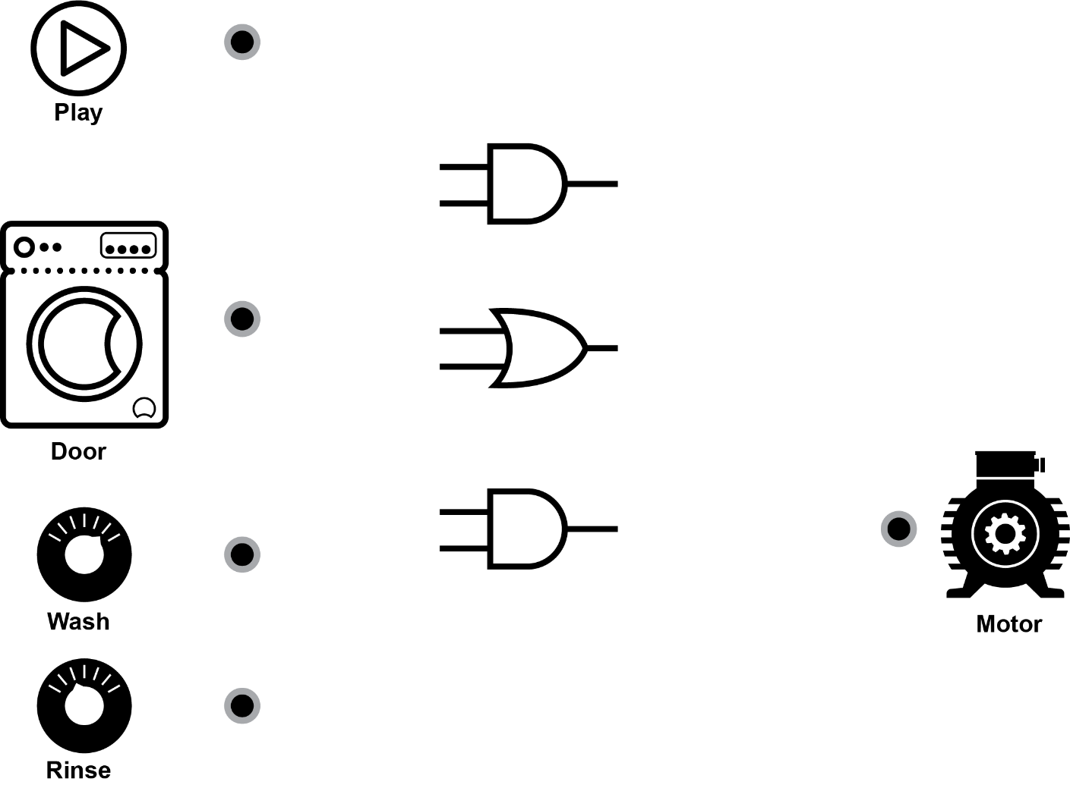

[Total 16 marks]