‘*Defying Gravity’*

*From the Musical ‘Wicked’*

**Stephen Schwartz**

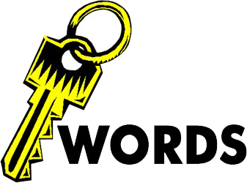

Do you know the meaning to all these words? Could you explain the meaning to someone else?

You may see some of them more than once. This is because they may be found under different areas of musical elements.

Test yourselves on these with the person beside you.

|  |  |  |  |  |
| --- | --- | --- | --- | --- |
| STRUCTURE | TEXTURE | TONALITY | MELODY | INSTRUMENTATION |
| Extended form | Homophonic |  | Conjunct | Duet |
|  | Monophonic |  | Angular | Spoken Dialogue |
|  | Polyphonic |  | Unlimited theme | Overdrive |
|  |  |  | Ostinato | Tremolo |
|  |  |  |  | Marcato |
|  |  |  |  | Pizzicato |
|  |  |  |  | Arco |
|  |  |  |  |  |

|  |  |  |  |  |
| --- | --- | --- | --- | --- |
| RHYTHM | HARMONY | DYNAMICS | CONTEXT | OTHER |
| Syncopation | Dissonant | Fortissimo | Musical | Musical Theatre |
|  | Augmented | pianissimo | Recitative |  |
|  |  | Sforzando | Dramatic song |  |
|  |  | fp |  |  |

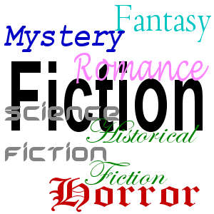

Genre/Cultural Context

**Stephen Schwartz (1948 – )**



The musical was designed to entertain lots of people- entertainment for the masses, it was not aimed solely for the upper classes who could afford expensive ticket prices. Musicians started in Ancient Greece where stories were acted and sung in amphitheaters.

Musicians can take many different forms such as ‘rock operas’ - *Tommy’* or ‘jukebox musicals’ such as *Mamma* Mia. Andrew Lloyd Webber is a very successful composer, he has composed many successful musicians such as *Joseph and the Amazing Technicolor Dreamcoat, Cats, Starlight Express* and *The Phantom of the Opera.*

Stephen Schwartzis an American music theatre composer and lyricist. Born in 1948 in New

York. In 1972 that he had his first success with the musical *Godspell*. In the 1990s he collaborated with the composer Alan Menkin on the scores of many Disney animated films such as *Pocahontas* and *The Hunchback of Notre Dame.* In 2003 he took on the role of both composer and lyricist for

*Wicked: The Untold Story of the Witches of Oz*, a musical based on the novel *Wicked: The Life and Times of the Wicked Witch of the West*. This is an alternative version of the *Wizard of Oz* and tells the story from the point of view of the witches, Elphaba (the Wicked Witch of the West)and Glinda, the Good Witch. Schwartz won a Grammy Award for his work as composer, lyricistand producer of *Wicked*.

‘**Defying Gravity**’ is a dramatic song and is the finale song for the first act, when Elphaba discovers that the Wizard of Oz is not the heroic figure she had originally believed him to be. Realising this, Elphaba vows to do everything in her power to fight the Wizard and his sinister plans. She sings of how she

wants to live without limits, going against the rules that others have set for her. It was originally

written in the key of D♭ major but has been transposed to D major in this edition.

**Music theatre** integrates songs, spoken dialogue, acting and dance within a popular form. Musicals are an extended piece of music theatre.

Schwartz: ‘Beautiful city’ from ***Godspell***

Schwartz: ‘Colours of the Wind’ from ***Pocahontas***

Minchin: ‘Naughty’ from ***Matilda***

Shaiman: ‘Mama, I’m a Big Girl Now’ from***Hairspray***



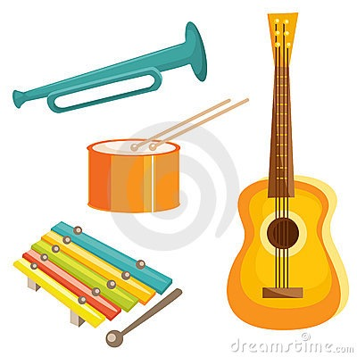

Instrumentation

‘Defying Gravity’ is a duet for the characters Elphaba and Glinda with some spoken dialogue in addition to the singing. The two characters either deliver their text spoken, half sung/spoken with music notated on the stave with crosses instead of note heads or entirely sung. These two singers require extremely versatile voices with a large range of just under two octaves, from G below middle C to F.

The orchestration used in this song combines traditional classical with popular music. There is heavy emphasis on percussion. *Wicked* uses a large orchestra: woodwind section (including additional instruments such as piccolo, bass clarinet and cor anglais), brass and string sections with a harp, electric guitars and three keyboards. It includes a wide variety of percussion instruments: drum kit, tubular bells and timpani.

Unusual instrumental techniques are used to create a magical, ethereal sound such as palm muting, chorus, delay and overdrive which is a distortion effect. The keyboards help to bulk out the sound made from each instrument family.

In bars 51-58 the strings play pizzicato but mainly play arco (using the bow). The trumpets also use mutes which changes the timbre of the instrument. The strings use tremolo effect to add tension for example in bar 34.

Within the drum kit, a closed hi-hat is used and plays constant crotchet rhythms in bar 51 to add rhythmic momentum. There is also a cymbal roll to add excitement as the piece moves into a key change for example in bar 122. The full orchestra plays at the climax of the song at bar 135, the when whole orchestra plays together this is also called tutti.

Texture

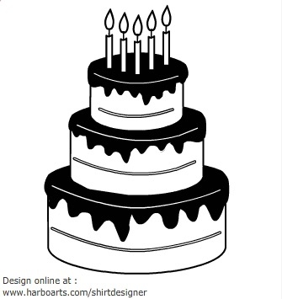

The opening texture is homophonic. There are marcato stabs heard in the orchestra and some monophonic lines from the singers.

The texture then gradually builds to a melody and accompaniment texture, the musical name for this type of texture is melody-dominated homophony. This means the singer is accompanied by chords in the orchestra. The texture during the chorus build further to become polyphonic. A full range of texture is used. In the accompaniment in bar 88 there is a short repeated pattern, also known as an ostinato which is repeated semiquavers.

Elphaba and Glinda usually sing separately but sometimes sing together in unison. An example of them singing in unison is in bar 101. They also sing in harmony such as thirds in bar 127. The texture at the end of the piece is contrapuntal. This means there are multiple musical ideas heard at the same time. In bar 186 we hear three different musical ideas with different lyrics

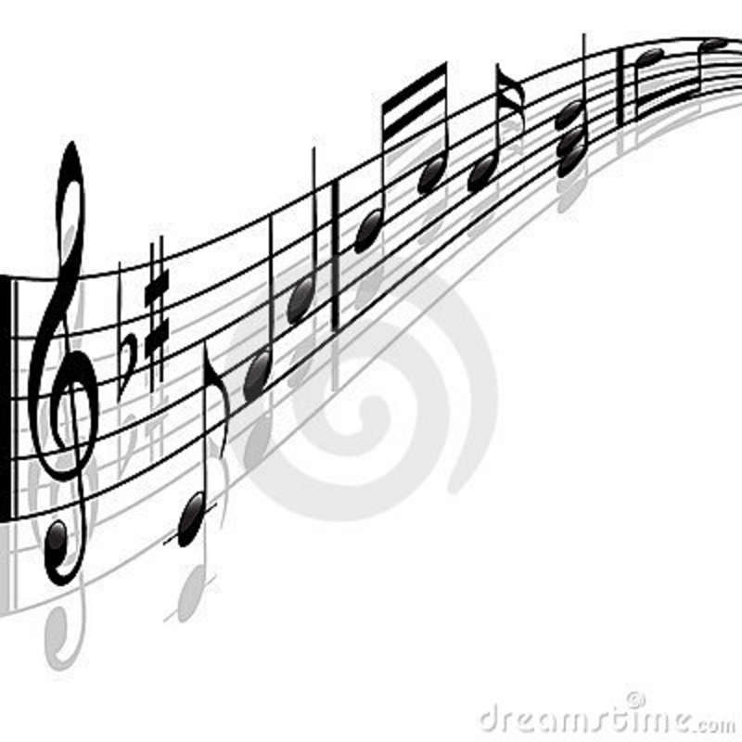

Melody

Within ‘Defying Gravity’ there are a range of short ideas used to represent characters or mood. These are called leitmotifs. Within this set work, the main leitmotif used is based on the opening 7 notes of ‘Somewhere over the Rainbow’ – this is called the Unlimited Theme. The text setting is syllabic - this means that each syllable has its own note. At the end of bar 175 there is vocalisation to the word ‘aah’. The melody at the start of the piece moves mainly conjunctly - this means that the melody moves by steps rather than leaps.

Many ideas are used to create the melody, sequence is used in bars 6 and 7, also the intervals of a perfect fourth and fifth are used a lot to create the melody in the verse. In the song these intervals are used to create wide angular leaps, the largest leap is in bars 39-40. The interval here is a compound perfect fourth. There is also a compound perfect fifth in bar 140-141. There is also a rising perfect fifth in bar 35.

Rhythm, Metre and Tempo

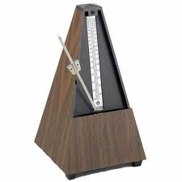

There are numerous tempo changes through this song and they are important to the overall structure. Add the tempo changes alongside the correct bar number.

|  |  |
| --- | --- |
| Bar 1 | Free tempo |
| Bar 20 | Andante |
| Bar 49 | Allegro |
| Bar 88 | Moderato |
| Bar 103 | Allegro |
| Bar 111 | Andante |
| Bar 129 | Allegro |
| Bar 162 | Andante |
| Bar 168 | Maestoso |

The main rhythmic focus alternates between slow chordal accompaniments and driving quaver rhythms. The melody is often syncopated- melody not on the main, strong beats of the bar. Heavy percussions is used to emphasis the rhythms.

At the end of a section there are often rallentandos used to go from Allegro to Andante as well as at the end of the piece.

The time signature changes from 3/2 triple timeto 2/2 duple time in the opening section. The majority of the piece is in 4/4 quadruple time. Syncopation is frequent throughout for example in bars 67–70. Dotted rhythms are also used throughout for example, in bar 82 on the word ‘gra-vi-ty’. Triplets are used both in quaver triplets form in bar 96 and as crotchet triplets in bar 60. The triplets create cross-rhythms against the quavers in the chorus.

Most of the rhythms are mainly made up of crotchet and quavers although there are some notes of longer duration particularly at the ends of phrases. Rests are often used to break up phrases. Each phrase starts with an off-beat entry after a crotchet rest for example, in bar 15. Pause marks or fermatas are used to lengthen and give freedom to longer rhythms, for example at the end in bars 174 and 176.



Structure

**The overall structure of this movement is Extended Verse Chorus from**

Intro, dialogue section 1, verse 1, chorus, link, verse 2, chorus, dialogue section 2, first bridge, chorus, link 2, verse 3, bridge 2, chorus, coda.

Within this structure the piece has multiple sections which are defined by tempo, contrasting

moods and melodic material.

**Complete the chart below by adding in the bar numbers:**

|  |  |  |
| --- | --- | --- |
| Bars 1–19 | Free tempo  recitative-like | Duet between Glinda and Elphaba with a combination of spoken dialogue and singing. Orchestral chord stabs at start- homophonic texture.  Then becomes chordal and sustained. Like a recitative because it moves through the action quickly to get to the next section. |
| Bars 20–48 | Andante  Verse - 32 | Homophonic chordal opening moving through different major keys. Legato, conjunct melody. The verse contains  tremolo strings with dissonant harmony for accompaniment- strings marked colla voce (with voice- follow singers tempo). |
| Bar 49–87 | Allegro  Chorus 1 - 50  Link 1 - 59  Verse 2- 63  Chorus 80 | The title hook leaping melody is sung over broken chord accompaniment and driving hi-hat rhythms. Next Glinda  sings a crotchet triplet-based melody before Elphaba  takes over with a syncopated version of the verse, which leads into the chorus. |
| Bar 88–102 | Moderato  Dialogue section 2- 88  Bridge - 93 | A contrasting section in the new key of G major with both  characters singing a new melody in unison over semiquaver accompaniment. |
| Bar 103–110 | Allegro  Chorus 3 103 | Return to D major for the chorus sung by both characters, opening in unison with strong piano accompaniment. |
| Bar 111–128 | Allegro  Link 2- 111  Revise version of into- 115  Vamp section -129  Verse 2- 135  Chorus 4- 152 | Climax of the song with full orchestra and loud dynamic.  Opens with the homophonic chordal music which leads  into an extended version of the verse at a higher register and with developed melodic and rhythmic ideas. There is  a reprise of the chorus |
| Bar 162–177 | Andante to  Maestoso  Link 3- 162  Coda- 168 | Build up to full tutti finale, in B minor at bar 168 with  Elphaba, Glinda, ensemble chorus and orchestra in counterpoint with different musical lines and lyrics. |

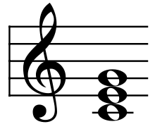

Harmony

Both major and minor chords are used throughout. The opening starts with very dramatic marcato chords (very strongly accented). Some chromaticism is used, for example the chords in the opening shift chromatically. D Major, C# min, C maj, B maj. There is some use of dissonance for example in bar 30 as well as altered chords- augmented chords- where the fifth of the chord is raised. At the end of the piece there is a pedal at bar 168. There is also some use of polytonal chords- where two different chord are layered on top of each other- for example, bar 173, C major + F major. A range of different chords are used to create an ambitious tonality at times.

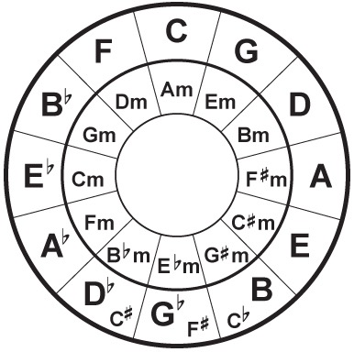

Tonality

In the opening of piece the tonality is ambiguous with chromatic movement and unrelated chord progressions. This means that it is unclear what key the piece is as the chords are not linked in any way. The key of the piece is in D major.

|  |  |
| --- | --- |
| Key | Bar |
| 1-20 | D major |
| 20-22 | B major |
| 22-32 | F major |
| 32-88 | D major |
| 88-102 | G major |
| 103- 115 | D Major |
| 115-132 | chromatic chords |
| 132-168 | B minor |
| final bar | D major |

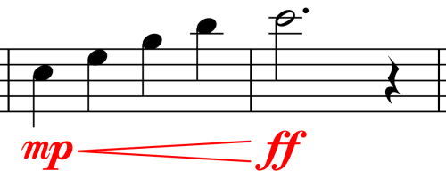

Dynamics

The full range of dynamics is used from fortissimo to pianissimo to create contrasting moods. The song has a large dynamic range and some unusual dynamics- from example sforzando (forced) and *fp* markings which means loud then immediately soft.

Possible Exam Questions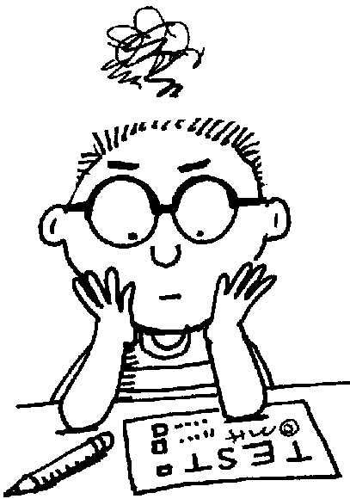

Describe how Schwartz sets the words Defying gravity whenever the phrase accord in the song. Describe how he varies the melody, rhythm and pitch each time.

Explain what a motif is and give an example from the song

Describe the music of the opening introduction (bars 1-14) referring to melody, harmony, tempo and texture.

Describe the structure of the song after the opening introduction mention at least three different areas of mood change.

Give two musical reasons why you like or dislike this song.

Listen to ‘Mamma I’m a big girl now’ from *Hairspray.* Can you identify three similarities and three differences between this song and ‘Defying Gravity’

If you were to write a musical based on a pre-existing plot from a novel, film or play, what would you choose and why?