# Worksheet 6 Boolean Algebra

**Task 1**

1. X, Y and Z are Boolean variables which can be either TRUE or FALSE, represented by 1 and 0.

Complete the following “rules” of Boolean algebra:

## **General rules** [9]

1. X ⋅ 0 =
2. X ⋅ 1 =
3. X ⋅ X =
4. X + 0 =
5. X + 1 =
6. X + X =
7. =

## **Commutative rule** [2]

1. X ⋅ Y =
2. X + Y =

## **Associative rule** [2]

1. X ⋅ (Y ⋅ Z) =
2. X + (Y + Z) =

## **Distributive rule** [2]

1. X ⋅ (Y + Z) =
2. (X + Y) (W + Z) =

*Note that X Y can be written as XY.*

2. Write down de Morgan’s first and second laws: [2]

3. Use de Morgan’s Laws and the rules of Boolean algebra to simplify the following expressions, stating which rule you use at each step.

(a) X Y + X(Y + Z) [2]

(b) [3]

(c) [3]

(d) [6]

(e) (X + Y)(X + Z) [6]

4. Complete the truth table to show that : [4]

|  |  |  |  |  |  |
| --- | --- | --- | --- | --- | --- |
| **A** | **B** |  |  |  | **A + B** |
| 0 | 0 |  |  |  |  |
| 0 | 1 |  |  |  |  |
| 1 | 0 |  |  |  |  |
| 1 | 1 |  |  |  |  |

**Task 2**

1. Simplify the expression A⋅B + A⋅ (B + C) [3]

Draw a logic circuit representing the simplified expression, using only 2 gates. [2]

2. (a) Write the Boolean expression representing the logic circuit below. [1]

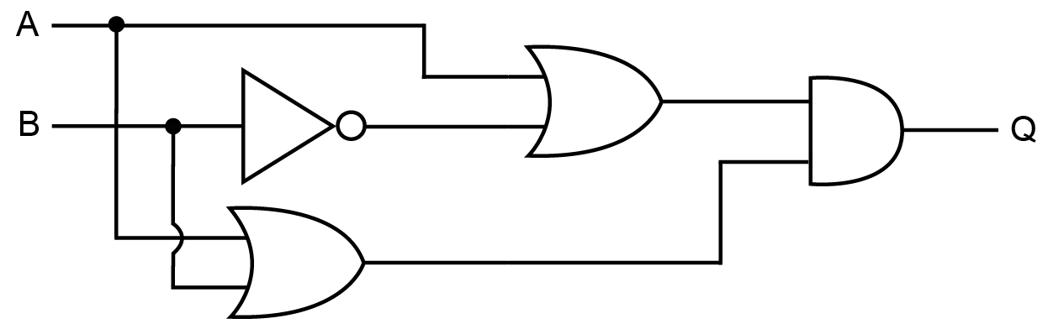

(b) Simplify the expression. [3]

(c) With reference to the above example, explain why de Morgan’s Laws and the rules of Boolean algebra have a huge commercial significance in the manufacture of computers. [2]