# Worksheet 4 Representing images

# Task 1 Bit depth

Carry out the following binary sums showing your working out:

|  |  |  |  |  |  |  |  |  |  |  |  |  |  |  |  |  |  |  |  |
| --- | --- | --- | --- | --- | --- | --- | --- | --- | --- | --- | --- | --- | --- | --- | --- | --- | --- | --- | --- |
|  |  |  |  |  |  |  |  |  |  |  |  |  |  |  |  |  |  |  |  |
|  |  |  |  |  |  |  |  |  |  |  |  |  |  |  |  |  |  |  |  |
|  |  |  |  |  |  |  |  |  |  |  |  |  |  |  |  |  |  |  |  |
|  |  |  |  |  |  |  |  |  |  |  |  |  |  |  |  |  |  |  |  |
|  |  |  |  |  |  |  |  |  |  |  |  |  |  |  |  |  |  |  |  |
|  |  |  |  |  |  |  |  |  |  |  |  |  |  |  |  |  |  |  |  |
|  |  |  |  |  |  |  |  |  |  |  |  |  |  |  |  |  |  |  |  |
|  |  |  |  |  |  |  |  |  |  |  |  |  |  |  |  |  |  |  |  |
|  |  |  |  |  |  |  |  |  |  |  |  |  |  |  |  |  |  |  |  |
|  |  |  |  |  |  |  |  |  |  |  |  |  |  |  |  |  |  |  |  |
|  |  |  |  |  |  |  |  |  |  |  |  |  |  |  |  |  |  |  |  |
|  |  |  |  |  |  |  |  |  |  |  |  |  |  |  |  |  |  |  |  |
|  |  |  |  |  |  |  |  |  |  |  |  |  |  |  |  |  |  |  |  |
|  |  |  |  |  |  |  |  |  |  |  |  |  |  |  |  |  |  |  |  |
|  |  |  |  |  |  |  |  |  |  |  |  |  |  |  |  |  |  |  |  |
|  |  |  |  |  |  |  |  |  |  |  |  |  |  |  |  |  |  |  |  |
|  |  |  |  |  |  |  |  |  |  |  |  |  |  |  |  |  |  |  |  |
|  |  |  |  |  |  |  |  |  |  |  |  |  |  |  |  |  |  |  |  |
|  |  |  |  |  |  |  |  |  |  |  |  |  |  |  |  |  |  |  |  |
|  |  |  |  |  |  |  |  |  |  |  |  |  |  |  |  |  |  |  |  |

|  |  |  |  |  |  |  |  |
| --- | --- | --- | --- | --- | --- | --- | --- |
| **111** | **110** | **101** | **100** | **011** | **010** | **001** | **000** |

1. What is the resolution of the image above?
2. What is the bit depth?
3. What is the file size in KB?
4. What would be the effect of increasing the bit depth to 24bits?
5. What are the disadvantages of increasing image quality?

# Task 2 Metadata

Metadata can be found by looking at the properties of a file. The process to view bitmap metadata in Windows is outlined below:

1. Browse to where the file is stored
2. Right-click on the file
3. Select ‘Properties’

Metadata will appear on both the **General** and **Details** tabs of the **Properties** window.

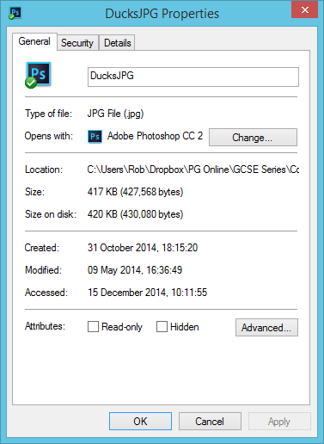 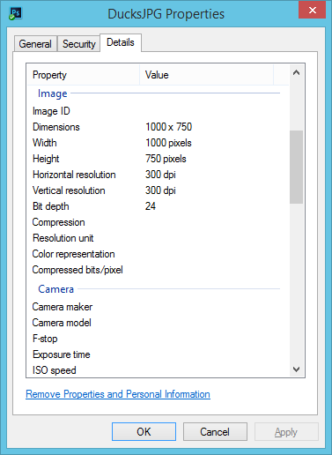

Complete the table below to find out what metadata is stored for the following files and what it is included for:

|  |  |  |  |
| --- | --- | --- | --- |
| **Type of file** | **Metadata 1** | **Metadata 2** | **Metadata 3** |
| A JPEG photo from digital camera | Camera manufacturer |  |  |
| A Bitmap image |  |  |  |
| A Word document |  |  |  |
| A PowerPoint presentation |  |  |  |