Three top cruise destinations

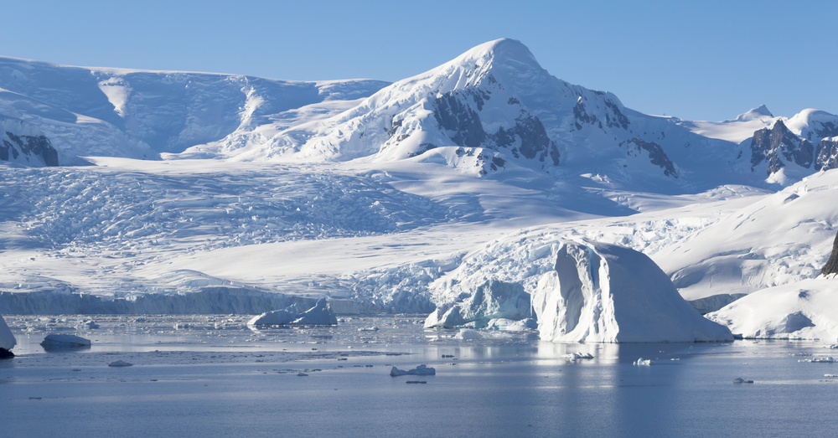

# Caribbean

Typically you might visit three or four countries on a one-week island-hopping cruise. If you’re thinking of a longer trip, you can visit even more islands. Some of the most popular include Jamaica, Barbados, Curaçao, Aruba, St Lucia and St Kitts, with stop-offs to lie on sandy beaches, participate in water sports or take tours to learn about the colourful history of each island.

For a different experience, Cuba is fascinating, and you’ll need more than   
just a one-day stop-off – ships often sail round the island stopping for a day at different ports.

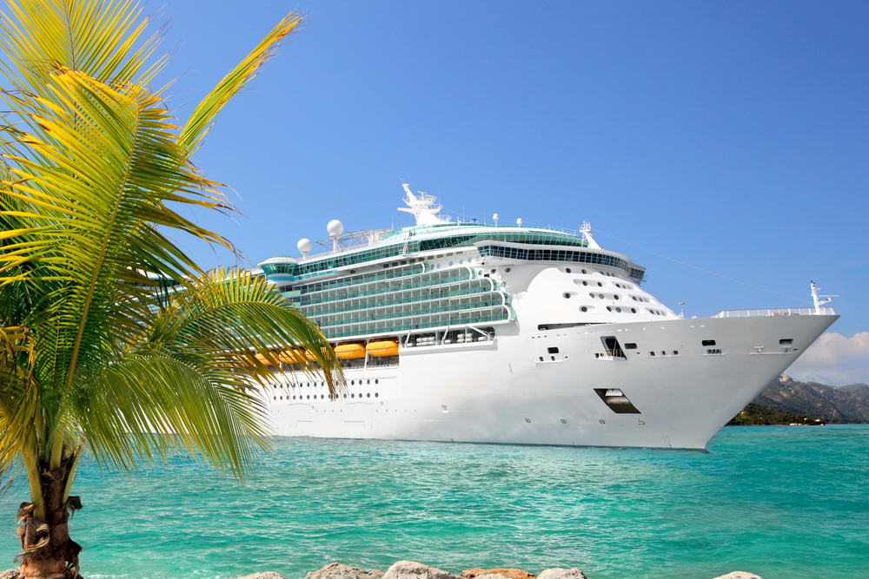

# Antarctica

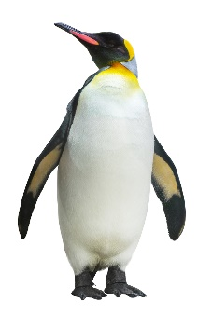If you fancy a unique cruise to the coldest, most remote part of the earth, Antarctica with its vast, unspoiled landscapes and gigantic icebergs will take your breath away.

You’ll cruise on a ship that holds no more than 200 passengers, and disembark to find yourself walking among penguins, getting close to sea lions and buckling on snowshoes for a walk across the spectacular landscape.

# Mediterranean

Why not try a cruise to some of Europe’s finest destinations, including Florence, Naples, Rome and Barcelona as well as some of the gems of the Mediterranean like St Tropez?

In Florence, you’ll be able to gaze in wonder at Michelangelo’s David. Walk around the famous city of Pompeii, buried under metres of lava from a volcanic eruption in 79 A.D.,   
and climb to the crater rim of nearby Mount Vesuvius.



The ruined city of Pompeii