# Homework 3 Client-server and Peer-to-peer

# What network architectures are being shown in the diagrams below? [2]

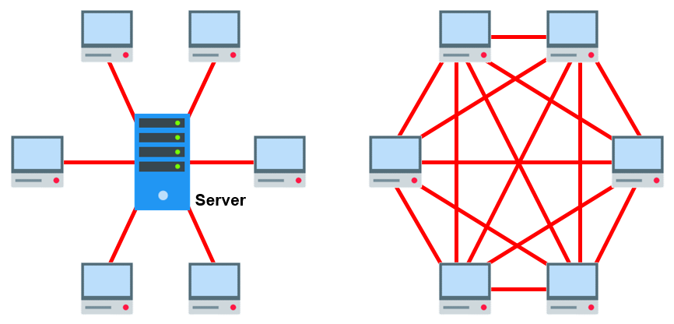

# Describe two advantages and two disadvantages of using a client-server architecture. [8]

**Advantage 1:**

**Advantage 2:**

**Disadvantage 1:**

**Disadvantage 2:**

# “There is little reason to follow a client-server architecture when setting up a personal home network”. Explain this statement. [4]

[Total 14 Marks]