Name: Class:

Task 1

A stained-glass window designer is creating a new window design. To assist with the construction of the window, work out the missing values of angles *a* to *i* in the component shapes below.

|  |  |
| --- | --- |
| A screenshot of a cell phone  Description generated with high confidence |  |
| (*a*) = (*b*) = (*c*) = | (*d*) = |
| A close up of text on a white background  Description generated with high confidence | A close up of a logo  Description generated with very high confidence |
| (*e*) = | (*f*) = |
| A close up of a sign  Description generated with very high confidence |  |
| (*g*) = (*h*) = | (*i*) = |

Task 2

Work out the surface area of the each laser cut acrylic component below.

|  |  |
| --- | --- |
| A close up of a sign  Description generated with very high confidence | A screenshot of a computer  Description generated with very high confidence |
| (a) | (b) |
| A screenshot of a video game  Description generated with high confidence | A close up of a logo  Description generated with very high confidence |
| (c) | (d) |
|  | |
| (e) | |

Task 3

Work out the volume of the following shapes.

|  |
| --- |
| A picture containing text  Description generated with high confidence |
| (a) |
|  |
| (b) A cube of side 6cm |
| A picture containing text  Description generated with high confidence |
| (c) |

Task 4

These cardboard tubes have an internal diameter of 11 cm and an external diameter of 13 cm. They have a length of 15 cm.

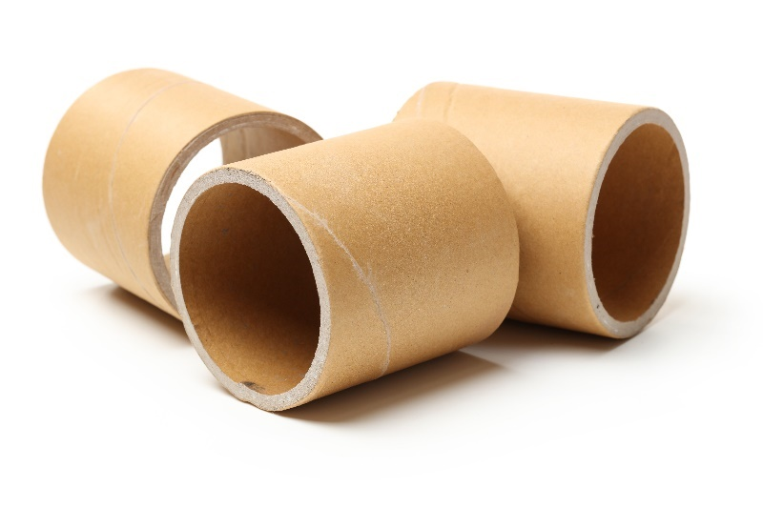

(a) Work out the external volume of one of these tubes.

(b) Work out the internal volume of one of these tubes.

(c) Use your answer to part (a) and part (b) to work out the volume of cardboard in   
one of the tubes.