# Worksheet 5 Abstraction and automation

**Task 1**

1. An algorithm is to be written to find the shortest route between two points. How can abstraction be applied to this problem?

What applications could such a program be useful for?

2. Give examples of some problems which can be “solved” by computer simulations

3. What factors would be relevant in a financial model which calculates the likely annual profit in a new coffee shop?

What factors would be irrelevant?

**Task 2**

4. You have been asked to write a procedure to count the number of vowels in a sentence. How can you ensure that the procedure will work for any length of sentence?

5. To implement a stack, you would need three procedures: InitialiseStack(stack, pointer), AddToStack(stack, pointer, item), RemoveFromStack(stack, pointer, item).

The identifiers in brackets are **parameters** defined in the main program and passed to the procedure.

What procedures and parameters would you need to be able to implement a queue?

6. A car dealer might use a procedure for displaying different models of a particular make of car. The user can specify what model they are interested in, how many doors the car should have, the paint colour, wheels, and interior specifications.

See <http://www.volkswagen.co.uk/configurator>

Draw a hierarchy chart to show how the procedure for displaying a particular model might be broken down into separate tasks and subtasks.

What type of abstraction is being used in this problem?

7. Solve this puzzle.

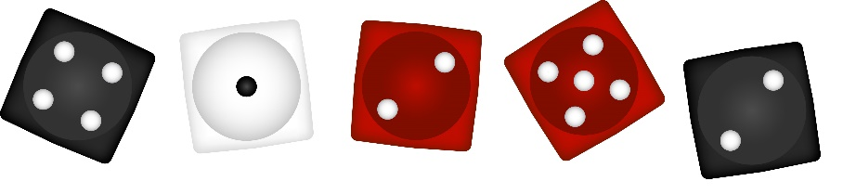

**Roll 1**

The answer to Roll 1 is: 4

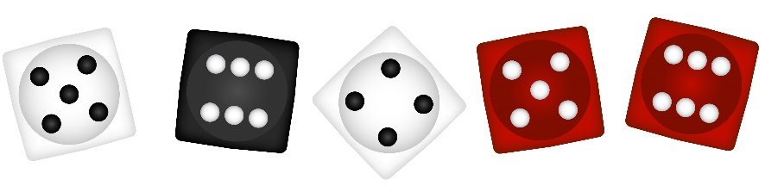

**Roll 2**

The answer to Roll 2 is: 8



**Roll 3**

The answer to Roll 3 is: 14



**Roll 4**

The answer to Roll 4 is: 0

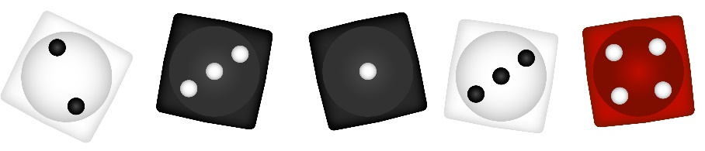

**Roll 5**

The answer to Roll 5 is: 4



**Roll 6**

What is the answer to roll six?

Why?