Name: Class:

**Task 1**

1. This image uses four colours so requires 2 bits per pixel. Fill each pixel in the image as a computer using the key.

|  |  |  |  |  |  |  |  |  |  |  |  |  |  |
| --- | --- | --- | --- | --- | --- | --- | --- | --- | --- | --- | --- | --- | --- |
| 10 | 10 | 10 | 10 | 10 | 10 | 10 | 10 | 10 | 10 | 10 | 10 | 10 | 10 |
| 10 | 00 | 00 | 10 | 00 | 00 | 10 | 00 | 00 | 10 | 00 | 00 | 00 | 10 |
| 10 | 00 | 00 | 10 | 00 | 00 | 10 | 00 | 00 | 10 | 00 | 00 | 00 | 10 |
| 10 | 10 | 10 | 10 | 10 | 10 | 10 | 10 | 10 | 10 | 10 | 10 | 10 | 10 |
| 10 | 00 | 00 | 10 | 00 | 00 | 10 | 00 | 00 | 10 | 00 | 00 | 00 | 10 |
| 10 | 00 | 00 | 10 | 00 | 00 | 10 | 00 | 00 | 10 | 00 | 00 | 00 | 10 |
| 10 | 00 | 11 | 10 | 10 | 10 | 10 | 10 | 10 | 10 | 10 | 10 | 10 | 10 |
| 10 | 11 | 11 | 10 | 10 | 10 | 10 | 10 | 10 | 10 | 10 | 10 | 01 | 01 |
| 10 | 10 | 10 | 10 | 11 | 11 | 10 | 10 | 10 | 10 | 11 | 11 | 10 | 10 |
| 00 | 00 | 00 | 00 | 11 | 11 | 00 | 00 | 00 | 00 | 11 | 11 | 00 | 00 |

|  |  |  |  |  |
| --- | --- | --- | --- | --- |
| **Key:** | 01 | 00 | 11 | 10 |

1. Calculate the file size of the following images:

|  |  |  |  |  |  |
| --- | --- | --- | --- | --- | --- |
|  | **Image Resolution** | **Number of colours** | **Colour depth in bits** | **File size in bits** | **File size in Bytes** |
| **Image 1** | **20 x 20** | **8** |  |  |  |
| **Image 2** | **10 x 10** | **8** |  |  |  |
| **Image 3** | **20 x 20** | **4** |  |  |  |

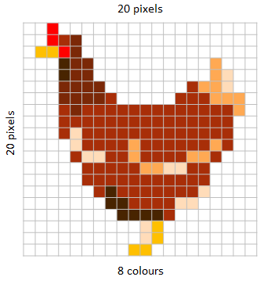 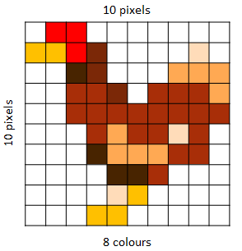 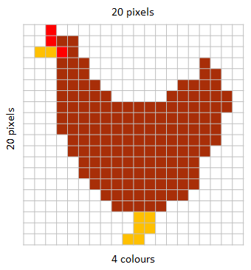

1. How does increasing the image resolution affect the file size?
2. Explain the relationship between image quality and file size

**Task 2**

1. Using the following bit pattern, shade in the pixel grid to create a black and white bitmap to create an image where black = 1 and white = 0: 00100 01110 11111 00100 01100

|  |  |  |  |  |
| --- | --- | --- | --- | --- |
|  |  |  |  |  |
|  |  |  |  |  |
|  |  |  |  |  |
|  |  |  |  |  |
|  |  |  |  |  |

1. What is the bit pattern for the following icon image where black = 1 and white = 0?

|  |  |  |  |  |
| --- | --- | --- | --- | --- |
|  |  |  |  |  |
|  |  |  |  |  |
|  |  |  |  |  |
|  |  |  |  |  |
|  |  |  |  |  |