Name: Class: Mark:

1. What is the meaning of abstraction.

Tick the correct definition. [1]

* **a** A sequence of steps to solve a problem.
* **B** Breaking down a problem into smaller parts
* **C** Drawings of a real-life situation
* **D** Removing or hiding parts of a problem that are not important

2. Look at the following maze:

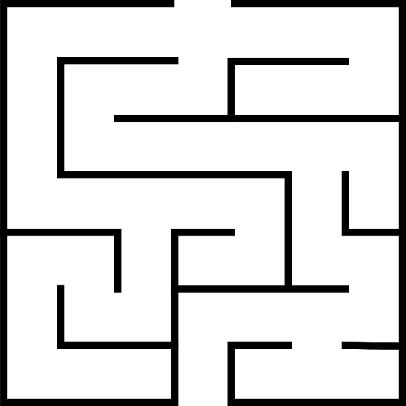

(a) Write numbers at the following points on the maze:

* Start point
* Decision points
* Dead ends
* End point [4]

(b) Create a network (graph) which represents the maze.

The first two nodes (circles) have been completed for you. [4]

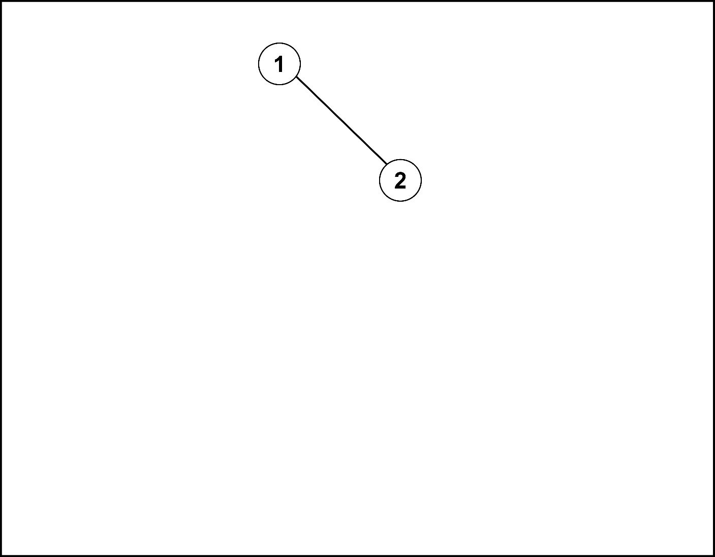

(c) Write down the order of nodes that a computer would need to visit   
to solve the maze. [1]

[Total 10 marks]