**DO’S AND DON’TS DURING**

**A JOB INTERVIEW**

**Activity 2:** Watch the **video clips, identify and complete** the **list of do’s & don’ts** in the table below.

[Good example](https://www.youtube.com/watch?v=SieNfciN274) [Poor example](https://www.youtube.com/watch?v=akjwDe081lA)

|  |  |
| --- | --- |
| **DO’S** | **DON’TS** |
|  |  |
|  |  |
|  |  |
|  |  |
|  |  |
|  |  |
|  |  |
|  |  |
|  |  |
|  |  |
|  |  |
|  |  |

**DO’S AND DON’TS DURING**

**A JOB INTERVIEW**

**Activity 1:** Watch the **video clips, identify and complete** the **list of do’s & don’ts** in the table below.

|  |  |
| --- | --- |
| **DO’S** | **DON’TS** |
|  |  |
|  |  |
|  |  |
|  |  |
|  |  |
|  |  |
|  |  |
|  |  |
|  |  |
|  |  |
|  |  |
|  |  |

**Activity 2:** Self-reflect and complete the below SWOT Analysis

**Name: _________________________ Date: _________________**

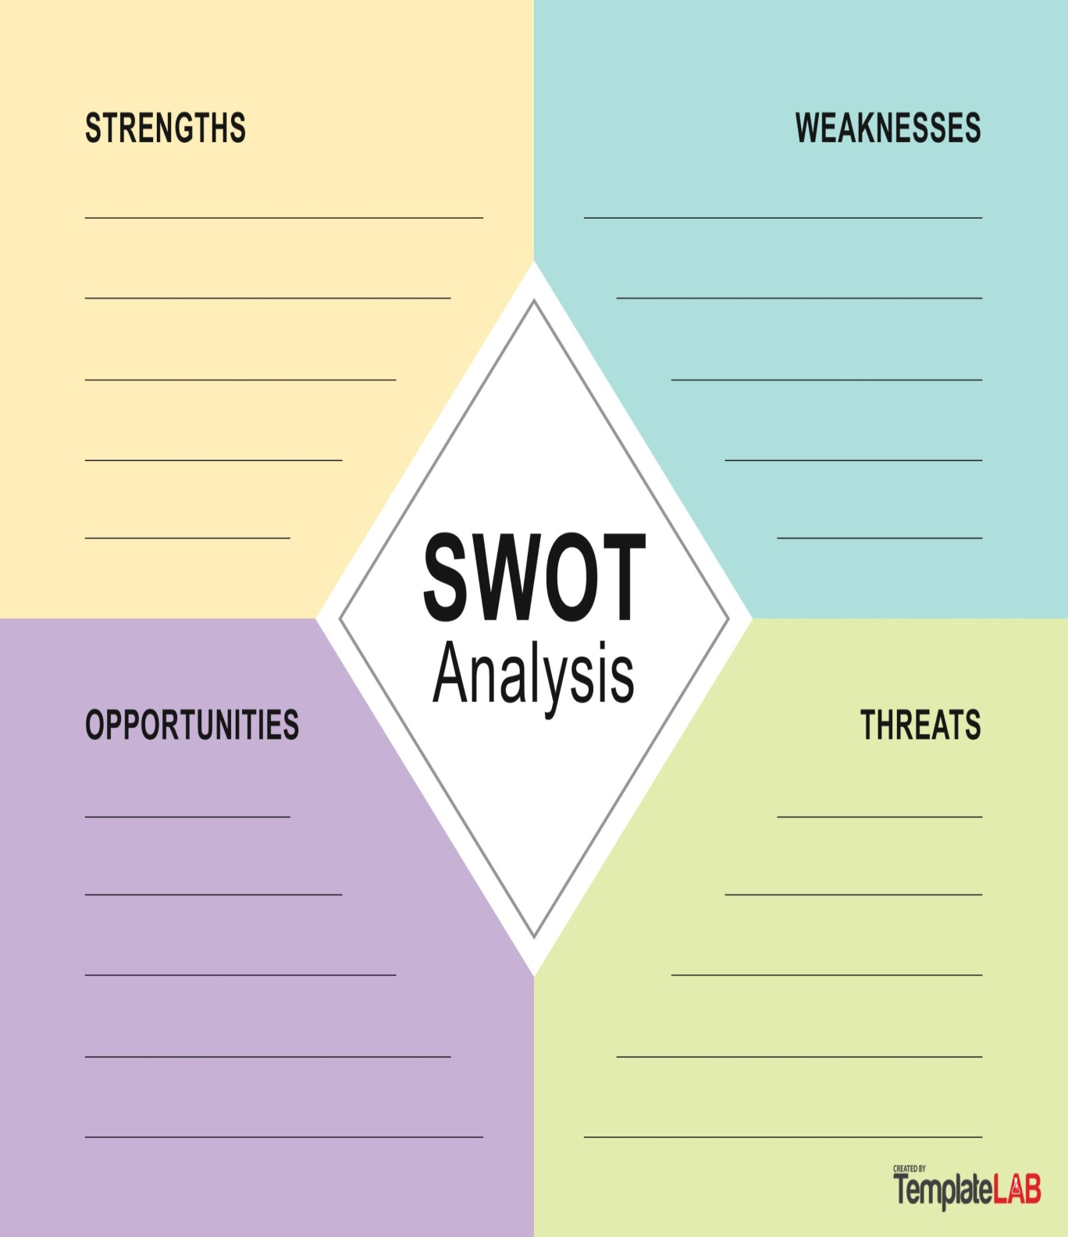

**INTERVIEW A CLASSMATE**

**Activity 3:** **Pair up with a classmate** and **use the question form** below to **interview each other.**

|  |
| --- |
| **Name of Interviewer:** |
| **Name of Interviewee :** |
| 1. **Tell me about your family, do you have any pets?** |
|  |
|  |
|  |
| 1. **What are your favourite foods?** |
|  |
|  |
| 1. **Tell me something you like to do in your spare time?** |
|  |
|  |
| 1. **If you had a superpower what would it be & why?** |
|  |
|  |
| **5. What kind of animal would say you are similar to & why?** |
|  |
|  |
| 1. **What is your favourite subject & what do you like most about it?** |
|  |
|  |
|  |

**Interview Observation Record**

|  |  |  |
| --- | --- | --- |
| **Observation** | **Observed** | **Comments** |
| Introduction |  |  |
| Handshake |  |  |
| Eye contact |  |  |
| Body language |  |  |
| Clarity of speech |  |  |
| Body Posture |  |  |
| Questions to  Interviewer |  |  |
| Ending interview |  |  |

**Use Job Descriptions from separate file**

**Letters of application to write prior to interviews below**

**MOCK INTERVIEW QUESTIONS**

**Activity 4**: **First, select a job you would like to enter.** **Then, spend 10 minutes to make notes** on the **mock interview questions** below. **Then** in pairs, **assign one person to be the interviewer** and the **other the interviewee. Then switch roles and repeat.**

|  |
| --- |
| **Q 1. Tell me about yourself?** |
|  |
|  |
|  |
| **Q 2. What are your hobbies?** |
|  |
|  |
|  |
| **Q3. What inspires and motivates you to work in this role?** |
|  |
|  |
|  |
| **Q4. What would you say your strengths are?** |
|  |
|  |
|  |
|  |
|  |
| **Q5. What do you think will be the most challenging, hardest part of this role?** |
|  |
|  |
|  |
|  |