Name: Class:

Task 1

A student wishes to make a cone from polypropylene to project sound.

The shape is based on a sector of a circle with radius 30 cm.

The angle marked on the diagram is 120°.

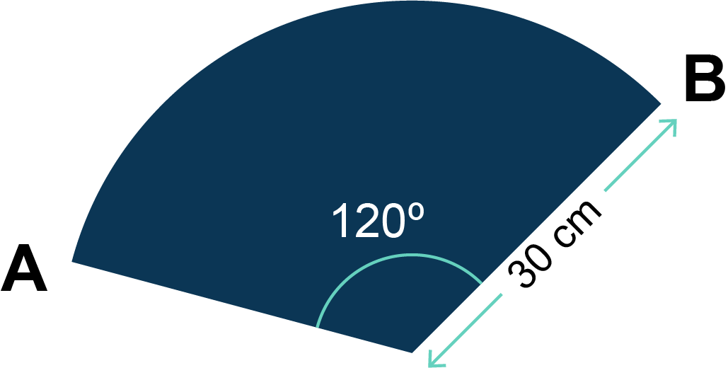

The circumference of a circle is given by *C* = *d* = 2*r*, where *d* is the diameter of the circle, *r* is the radius. Take  as 3.14.

Give all answers to 1 decimal place.

(a) Calculate the area of the polypropylene sector.

(b) Calculate the length of the arc of the sector, that is, the length of the curved part.

(c) Calculate the total perimeter of the sector, that is, the total length of the outside of the shape.

Task 2

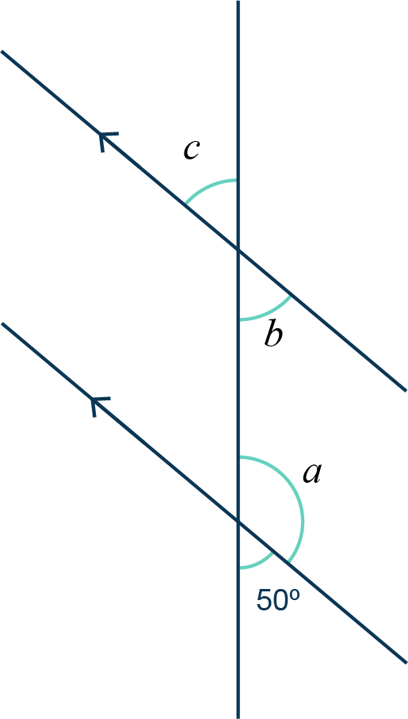A student draws two parallel lines on the lid of their project so they can accurately place a self-adhesive vinyl logo.

Work out the sizes of angles *a*, *b* and *c*.