Worksheet 4: Seat booking

Task 1: Formatting the Seat Booking spreadsheet

1. Open the spreadsheet TNBT Seat Booking Starter. This has the basic seating plan that you will use, and the beginnings of some calculations to help you calculate the revenue from seat sales and the number of seats that have been sold.
2. Merge and centre the cells that the stage occupies. Fill it will a suitable colour.
3. Add different Fill colours to each of the three seat categories Premium, Standard and Economy. Format all these cells so that the text (A, S or C) is centred in each cell.
4. Select all the seats. (You can hold down the Ctrl key while selecting different areas.) Add conditional formatting to turn the cells grey once they have been sold. To do this, from the Home tab select Conditional formatting, New Rule, Format only cells that contain No Blanks. Click the Format button and choose a grey colour.
5. Save your spreadsheet at frequent intervals!

Task 2: Adding data validation

1. You must allow the user to enter only A, S or C in a seat cell to show that it has been sold. To do this, you need to add validation to the seat cells. Start by selecting all the seat cells.
2. Click the data tab and select Data validation. In the Allow box, select List.

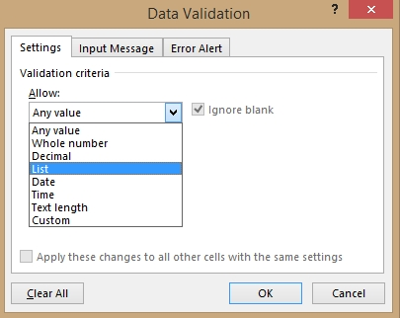 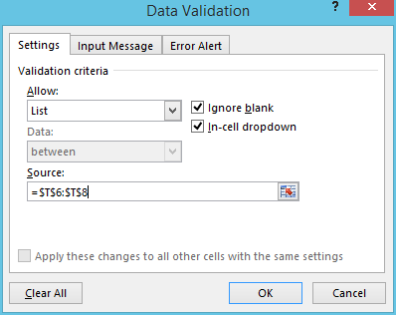

1. With the cursor in the Source box, highlight the three cells T6 to T8 containing the letters A, S and C.
2. Click the Error Alert tab and enter a title for the error message which will appear when the user enters invalid data. Then enter a suitable error message.
3. Now try entering a letter into a seat cell. A dropdown list of valid entries appears.

Task 3: Calculating the number of seats sold

1. You need the COUNTIF function to do this. The format of this function is  
   COUNTIF (range, criterion)

The function counts the number of cells within a range that meet a single criterion that you specify. So to count the number of premium seats sold to adults, (cell Y13), you need to enter the formula =COUNTIF(E9:P10, “A”).

Enter formulae to count the number of seats sold in every category, as well the total sold in each category.

1. Look at the formula in AC13 to calculate the number of premium seats remaining. Enter formulae to find the number of standard and economy seats remaining, and in cell AC16, the total seats remaining.

Task 4: Calculating the revenue from seat sales

1. Cell W7 calculates the percentage of the full price for any seat that a student will have to pay, given that they receive a 25% discount. The cell has been named StudentPercent. Insert an appropriate formula in cell W8 and name the cell ChildPercent. (Enter the name in the box to the left of the formula bar.)
2. In V13, a formula has been entered which calculates the price that a student pays for a Premium seat. Enter formulae to calculate all the other prices paid by students and children for Premium, Standard and Economy seats.
3. Now fill in the table which shows the Income from seat sales, and calculate the total revenue in each category.
4. Enter the overall total revenue in a suitable cell, and give it a label.
5. Save your spreadsheet.