**Homework 5 Querying a database**

A secondhand car dealer keeps a database of cars for sale. A sample of the data is shown below.

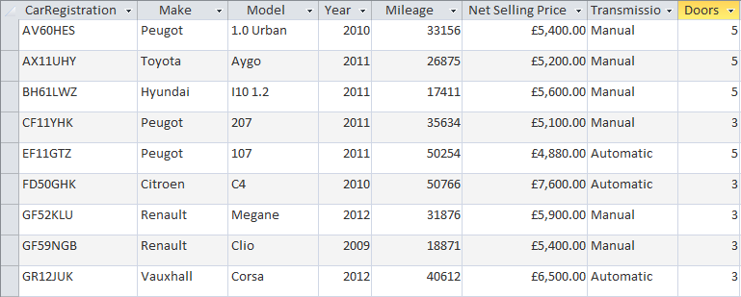

1. What is the purpose of a primary key in a table? [1]
2. State which field would make a suitable primary key in this table. [1]
3. State the most appropriate data type for the following fields:

Mileage ________________ [1]

Net selling price ________________ [1]

1. State the registration number of the cars that will be found using each of the following criteria:

Mileage < 20000 [1]

______________________________________________________________________

Year >=2011 and Transmission = “Automatic” [1]

(Make=”Peugeot” OR “Renault”) AND (Net Selling Price <= 5200.00) [1]

1. Write the criteria for a query which will select all cars with 5 doors made in 2011 or after. [3]

[Total 10 marks]