Worksheet 5: Health and safety

**Task 1**

Take a look at the two images below. One of the ladies is quite comfortable, but the other one might have some aches and pains if she spends too long in that position. Which one   
is correct?

Can you spot the differences?

 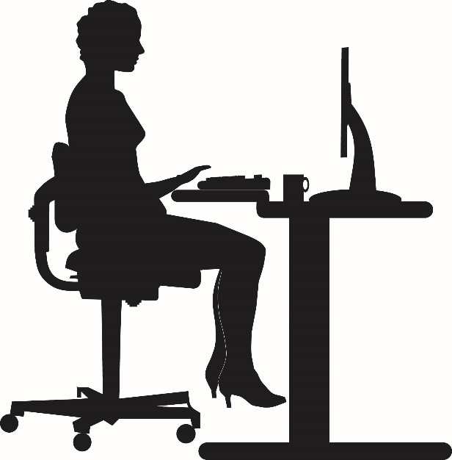

**B**

**A**

Circle and number **ten** differences in the image that shows potential health issues to the user. List below a description of each of the differences.

1.

2.

3.

4.

5.

6.

7.

8.

9.

10.