Name: Class: Mark:

# Convert the following binary values into denary: [2]

* 1. 00011011
  2. 11100110

# Circle the binary value below that represents the denary value 87? [1]

* 1. 01011010
  2. 11000100
  3. 01010111
  4. 00011010

# Convert the following values to and from Hexadecimal: (Show your working). [8]

* 1. Denary 37 to Hex
  2. Denary 59 to Hex
  3. Hex 11 to Denary
  4. Hex 2F to Denary
  5. Hex 1A to Binary
  6. Hex 16 to Binary
  7. Binary 0011 0111 to Hex
  8. Binary 1101 1111 to Hex

1. Multiply the binary value 0011 0010 by 2, by using a logical shift. [1]
2. Colours in art packages are often given using hexadecimal as illustrated below with **#00ccff**.

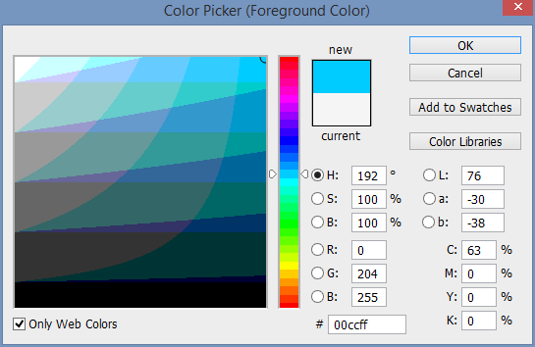

Explain why hexadecimal is used rather than the actual 24-bit colour value. [2]

1. Add 00100111 to 00101010. You should include your working. [2]

|  |  |  |  |  |  |  |  |  |
| --- | --- | --- | --- | --- | --- | --- | --- | --- |
|  |  |  |  |  |  |  |  |  |
|  | 0 | 0 | 1 | 0 | 0 | 1 | 1 | 1 |
| + | 0 | 0 | 1 | 0 | 1 | 0 | 1 | 0 |
|  |  |  |  |  |  |  |  |  |

1. Add 00100111 to 00111010. You should include your working. [2]

|  |  |  |  |  |  |  |  |  |
| --- | --- | --- | --- | --- | --- | --- | --- | --- |
|  |  |  |  |  |  |  |  |  |
|  | 0 | 0 | 1 | 0 | 0 | 1 | 1 | 1 |
| + | 0 | 0 | 1 | 1 | 1 | 0 | 1 | 0 |
|  |  |  |  |  |  |  |  |  |

1. An error occurs when you try to add 11011001 to 11100100 and store it as an 8-bit number.

Explain the error that occurs. [2]

[Total 20 marks]