# Worksheet 5 Logic Gates

**Task 1**

1. Write the following Boolean expressions using Boolean notation: [3]

(a) (A AND B) OR NOT (D AND E)

(b) NOT A AND NOT (B OR C)

(c) (A AND B) OR (B AND (NOT C))

2. (a) Complete the truth table for the following logic circuit. [8]

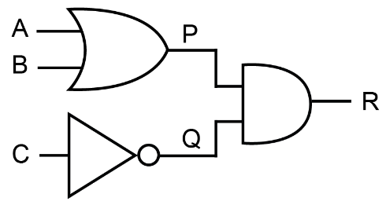

|  |  |  |  |  |  |
| --- | --- | --- | --- | --- | --- |
| **Input A** | **Input B** | **Input C** | **P = A OR B** | **Q = NOT C** | **Output R = (A OR B) AND (NOT C)** |
| 0 | 0 | 0 |  |  |  |
| 0 | 0 | 1 |  |  |  |
| 0 | 1 | 0 |  |  |  |
| 0 | 1 | 1 |  |  |  |
| 1 | 0 | 0 |  |  |  |
| 1 | 0 | 1 |  |  |  |
| 1 | 1 | 0 |  |  |  |
| 1 | 1 | 1 |  |  |  |

(b) Write a Boolean expression to represent this circuit, using Boolean notation. [1]

3. Draw logic circuits to represent the following Boolean expressions, and in each case say what is output if A = 1, B = 0 and C = 1, showing the output from each gate.

(a) Q = NOT ((A OR B) AND C) [6]

(b) Q = A  **•** (NOT (B + C)) [6]

**Task 2**

1. Draw the truth tables for the following logic circuits:

(a) [4]

|  |  |  |
| --- | --- | --- |
| **Input A** | **Input B** | **Output Q** |
|  |  |  |
|  |  |  |
|  |  |  |
|  |  |  |

(b) [8]

|  |  |  |  |  |  |
| --- | --- | --- | --- | --- | --- |
| **Input A** | **Input B** | **Input C** | **P = NOT (A AND B)** | **NOT C** | **Q = (NOT A AND B) OR NOT C** |
|  |  |  |  |  |  |
|  |  |  |  |  |  |
|  |  |  |  |  |  |
|  |  |  |  |  |  |
|  |  |  |  |  |  |
|  |  |  |  |  |  |
|  |  |  |  |  |  |
|  |  |  |  |  |  |

(c) Draw the logic circuit for the expression: [3]

2. Draw truth tables for each of the following logic circuits to show that they are equivalent.

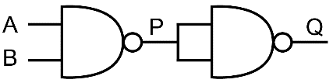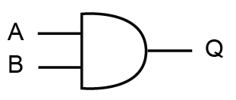

(i) (ii)

Truth table (i) [1] Truth table (ii) [4]

|  |  |  |
| --- | --- | --- |
| **Input A** | **Input B** | **Output Q** |
| 0 | 0 |  |
| 0 | 1 |  |
| 1 | 0 |  |
| 1 | 1 |  |

|  |  |  |  |
| --- | --- | --- | --- |
| **Input A** | **Input B** | **P =**  **NOT (A AND B)** | **Q =**  **NOT (P AND P)** |
|  |  |  |  |
|  |  |  |  |
|  |  |  |  |
|  |  |  |  |

3. (a) Write the following Boolean expression using Boolean notation:

(A XOR B) AND (NOT (C XOR D)) [1]

(b) Draw the logic diagram using only XOR, NAND and NOR gates, showing the output from each gate if the inputs for A, B, C and D are all 1. [12]