Homework 1: Email scams

Here is an example of a phishing email

**From:** [**security@halifax.uk.buildsociety.org.uk**](mailto:security@halifax.uk.buildsociety.org.uk)

**To:** [**john.smith@email.com**](mailto:john.smith@email.com)

**Subject: URGENT – NOTICE OF ACCOUNT SUSPENSION**



**DEAR CUSTOMER**

**YOUR ONLINE BANK ACCOUNT HAS BEEN SUSPENDED AS OUR SECURITY TEAM BELIEVE THAT THERE MAY   
HAVE BEEN A ILLEGALLY ACCESSED.**

**IN ORDER OT CONTINUE TO USE YOUR ACCOUNT YOU NEED TO RECONFIRM YOUR ACCESS DETAILS IMMEDIATELY**.

**IF YOU DO NOT DO THIS, YOUR ACCOUNT WILL BE PERMANENTLY SUSPENDED.**

**CLICK HERE TO CONFIRM YOUR DETAILS**

**YOURS SINCERELY**



**NICOLAS WILLAMS**

**CONSUMER DIRECTOR**

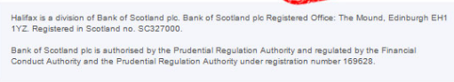

Identify 5 things that should alert you to the fact it this is a fake email.

[10 marks]