**Worksheet 1: TNBT Series One (USA) – Voting figures**

Task 1: Entering the data and formulae

1. Save a copy of the spreadsheet TBNT Series1 USA Voting.xls in your own area. This is the beginnings of the spreadsheet which will hold the voting figures each week of TNBT Series 1 in the USA.
2. Copy the following voting figures into the spreadsheet.

|  |  |  |  |
| --- | --- | --- | --- |
| **Phone Votes** | | **Text Votes** | |
| **Week** | **Votes** | **Week** | **Votes** |
| 1 | 179037 | 1 | 165458 |
| 2 | 168184 | 2 | 259852 |
| 3 | 141822 | 3 | 180341 |
| 4 | 90754 | 4 | 109749 |
| 5 | 98160 | 5 | 279400 |
| 6 | 191707 | 6 | 214129 |
| 7 | 82895 | 7 | 211307 |
| 8 | 103601 | 8 | 112725 |
| 9 | 123429 | 9 | 233154 |
| 10 | 103334 | 10 | 147114 |

1. In cell C12, enter a formula to calculate the income from Phone votes in Week 1. You could use the formula is =B12*0.55

What would be a better formula to use? ___________________________________  
  
Why is this a better formula?   
  
___________________________________________________________________  
  
___________________________________________________________________

1. Copy this formula into cells C13 to C21. You can do this by clicking and holding on the square in the bottom right corner of the cell, and dragging down through the cells C13 to C21. Notice that the formula automatically adjusts so that it refers to the correct week each time. This is known as relative referencing.
2. In cell G12, enter a formula to calculate the income from Text votes in Week 1. Copy the formula to the cells for weeks 2 to 10.
3. In cell C22, you need a SUM function to calculate the total. Enter the formula =SUM(C12:C21).
4. Enter a similar formula in cell G22. (You can copy and paste it from cell C22 if you like.)
5. In cell B7, enter the formula for Overall Income. This is the sum of the phone and text incomes. The formula is =C22+G22
6. Save your spreadsheet.

Task 2: Formatting the spreadsheet

1. Look at the screenshot of the formatted spreadsheet below. Apply formatting to your own spreadsheet to make it look similar.

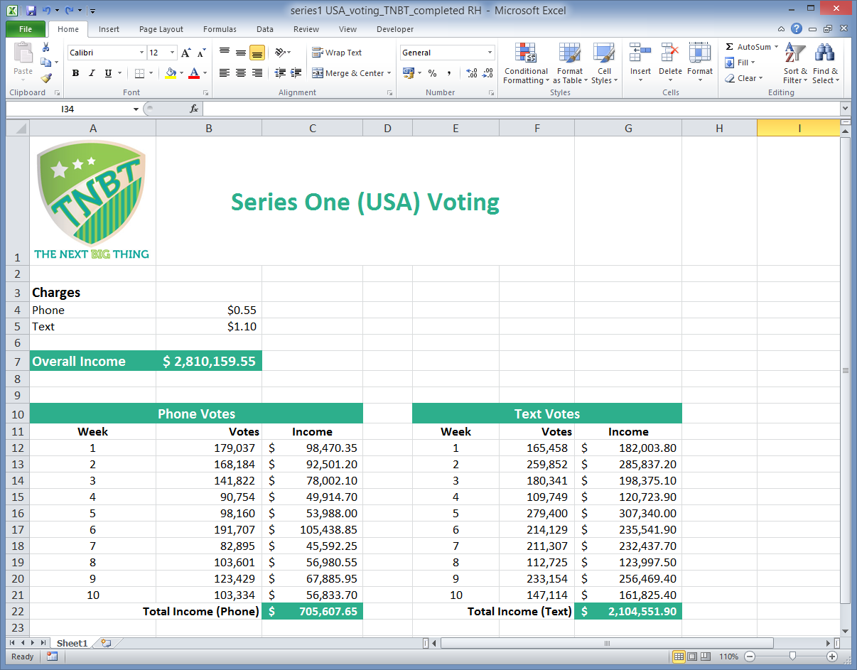

1. Add the TNBT logo graphic to the spreadsheet. Use Insert, Illustrations, Pictures on the main menu.
2. Save your spreadsheet.

Task 3: Modelling different scenarios

1. Use your spreadsheet to find out what you you would have to charge for a text vote in order to generate an overall income of $3,500,000.

Answer: ­­­­­­­­­­­­­­­­­­­­­­­­­­­__________________________________

1. Reset the price for texts to $1.10. Find out how many text votes would be needed to generate an income for texts in Week 1 of $150,000.

Answer: __________________________________