# Worksheet 1 Mealy machines

**Task 1**

1. (a) Draw the FSM that **accepts** all binary strings with an odd number of 1s.

* + The FSM will need two states: even and odd.
  + The accepting state will be the odd state.
  + Check your FSM with the strings: 0101 and 0111.

|  |  |  |  |  |
| --- | --- | --- | --- | --- |
| **Current State** | Even |  |  |  |
| **Input** | 0 | 1 | 0 | 1 |
| **New State** |  |  |  |  |

|  |  |  |  |  |
| --- | --- | --- | --- | --- |
| **Current State** | Even |  |  |  |
| **Input** | 0 | 1 | 1 | 1 |
| **New State** |  |  |  |  |

1. (b) The following FSM will accept only certain sequences of the symbols a and b.

Which of the following sequences will it accept?

(i) a (ii) baba (iii) bbaa (iv) baa

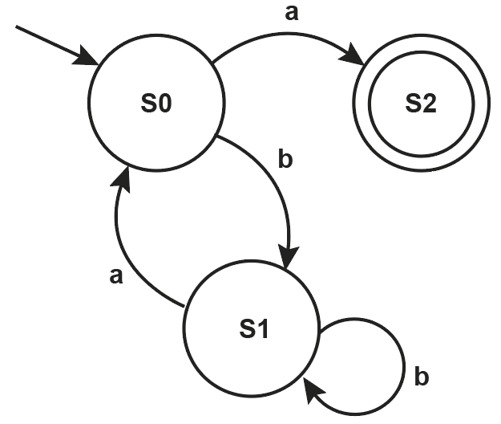

**Task 2**

2. A 4-state Mealy machine outputs 1 when the input contains the string 0100.

1. Complete the drawing of the Mealy machine.

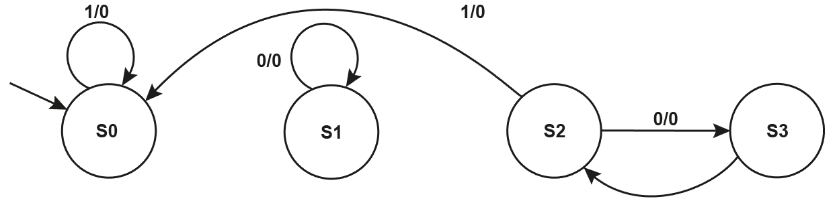

1. Check the machine with the input string: 0101 0010 0110 0111

|  |  |  |  |  |  |  |  |  |  |  |  |  |  |  |  |  |  |
| --- | --- | --- | --- | --- | --- | --- | --- | --- | --- | --- | --- | --- | --- | --- | --- | --- | --- |
| **Input** | 0 | 1 | 0 | 1 | 0 | 0 | 1 | 0 | 0 | 1 | 1 | 0 | 0 | 1 | 1 | 1 |  |
| **State** | S0 |  |  |  |  |  |  |  |  |  |  |  |  |  |  |  |  |
| **Output** |  |  |  |  |  |  |  |  |  |  |  |  |  |  |  |  |  |

1. How many times did the substring 0100 appear in the input?

**Task 3**

3. (a) Draw the Mealy machine diagram for this state transition table.

|  |  |  |  |
| --- | --- | --- | --- |
| **Input** | **Current state** | **Output** | **Next state** |
| 0 | S0 | 0 | S0 |
| 1 | S0 | 0 | S1 |
| 0 | S1 | 0 | S0 |
| 1 | S1 | 0 | S2 |
| 0 | S2 | 0 | S3 |
| 1 | S2 | 0 | S2 |
| 0 | S3 | 0 | S0 |
| 1 | S3 | 1 | S0 |

(b) Complete the state sequence for 011011011100.

|  |  |  |  |  |  |  |  |  |  |  |  |  |  |
| --- | --- | --- | --- | --- | --- | --- | --- | --- | --- | --- | --- | --- | --- |
| **Input** | 0 | 1 | 1 | 0 | 1 | 1 | 0 | 1 | 1 | 1 | 0 | 0 |  |
| **State** | S0 |  |  |  |  |  |  |  |  |  |  |  |  |
| **Output** |  |  |  |  |  |  |  |  |  |  |  |  |  |

4. (a) Complete the state transition table for this Mealy machine.

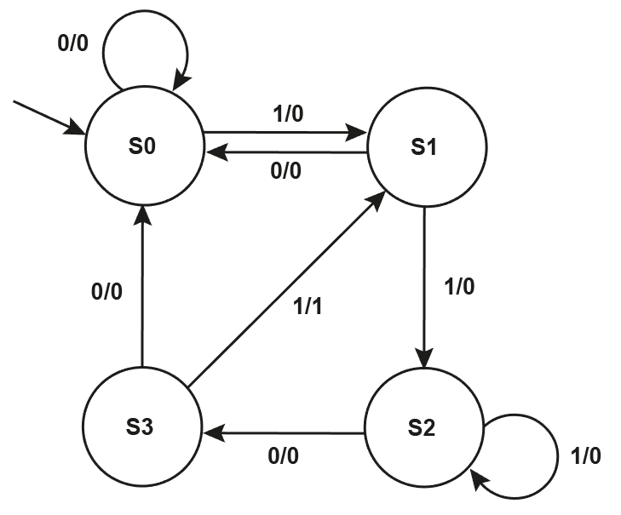

|  |  |  |  |
| --- | --- | --- | --- |
| **Input** | **Current state** | **Output** | **Next state** |
| 0 | S0 |  |  |
| 1 | S0 |  |  |
| 0 | S1 |  |  |
| 1 | S1 |  |  |
| 0 | S2 |  |  |
| 1 | S2 |  |  |
| 0 | S3 |  |  |
| 1 | S3 |  |  |

(b) Complete the state sequence for 011011011100.

|  |  |  |  |  |  |  |  |  |  |  |  |  |  |
| --- | --- | --- | --- | --- | --- | --- | --- | --- | --- | --- | --- | --- | --- |
| **Input** | 0 | 1 | 1 | 0 | 1 | 1 | 0 | 1 | 1 | 1 | 0 | 0 |  |
| **State** | S0 |  |  |  |  |  |  |  |  |  |  |  |  |
| **Output** |  |  |  |  |  |  |  |  |  |  |  |  |  |

1. Explain what substring the two FSMs were intended to recognise and how they differ in doing so.