# Homework 3 Regular Expressions

1. Complete the table to show either the Regular Expression or the definition of the strings that will be accepted by the Regular Expression. The first one is done for you. The alphabet for this question is {0, 1}.

[3]

|  |  |
| --- | --- |
| **Regular Expression** | **Description of valid input strings** |
| 0+1 | Must begin with one or more 0s, followed by a single 1 |
|  | Begins and ends with 1 |
|  | Must have no 1s or only have a single occurrence of 1 |
| 0*(10*10*)* |  |

1. Indicate which strings are accepted and which are rejected by the regular expression [4]

C = {A…Z} L = {a…z}

|  |  |
| --- | --- |
| **Regular Expression** | **Strings** |
| (C|L)ook | Book ook kook oook |
| Co+K | Book nook LooK rooooK |
| a(b)*c | abc ac cab abbc |
| b?|a?c | c baa bc bac abc |

1. Draw the FSM for each of the following Regular Expressions.

(a) ((10)1+0)* [3]

(b) (0|1)*1 [3]

(c) a|a+b [3]

4. Write the regular expressions for each of the following FSMs. [4]

(a)

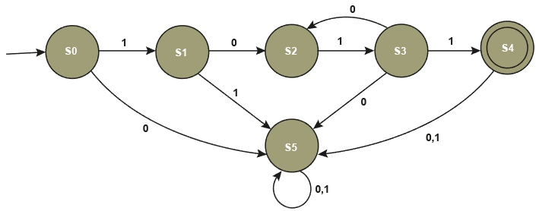

(b)

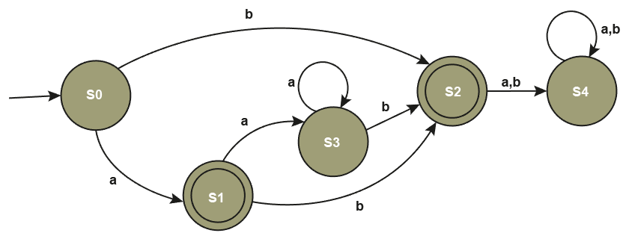

[Total 20 Marks]