Name: Class:

Task 1

Look at the following devices, some of which are robots. For each one, tick whether it has the following features that are needed for robots:

* A mechanical structure or framework
* Electrical components (such as sensors, microprocessors and actuators)
* Programmable

Also, make one tick to identify whether each row is a robot.

|  |  |  |  |  |  |
| --- | --- | --- | --- | --- | --- |
| **Device name** | **Image of device** | **Contains a mechanical structure / framework** | **Contains electrical components (sensors, microprocessors, actuators)** | **Is it programmable?** | **Is it a robot?** |
| Ford Escort (1996) |  |  |  |  |  |
| Self-driving delivery vehicles |  |  |  |  |  |
| Lawn mower |  |  |  |  |  |
| Robotic arm |  |  |  |  |  |
| Lego® toy house |  |  |  |  |  |
| Mindstorms programmable Lego |  |  |  |  |  |
| Bike delivery |  |  |  |  |  |

Task 2

Look at the following robot arm.

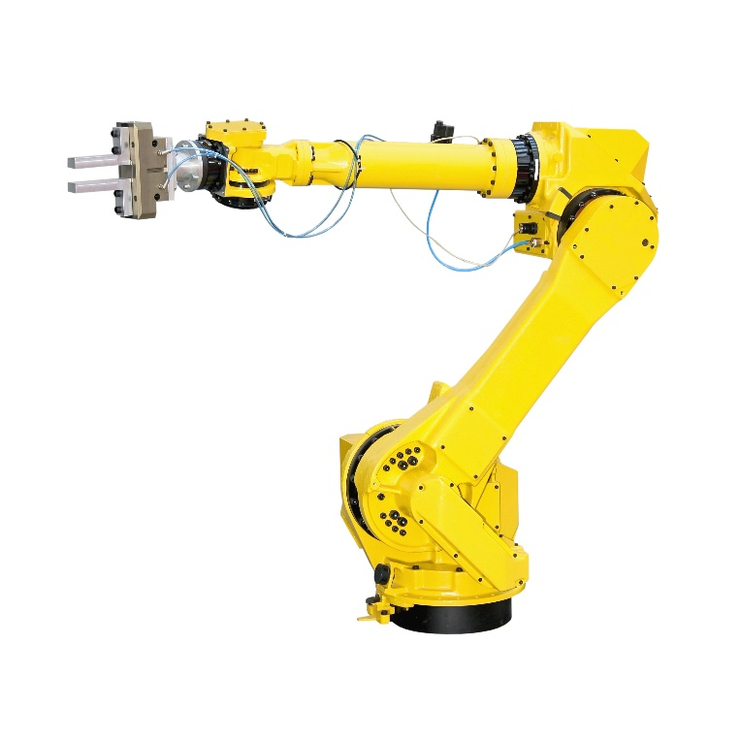

Identify **seven** actuators on the robot arm by circling or drawing arrows to them. Label each arrow between 1 and 7.

Discuss with a partner how the actuators can be moved so that the arm is able to grab an object on the table.

Task 3

Domestic robots include vacuum cleaners, lawn mowers and even robot kitchens.

(a) Research **one** of these robot types and make notes about how they work below.

(b) Feedback what you have learnt to the rest of the class.

Task 4

Robot buses have been in use in Finland since 2016. They work alongside ordinary buses, taking up to 12 passengers short distances without a driver.

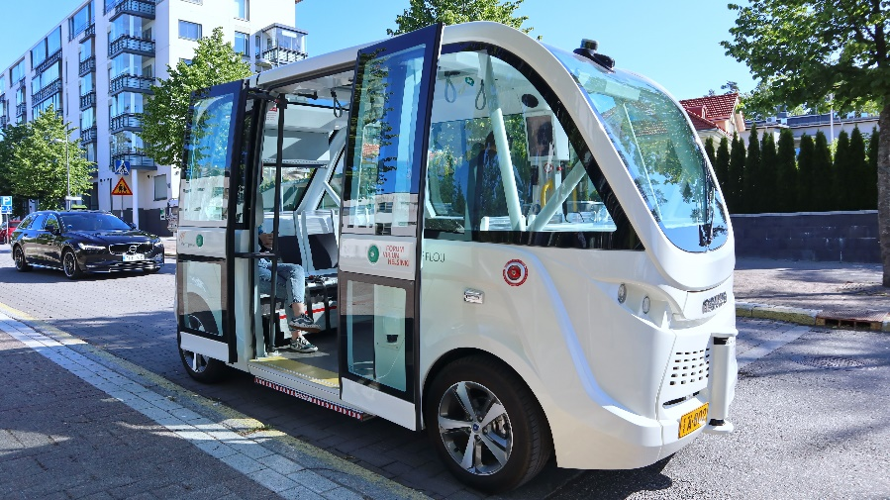

Discuss with a partner or in a small group the advantages and disadvantages of this type of robot.

Record your thoughts in the table below.

|  |  |
| --- | --- |
| **Advantages** | **Disadvantages** |
|  |  |
|  |  |
|  |  |
|  |  |