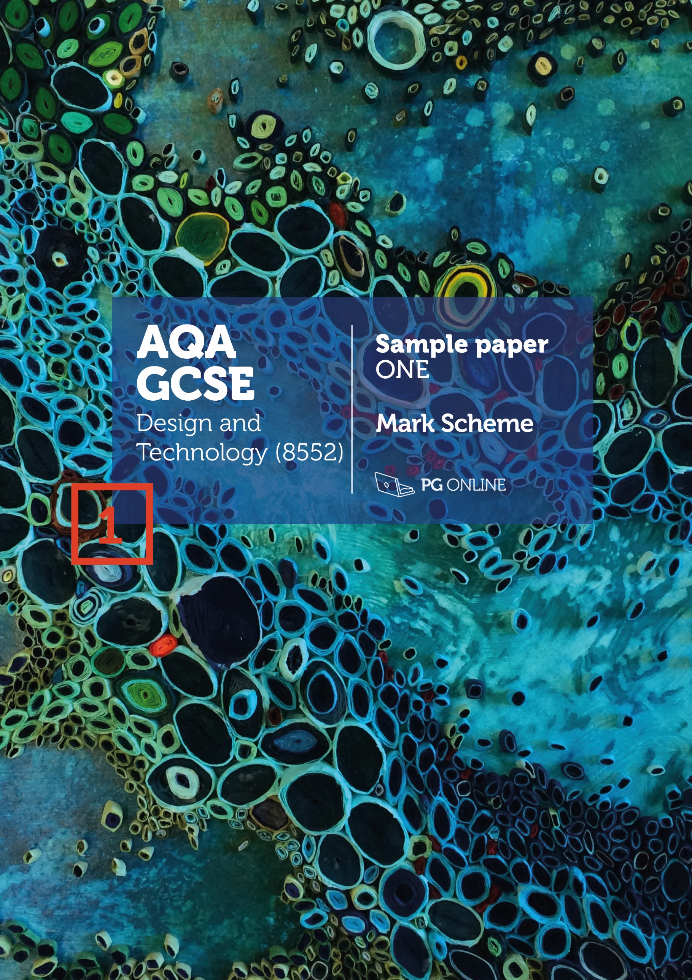

**Copyright**

© 2018 PG Online Limited

The contents of this pack are protected by copyright.

The pack and all the other associated files distributed with it are supplied to you by PG Online Limited under licence and may be used and copied by you only in accordance with the terms of the licence agreement between you and PG Online Limited. Except as expressly permitted by the licence, no part of the materials distributed with this pack may be used, reproduced, stored in a retrieval system, or transmitted, in any form or by any means, electronic or otherwise, without the prior written permission of PG Online Limited.

**License agreement**

This is a legal agreement between you, the teaching institution, and PG Online Limited. PG Online Limited grants to you a non-exclusive, non-transferable, revocable licence to use this supplement and all other associated files distributed with it in the course of teaching by your teachers and/or employees.

The materials distributed with this pack may be copied and used by your teachers and/or employees on a single site only in the course of their teaching. You warrant that you shall not, and shall procure that each of your teachers and/or employees shall not, share in any way any of the materials or part of the materials with any third party, including users on another site or individuals who are teachers and/or employees of a separate institution. You acknowledge and agree that the materials must remain with you, the teaching institution, and no part of the materials may be transferred to another institution. You also warrant that you shall not, and shall procure that each of your teachers and/or employees shall not, procure, authorise, encourage, facilitate or enable any third party to reproduce these materials in whole or in part without the prior permission of PG Online Limited.

In consideration of the licence granted to you, you shall indemnify PG Online Limited against all liabilities, costs, expenses, damages and losses (including but not limited to any direct, indirect or consequential losses, loss of profit, loss of reputation and all interest, penalties and legal costs and all other professional costs and expenses) suffered or incurred by PG Online Limited arising out of or in connection with the exercise by you of your rights granted under this licence.

GCSE Design and Technology

Sample paper 1 mark scheme

This sample paper and mark scheme has been carefully compiled and checked to ensure parity across the six specialist areas. It is the normal process for the mark schemes of live papers to go through a standardisation process where students’ responses are analysed and any answers not covered in the mark scheme are discussed and legislated for. As this is a sample paper only, this process has not been undertaken. Whilst this paper and mark scheme have been technically proofread, there may be additional responses that are worthy of marks. Teachers discretion should be applied in these circumstances.

Instructions for level of response marking

Descriptors are provided for different levels of response along with appropriate marks for each level. Read through a students’ answer, annotating to show the qualities that have been achieved, before applying the level based mark scheme.

Determining a level

Start with the lowest level of response in the mark scheme and assess if the different qualities indicated have been met. If they have, move to the next level and check to see if these have been met. Continue the process until you can match the level with the answer. With repetition it becomes easier and quicker to work up through the levels of the mark scheme.

The principle of ‘best fit’ should be adopted and if small elements of a level are missing but the majority has been covered, then this is the appropriate level to award.

Determining a mark within a level

Having decided on the level, the mark within the level must be determined. Use the descriptors to help with this along with the indicative content. Where there is any doubt, it is advisable to read back through the answers again and reapply it to the indicative content. Students do not need to cover all of the indicative content to reach the top marks. Additionally the indicative content is not designed to be exhaustive and alternative appropriate answers may well be taken into consideration.

Student answers that do not contain any relevent content must be awarded zero marks.

SECTION A - Core Technical Principles

# 1: Flashing lights [1 mark]

# 2: Class 1 lever [1 mark]

# 3: Malleability [1 mark]

# 4: Heat [1 mark]

# 5: Corrugated card is used as protective packaging [1 mark]

# 6: Wool [1 mark]

# 7: Brass [1 mark]

# 8: A light emitting diode is an input component [1 mark]

# 9: Fibres are spun, blended and/or layered to make enhanced fabrics [1 mark]

# 10: Packaging boxes [1 mark]

# 11: Award 1 mark for each property up to 2 marks maximum. [2 marks]

# Accept any other reasonable response.

# Flame proof / heat resistant / thermal stability

# Stab/cut/tear proof / high strength / toughness

12: **Award 1 mark for each reason** **up to 2 marks maximum** [2 marks]

Accept any alternative correct response.

# flat and rigid

# comes in large sheets

# good compressive strength

# cost effective to cover a large area

13.1a: Possible responses are not limited to the following: [1 mark]

# Glass reinforced plastic, accept GRP or fibreglass

# Carbon reinforced plastic, accept CRP or carbon fibre

# Concrete/reinforced concrete

# Duct tape

# Laminated safety glass

# Composite woods such as plywood

# Metal matrix composites (ceramics)

# Mud and straw construction brick

# Wattle and daub

13.1b: **Award 1 mark for each correct material up to 2 marks maximum** [2 marks]

This list is not exhaustive. Accept any alternative correct response.

# GRP – Fibreglass matting / resin (any variety) / gelcoat accept colouring agent

# CRP – Carbon fibre matting / resin (any variety) / colouring agent

# Concrete/reinforced concrete – aggregate/sand/stone (any variety) / cement / steel reinforcements / limestone / clay, accept variations

# Duct tape – woven cloth / adhesive / PET/PVC film or similar, accept plastic

# Laminated safety glass - toughened glass / adhesive / plastic film / wire mesh

# Composite woods such as plywood – wood veneers / resin, accept adhesive

# Metal matrix composites (ceramics) – accept various metals / ceramics or alternative organic compounds

# Mud and straw construction brick – mud / straw

# Wattle and daub – wooden strips / sand / mud / animal dung / clay

# Car tyres – rubber / steel belt / plastics / fillers

# PCBs – as per GRP

# Tetra Pak or similar – polythene / adhesive / aluminium foil / paper, card, board

13.2: **Award 1 mark for each correct reason.** [1 mark]

Accept any alternative correct response.

# They are hard to separate back into their original materials

# As they are hard to separate they can be difficult/impossible to recycle

# Irreversible processes take place such as resins curing which make them difficult to process and recycle

13.3a: £3.25 [1 mark]

13.3b: £162.50 [1 mark]

SECTION B - Specialist Technical Principles

14.1: **Award 1 mark for identifying each simply explained reason and award a second mark where extra clarification is given. No marks are to be available for naming the process.**  [2 marks]

**Indicative responses:** accept alternative correct responses.

|  |  |
| --- | --- |
| Laminating | To create rigidity or other form of strength / to improve functionality / make stable / add properties of different materials |
| Embossing | To create a raised / textured / contrasting surface on a material / give an aesthetic affect / create braille |
| Extrusion | To create a tube or other profile of a given material / create strength through shaped profiles / create long lengths / can be cut to size or continuous feed |
| Laser cutting | To create accurate cut shapes of a given material / repetitive accuracy / minimal waste / fast process |
| Pleating | To create body / weight / drape / strength / warmth / aesthetic qualities in a given material |
| Anodising | To create a hard-wearing surface / a colourful finish / a non-conductive coating / a protective coating / an aesthetic finish to a given material |

14.2: **Award up to 4 marks for explaining the specialist process.** **Notes or sketches alone can get up to a maximum of 3 marks.** [4 marks]

|  |  |
| --- | --- |
| 3-4 marks | A complete explanation of the process is well presented/explained. It is accurate and shows good knowledge and understanding of how a material(s) is processed. Good use of correct technical terminology and appropriate tooling/resources for the process to be performed. |
| 1-2 marks | A simplistic description with some errors and/or poorly explained. It shows basic knowledge and understanding of how a material(s) is processed. A basic attempt at technical terminology and tooling/resources used to perform the process is given. |
| 0 marks | Nothing worthy of credit |

**Indicative content:** The answers in the table give some areas where the students may have explored. Award credit for the use of diagrams and descriptions that are appropriate to the chosen process. The processes are not material specific and could be answered with an appropriate material for the process.

|  |  |
| --- | --- |
| **Process** | **Procedure of the process** |
| Laminating | Layers of material are bonded together  Usually a permanent or semi-permanent form of bonding is used, either an adhesive, a thread or other bonding method  Layers are cut to size and prepared, this may include sizing or providing a key for increased adhesion before adhesive is added for some materials  Pressure, vacuum bags, clamps, pins or similar can be used to keep the layers in position while bonding, curing, sewing or other method takes place  The bonded materials are released from any holding devices  The laminated product or component normally needs some finishing to the edges or other surfaces |
| Embossing | The shape, pattern, texture that is to be embossed needs to be prepared. The two plates are used known as the relief die (female) and the counter die (male)  A sheet of appropriate material is selected and placed between the dies  Pressure and on occasions heat is applied  The material is removed and trimmed if necessary  The fibres of the material for paper, card and some textiles are permanently compressed and retain the shape of the dies |
| Extrusion | The selected material is usually turned into a liquid/paste form through heat and/or pressure  It is forced under pressure (often using hydraulic systems) through a shaped die  The die is usually made from metal and has been specifically shaped to create the profile of the extrusion  As the forced material is passed through the die the extrusion is formed in a long and often continuous form  The extruded material is passed on to a cooling table/water trough where it cools and hardens into its finished shape  Some extruders cut the extruded parts to length as it is extruded, some are wound onto reels |
| Laser cutting | Material is cut to size to the size of the laser cutter or the workpiece  Material is placed on the bed of the laser cutter or in the rotary attachment  The CAD file to be processed is loaded onto the computer  The laser cutter settings of speed/power are adjusted to the thickness/type of material and the desired depth of cut/engrave  The laser is focused to the surface of the material  Ensure extraction is on or is automatic  The laser runs the CAD file  The material is removed from the laser cutter |
| Pleating | Allow for an explanation of any appropriate pleat e.g. knife, box, accordion etc.  The garment/item pattern (if used) is measured/read for the material allowance/overlap and style of the pleats (accept freehand measuring)  Use of pins/chalk/card guide/pleating tool for the measurement/spacing for the pleats  Orientate the material correctly  Fold pleats with the correct orientation, distance and overlap  Press pleats using an iron or heat press  Sew along appropriate edge to secure in place |
| Anodising | Allow for an explanation of any appropriate material  Material is prepared by cleaning  Some materials may be chemically etched for a matt finish or chemically brightened for a smooth finish  Material is placed into an anodising bath/tank  An electrical charge is passed between the material and the electrolyte in the tank  The material/job is positive (anode) and the electrolyte solution is negative (cathode)  The material is then coloured/dyed for aesthetics  The material is then sealed for protection, to stop colour fade, to stop it being porous |

15.1: **Award up to 2 marks for two different features.** [2 x 2 marks]

|  |  |
| --- | --- |
| 2 marks | A complete description applying both knowledge and understanding of why the selected product is suitable for one-off production |
| 1 mark | A simple description with some errors and misunderstanding of why the selected product is suitable for one-off production |
| 0 marks | Nothing worthy of credit |

**Indicative content:**

|  |  |
| --- | --- |
| **Product** | **Features that are suitable for one-off production** |
| Tailored suit | Fabric will probably have been acquired to meet the client’s requirements  Garment design and details are made to specific requirements  Personalised measurements taken for a bespoke fit for a single client  Hand cut, sewn and finished using skilled labour  Likely to involve 2nd fitting stage to ensure correct fit and client’s approval  Likely to be expensive and take a long time to produce |
| Wedding ring | The unique design will have been created with close communication with the client to meet their specific requirements  The ring will be made to measure; the exact size of the client  The stone and setting will be hand cut/shaped/crafted by skilled craftsperson’s  The ring will be hand finished and polished  Likely to be expensive and take a long time to produce |
| Fibreglass sculpture | The unique design will have been created with close communication with the client to meet their specific requirements  The mould (probably wooden) will be made to the exact design of the client/artist  The fibreglass process will be undertaken by skilled craftsperson’s  The fibreglass sculpture will be hand painted/finished/protected and mounted  Likely to be expensive and take a long time to produce |
| Wooden bureau | The intricate and unique design will have been made to be ornate and fit with particular surroundings  Marquetry is a skilled process that is done by hand  Wood joints will have been hand cut  Hand staining, sanding and polishing  Catches, latches, locks and other mechanisms will have been added by hand  Likely to be expensive and take a long time to produce |
| Architectural model | The intricate and unique design will have been copied / taken from architectural drawings / CAD files  Hand processes and one-off CNC programming likely  Use of rapid prototyping for individual or repeated parts  Hand bonding of layers, hand cutting of some components, hand finishing / painting / spraying / assembly of final parts  Likely to be expensive and take a long time to produce |
| Personalised wheelchair | Designed to fit specific needs of the user e.g. personal dimensions and ergonomics using specific anthropometric data from the client/user  Weight distribution will need to be aligned to the user to ensure safety in use  Programming of circuitry and controls will need to be specifically set to the user’s abilities so that ease of operation can be established by the user  Accept alternative responses regarding adjustability / ergonomics not repeating elements mentioned in other points  Likely to be expensive and take a long time to produce |

15.2: **Award up to 4 marks for explaining a specialist process requiring   
hand finishing.**

**Notes or sketches alone can get up to a maximum of 3 marks.** [4 marks]

|  |  |
| --- | --- |
| 4 marks | A complete explanation of the process is well presented/explained. It is accurate and shows all stages in the correct order. Thorough knowledge and understanding of how a material(s) is processed. Excellent use of correct technical terminology and appropriate tooling/resources for the process to be performed. |
| 3 marks | A good explanation of the process. It is presented/explained with a good level of accuracy. Most stages are shown and mostly in the correct order. Good knowledge and understanding of how a material(s) is processed. Good use of technical terminology and appropriate tooling/resources for the process to be performed. |
| 2 marks | A simplistic description with some errors/gaps and/or poorly explained. It shows basic knowledge and understanding of how a material(s) is processed. A basic attempt at technical terminology and tooling/resources used to perform the process is given. |
| 1 mark | A very basic description of a process that may have stages/information missing. Incorrect sequence and terminology used. The process may not be named correctly |
| 0 marks | Nothing worthy of credit |

**Indicative content:** The answers in the table give some areas where the students may have explored. Award credit for the use of diagrams and descriptions that are appropriate to the chosen process. The processes are not material specific and could be answered with an appropriate material for the process.

|  |  |
| --- | --- |
| **Product** | **Processes requiring hand finishing** |
| Tailored suit | Hand sewing/stitching  Interfacing, buttons/buttonholes, fitting of pockets, fitting sleeve into arm hole in jacket body lining |
| Wedding ring | Brazing, hard/silver soldering, planishing, filing, polishing |
| Fibreglass sculpture | Creation of the mould, GRP process, hand colouring/positioning of graphics, bonding the mould together, attaching the fibreglass body to the plinth |
| Wooden bureau | Wood jointing, marquetry, sanding, varnish/wax application, French polishing |
| Architectural model | Marking out of materials, CAD to client’s specific requirements, hand-cutting of materials, hand-assembly, hand-painting/finishing |
| Personalised wheelchair | Components manufactured to user’s specific needs and dimensions, PCB programming to facilitate special needs, sensors calibrated and positioned to client’s ability/method to control the device |

16: **Award up to 2 marks for a correct answer in each of   
two different areas.**  [2 x 2 marks]

|  |  |
| --- | --- |
| 2 marks | A correctly stated property of the material and a complete reasoning of why it is appropriate for the intended use |
| 1 mark | A stated property that may be simplistic or incomplete with some reference as to why it is acceptable for the intended use |
| 0 marks | Nothing worthy of credit |

**Indicative content:** accept alternative suitable property and response.

|  |  |
| --- | --- |
| Acrylic – for a moulded bath | Malleable when heated – so that it can be formed to shape  Tough in thick sheets – so that it can withstand knock/bumps in use / hold the weight of a large body of water and persons bathing  Good heat retention / insulative properties keeping water hot |
| Carton board – for a point of sale display stand | Rigid – so that the POS will be self-supporting  Printable surface – so advertising and other information can be added |
| Cast iron – for a metalwork vice | Tough (in thick sections) – to resist shattering on impact from being used in a workshop with tools and the pressure exerted on the vice jaws  Hard – to resist indentation and wear from tools |
| Ash – for a baseball bat | Flexible – to withstand pressure exerted when being used or when dropped/thrown and resisting shock/vibrations travelling to the player  Tough – to withstand wear and indentation in use / resists chipping and splintering |
| Elastane – for a pair of cycle shorts | Flexible – so that it can stretch over limbs/bodies with ease and gives comfort to the user  Water proof/resistant – so that it repels/wicks water away from the body / dries quickly / washes well |
| Microcontroller – for use in an electronic snooker scoreboard | Compact/small – so that fewer components/ICs are needed to complete the task meaning less space is required  Programmable – so that the system can be updated / the microcontroller can replicate the processes of many discrete components |

17: **Award up to 8 marks for an analysis of the use of recycled materials   
over the use of virgin material** [8 marks]

|  |  |
| --- | --- |
| 7-8 marks | An engaging, coherent and logical analysis featuring a range of points with excellent understanding of issues surrounding the use of recycled materials as opposed to the use of virgin stock. Detailed analysis and evaluation of these points leads to conclusions that designers could consider in relation to the manufacturer, the consumer and the client. |
| 5-6 marks | A logical discussion which includes a good understanding of issues surrounding the use of recycled materials over the use of virgin stock. Good analysis and evaluation of points raised, leads to some conclusions being drawn as to why designers could consider alternative materials and the positive effects for the manufacturer, the consumer and the client. |
| 3-4 marks | The response shows a good understanding of some issues surrounding the use of recycled materials over the use of virgin stock. A few points raised with some analysis/evaluation from a designer’s point of view. Arguments may lack some coherence and conclusions may be weak or unsubstantiated and any benefit to stakeholders may be tentative. |
| 1-2 mark | Some understanding of the key issues is covered with limited awareness of recycled materials being beneficial over virgin stock. One or two points showing limited analysis and/or evaluation although lacking coherency. Little or no conclusion drawn. |
| 0 marks | Nothing worthy of credit |

**Indicative content:**Indicative content listed is provided to illustrate points that students may make about the examples given in the question, which would demonstrate their understanding of why recycled materials might be chosen over virgin material by designers and how this might positively affect stakeholders. Students may refer to some or all of the examples or they may offer alternative responses in their answer. Students are not required to express and/or discuss the examples given. Marks should be awarded for anything worthy of credit.

Reasons designers may choose recycled materials over virgin material:

# It may be cheaper to use / meaning cheaper product costs / more profits for the manufacturer / more competitive edge / cheaper for the consumer

# It uses less energy than virgin stock to produce / reducing product’s carbon footprint / less CO2 produced/released / better for the environment

# It reduces the need for raw materials / reducing impact on finite resources / meaning raw materials will last longer

# It prevents materials being sent to landfill / less impact on space needed for landfill sites / less potential for harm to wildlife, flora and fauna from leaching

# Creates more demand for recycled materials / encourages more recycling / creates an industry around recycling / breeds invention/innovation for collection of and use of recycled products and materials

# It offers ‘green’ credentials to the product / broadening appeal, being ‘eco-friendly’ / reduces carbon footprint for all in the chain / commercial appeal to environmentally conscious consumers

# If waste from the product’s manufacture is used, it reduces the amount of new material needed

SECTION C – Designing and Making Principles

18: **Award up to 4 marks for each of the three sections of the question.**

|  |  |
| --- | --- |
| 3-4 marks | Well described and justified analysis containing full evaluation, drawing conclusions having considered both positive and negative factors. |
| 1-2 mark | Brief points mentioned but not fully explained. Analysis present but limited evaluation / conclusions drawn. May have focused solely on either positive or negative factors. |
| 0 marks | Nothing worthy of credit |

**Indicative content** for the evaluation of the hearing aid in terms of the following points:

18.1: Suitability for the user [4 marks]

# Water resistant which allows for use when outdoors and does not absorb sweat

# Easy to use/locate on/off switch and volume/sensitivity control

# Lightweight so that it is comfortable to wear for long periods of time

# Easy to replace/recharge batteries

# Flexible enough to adapt to different users

# Robust enough to resist knocks, bumps, wear and tear

# Hard plastic may be uncomfortable to wear for prolonged periods of time

# Plastic casing may cause perspiration against the skin

18.2: Aesthetic qualities [4 marks]

# Flesh coloured and transparent to blend in with skin tone and be less noticeable

# The main body has a curved profile which fits well to back of the ear

# Round earpiece to fit comfortably in the inner ear

# Flexible transparent link between earpiece and the main body for comfort and discretion

# Controls are mounted at the rear of the main body so as not to be noticeable to others

# Bulky design / old fashioned design might not appeal to all users

18.3: Ergonomics [4 marks]

# Ear piece is rounded and has a flexible shroud to enable a compression / tight fit into the inner ear to prevent it falling out in use

# Rear mounted controls make it easy to adjust volume and switch on and off

# The hearing aid is lightweight so is comfortable when worn for long periods of time

# Batteries are small and easily replaced/recharged

# Plastic components next to the skin may be uncomfortable and cause sweating in certain conditions

19.1:  **Award up to 4 marks for an explanation of the term tolerance** [4 marks]

|  |  |
| --- | --- |
| 3-4 marks | Student demonstrates a clear knowledge of what tolerance is and a good understanding of why it is important for designers/manufacturers to consider it when checking the quality of products/systems. Relevant points will be used to illustrate the necessity for tolerance in achieving repetitive accuracy, as per the indicative content. |
| 1-2 mark | Student demonstrates knowledge of what tolerance is but understanding of its importance in quality checking is limited and points to illustrate this may not be given. |
| 0 marks | Nothing worthy of credit |

**Indicative content:**Tolerance is the measurement of the amount of error that is allowed for a given task. Tolerance is used in quality checking to ensure products and systems perform correctly to a given set of criteria.

Not limited to, but reference to the following may be included in responses:

# Physical checking of item for size/weight/resistance etc., to ensure it falls between given minimum and maximum levels

# Items are rejected/changed/adjusted if they fall outside acceptable levels. This ensures all items are the same/within tolerance/have repetitive accuracy

# Go/no go gauges may be used to speed up tolerance measuring

# Differing levels of quality checking may be used, check all/random selection/certain amount per batch/run/day etc.

# Changing tolerances can indicate wear/maintenance problems in a manufacturing/tooling system. It can be used as a diagnostic tool for targeted maintenance

19.2:  **Award 1 mark for each valid quality check up to a maximum of 2 marks   
and award 1 mark for each valid explanation up to a maximum   
of 2 marks** [2 x 2 marks]

|  |  |
| --- | --- |
| 2 marks | A correctly described quality check of a specific component/system and a complete explanation of why/how tolerance is used to determine quality |
| 1 mark | A stated quality check that may be simplistic or incomplete with some reference as to why tolerance is used |
| 0 marks | Nothing worthy of credit |

**Indicative content:** this is not an exhaustive list. Credit any alternative valid response.

# Measure the size of a component earpiece/main body/joining tube to ensure it fits

# Measure the weight of the parts of hearing aid to ensure it is correctly manufactured

# Measure the audible output of the earpiece to ensure it works at the appropriate range to be heard by the user

# Measure the drain on the battery to ensure the circuitry is working correctly

# Operate the power switch and volume controls to ensure the unit works correctly

# Test materials to ensure they meet required standard (i.e. BSI)

20.1: **Award 1 mark for the two correct percentages and 1 mark for the   
two correct number of users.** [2 marks]

|  |  |  |
| --- | --- | --- |
| **Most important feature** | **Number of users** | **Percentage of total** |
| Ultra-small size | **120 / 25 = 30** | **100 / 120 x 30 = 25%** |
| Very long battery life | 6 | 5% |
| Cost under £700 each | 6 | **100 / 120 x 6 = 5%** |
| Rechargeable batteries | **120 / 10 = 12** | 10% |
| Almost invisible to sense when worn | 66 | 55% |
| Total | 120 | 100% |

20.2: **Award 1 mark for correctly filling in each of the two missing bars   
to the correct percentage.** [2 marks]

Percentage of users choosing most   
important features

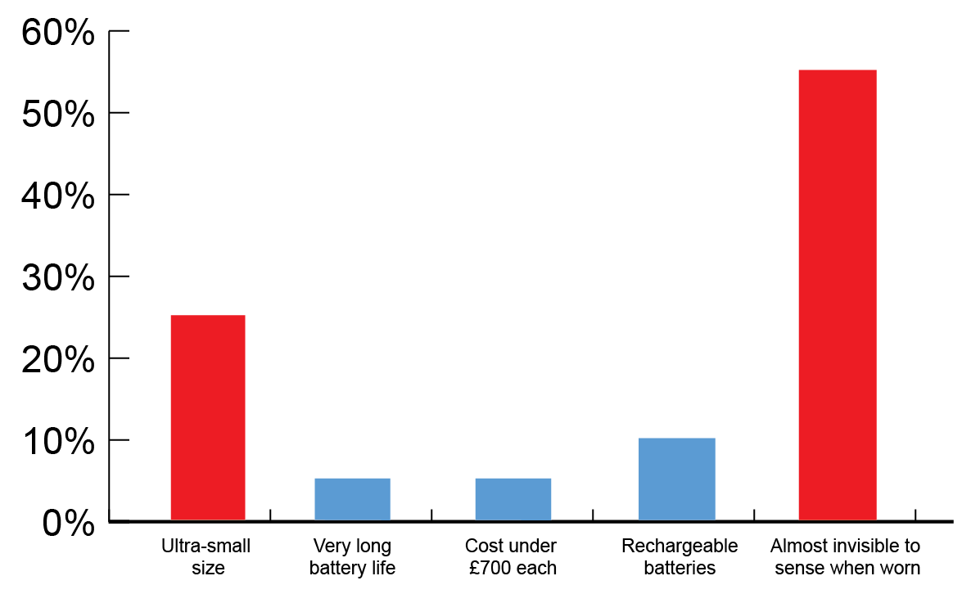

20.3: **Award up to 3 marks as follows.** [3 marks]

|  |  |
| --- | --- |
| 3 marks | Analysis is correct and shows a clear understanding combined with a comprehensive explanation as to how the data would influence the design of a new model. Consideration is given to a range of factors. Not all need to be covered. |
| 2 marks | Observations are correct and show some understanding of how the data could be used. The explanation of how the new design may be influenced is likely to lack detail and will cover only limited points. |
| 1 mark | Limited observations are correct and show only a basic understanding. No, or very limited, explanation of how the data could be used in a new model. |
| 0 marks | Nothing worthy of credit |

**Indicative content:**

# The most popular feature is for the hearing aid to be almost invisible when worn, meaning that it could be made smaller and/or the use of materials blend in with the body more effectively when worn

# The data suggests that the second most important feature is that it should be an ultra-small size, which links neatly with the first point, meaning that miniaturisation of components is very important

# 10% of people want a rechargeable battery, which means that it might need a port for a charging device or to be compatible with a wireless charging station

# Cost doesn’t seem to be too much of a deterrent to purchasing, meaning most people are happy to pay for the right product of a small size

# Only 5% of users wanted a very long battery life, meaning that changing batteries or charging them regularly is not too much of an issue

# Size and discretion are the most important factors to consider in the design of a new model

Award any other valid responses.

21.1: **Award 1 mark for each valid source of information up to a maximum   
of 2 marks and award 1 mark for each valid point of influence up  
to a maximum of 2 marks** [2 x 2 marks]

|  |  |
| --- | --- |
| 2 marks | A correctly described quality check of a specific component/system and a complete explanation of why/how tolerance is used to determine quality |
| 1 mark | A stated quality check that may be simplistic or incomplete with some reference as to why tolerance is used |
| 0 marks | Nothing worthy of credit |

**Indicative content:** Give credit where the influence is appropriate to the source.The table is not an exhaustive list of sources and is in no particular order. The same areas of influence may appear in numerous answers taken from the first two columns.

|  |  |  |
| --- | --- | --- |
| **Sources of date gathering / market research** | | **Influence on a design** |
| Interviews | Product analysis | Answers relating to form, shape, size etc. |
| Questionnaires | Taking measurements | Answers relating to aesthetics |
| Focus groups | Observations of users | Answers relating to function requirements |
| Case studies | Official statistics | Ergonomic data |
| Physical material testing | Company information | Anthropometric data |
| Site study | Exemplar work of others | Answers relating to ease of use and accessibility |
| Reading written articles, books, magazines, Internet | Media such as TV, radio and other news sources | Desire for sustainability and other green credentials |

21.2: **Award up to 3 marks as follows, see indicative content below.** [3 marks]

|  |  |
| --- | --- |
| 3 marks | Response is correct and shows a clear understanding combined with a comprehensive explanation as to why prototypes are given to potential users to review. Consideration is given to a range of factors. Not all need to be covered. |
| 2 marks | Observations are correct and show some understanding as to why prototypes are given to potential users to review. The factors considered are likely to lack detail and will cover only limited points. |
| 1 mark | Limited observations are correct and show only a basic understanding. No, or very limited, explanation of why customer product reviews influence design. |
| 0 marks | Nothing worthy of credit |

**Indicative content:**

# Customers will ignore instructions and use a product as they see fit, giving insight as to the way it will be used in reality

# Designers can see if it is fit for purpose

# Potential to learn which features are not needed/used

# Learn about preferred function and what is missing/needed

# Learn which parts wear too easily

# Learn whether parts are over-engineered and are wasteful/could be made more efficiently

# Learn about preferred aesthetics

# Learn about accessibility for different user groups

# Learn about ergonomic and anthropometric requirements

# Learn about choice of materials used/potential changes

# Learn whether packaging is appropriate

# Learn whether the instructions for use are appropriate