**Homework 2: Formulae and formatting**

1. Suggest two applications (other than the application described in question 2) that could be implemented effectively using a spreadsheet. In each case describe a (different) feature of a speadsheet which would make it suitable for the application.

Application 1: ______________________________________________________

Feature 1: ______________________________________________________

____________________________________________________ [2]

Application 2: ______________________________________________________

Feature 2: ______________________________________________________

____________________________________________________ [2]

2. A spreadsheet showing the marks of four students for three tests is shown below.

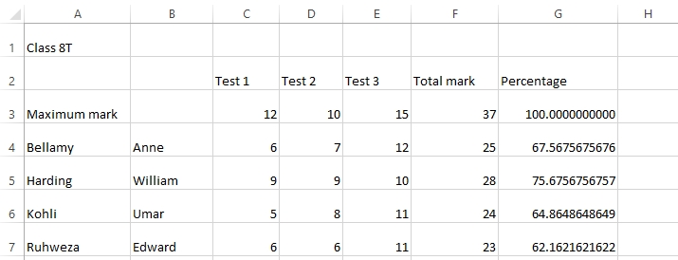

(a) State three ways in which cell formatting could be applied to improve the appearance of the spreadsheet. [3]

(b) What is the formula in cell F3? _____________________________________ [1]

(c) What is the formula in cell G5? _____________________________________ [2]

[Total 10 marks]