# Worksheet 6 Big data

**Task 1**

1. Explain what is meant by these three characteristics of Big Data:

(a) Volume

(b) Velocity

(c) Variety

2. Why can “Big Data” not be held in a traditional database structure?

3. Research examples of Big Data and Smart Cities and make notes about what you can find out about.

Summarise your findings in a one-minute presentation.

**Task 2**

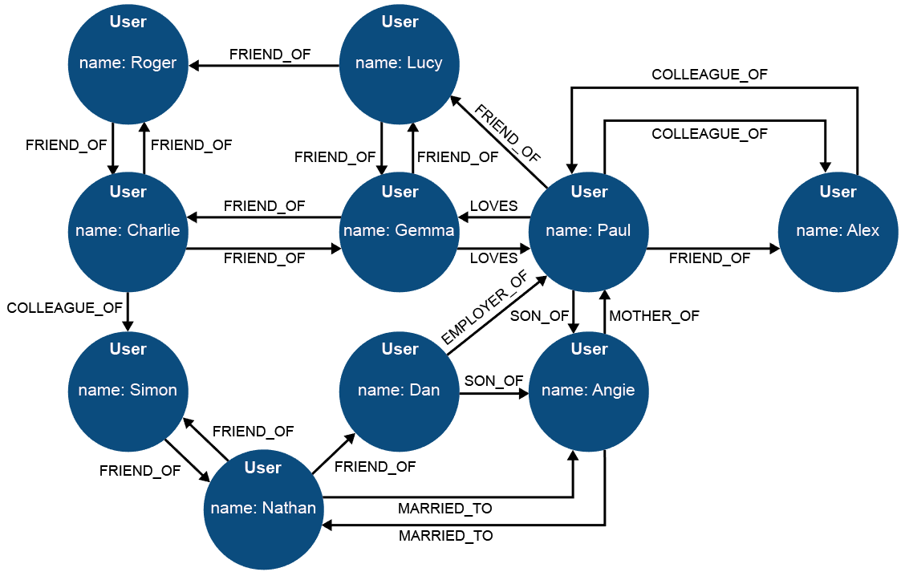

2. How many degrees of separation are there between Roger and Angie?

3. Identify some of the nodes, edges and properties of the above graph.

4. Discussion: can ‘colleague_of’ work in only one direction? Can ‘employer_of’ work in both directions? Are human relationships simple to define – or immutable?

**Task 3**

5. Watch the video about Hadoop distributed programming compared to SQL, at <https://youtu.be/MfF750YVDxM> (6:13)

You are a Big Data consultant. Prepare a one minute presentation to brief a client on which approach they should use, and why, for:

* managing the payroll for a group of UK academy schools.
* researching student attitudes to school uniform policies as expressed through social media.
* managing a traffic light control system in a Smart City, with the aim of both reducing congestion and giving priority to emergency service vehicles responding to incidents.

6 Research the PageRank algorithm at the heart of the Google story. Consider how the scale of web search activity has grown in your lifetime.