Name: Class: Mark:

1. When data is compressed and none of the original information is lost, it is known as which type of compression? Tick the correct answer. [1]

* **A** Binary tree compression
* **B** ASCII compression
* **C** Lossless compression
* Lossy compression

2. Look at the following binary tree.

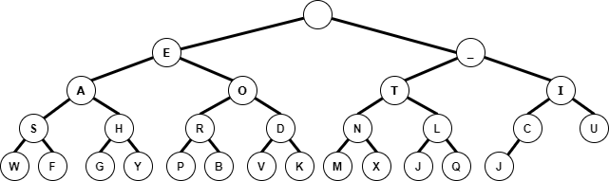

(a) A four-letter word is being stored. The following directions are given for letters in the word.  
LEFT, LEFT, LEFT, RIGHT [1]  
LEFT, RIGHT [1]  
LEFT, RIGHT  
LEFT, RIGHT, RIGHT [1]  
What word is being stored?

(b) ASCII uses 8 bits to store each letter.  
How many bits would be required to store a four-letter word? [2]

(c) How many bits would be required to store the LEFT/RIGHT combinations,   
assuming that 0 is LEFT and 1 is RIGHT? [1]

(d) Write out the directions that are needed to search the binary tree for the word “MAT”.

Letter 1: [1]

Letter 2: [1]

Letter 3: [1]

[Total 10 marks]