Name: Class: Mark:

1. Look at the following photos of police suspects taken a year apart.

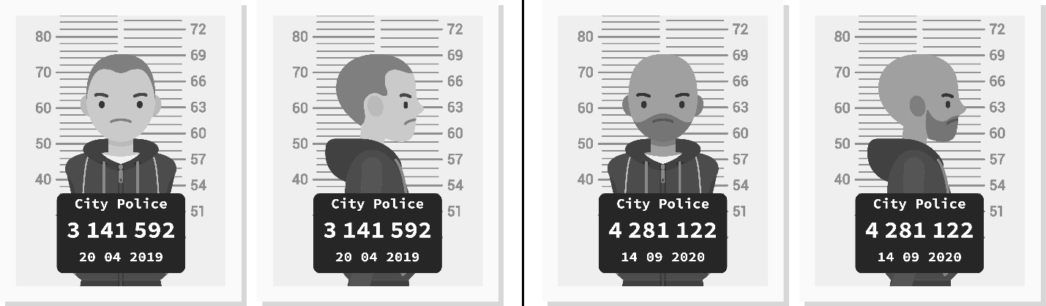

(a) In your opinion, is the person on the top row of photos the same as the person on the bottom row?

(b) Give **three** reasons for your decision. [3]

Reason one:

Reason two:

Reason three

(c) Explain why facial recognition would typically work better with the photo on the left rather than the one on the right. [2]

2. Look at the V shape in Image A below.

|  |  |  |  |  |  |  |
| --- | --- | --- | --- | --- | --- | --- |
|  |  | **5 pixels** |  |  |  |  |
|  |  |  |  |  |  |  |
|  |  |  |  |  |  |  |
|  |  |  |  |  |  |  |
|  |  |  |  |  |  |  |

**Image A**

One rule to detect a V is to measure the distance between two lines. As you go down through the pixels, the number should be the same or lower if it is a V.

In the image above, the first row shows five white pixels between the V shape. The second row shows three white pixels and the third row shows one pixel. Below this, no white pixels are given.

(a) Three images are given below. Complete the table to show how the rule is applied   
and whether the image shows a V. The first shape has been completed for you. [4]

|  |  |  |  |  |  |  |  |  |  |  |  |  |  |  |  |  |  |  |  |  |  |  |  |  |  |  |  |
| --- | --- | --- | --- | --- | --- | --- | --- | --- | --- | --- | --- | --- | --- | --- | --- | --- | --- | --- | --- | --- | --- | --- | --- | --- | --- | --- | --- |
|  |  |  |  | |  |  |  |  | |  | |  |  |  |  |  |  |  | |  | |  |  |  |  |  |  |
|  |  |  |  | |  |  |  |  | |  | |  |  |  |  |  |  |  | |  | |  |  |  |  |  |  |
|  |  |  |  | |  |  |  |  | |  | |  |  |  |  |  |  |  | |  | |  |  |  |  |  |  |
|  |  |  |  | |  |  |  |  | |  | |  |  |  |  |  |  |  | |  | |  |  |  |  |  |  |
|  |  |  |  | |  |  |  |  | |  | |  |  |  |  |  |  |  | |  | |  |  |  |  |  |  |
| **Image A** | | | | | | | | | | | **Image B** | | | | | | | | | | **Image C** | | | | | | |
| White pixels between the black lines for each row | | | | Row 1: 5  Row 2: 3  Row 3: 1  Row 4: 0  Row 5: 0 | | | | |  | | Row 1:  Row 2:  Row 3:  Row 4:  Row 5: | | | | | | | |  | | Row 1:  Row 2:  Row 3:  Row 4:  Row 5: | | | | | | |
| Is it a V according to the rule? | | | | Yes | | | | |  | | Is it a V? | | | | | | | |  | | Is it a V? | | | | | | |

(b) Give one extra rule which would help an AI system to recognise a V shape. [1]

[Total 10 marks]