**Task 2**

**On your computer open, the Python idle**

**and save a new file**

Type the following text:



Press the Enter key and then type the following.

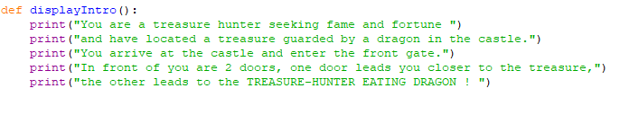

Or copy and paste

print("You are a treasure hunter seeking fame and fortune ")

print("and have located a treasure guarded by a dragon in the castle.")

print("You arrive at the castle and enter the front gate.")

print("In front of you are 2 doors, one door leads you closer to the treasure,")

print("the other leads to the TREASURE-HUNTER EATING DRAGON ! ")

Run the program (F5 or Run > Module)

What happens?

Now type **displayIntro()**

Explain what you have done so far.

Specifically mention:

Use of def keyword to define a function

Calling the displayIntro() function from the Python shell