How to make a digital contact sheet

**What is a contact sheet?**

The contact sheet (also called contract proof) is a positive print of all the negative images from a roll of film. Contact sheets were typically made to allow the photographer to view a mini preview of all the film to determine which photographs are best to print.

**Why make a digital contact sheet?**

A good question. The reason we still use contact sheets is to demonstrate that firstly you have taken a series of pictures exploring the subject and that you are being selective about your work.

**So how do I do it?**

1. **Download all your pictures into a single folder (there should be nothing else in it)**
2. **Change the view menu. (Click the view menu and select “Extra Large Icons”**

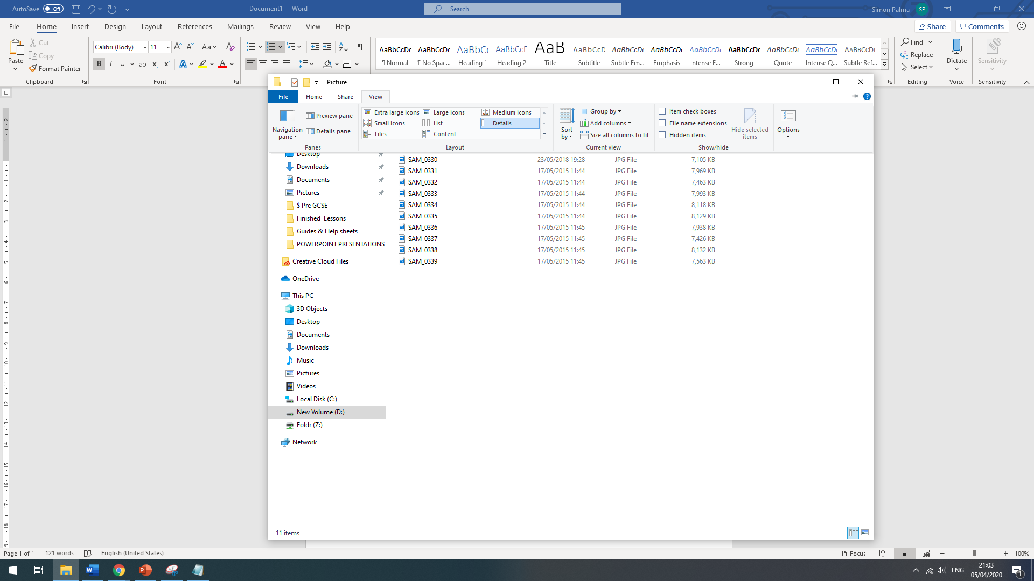

**Your View should now have changed**

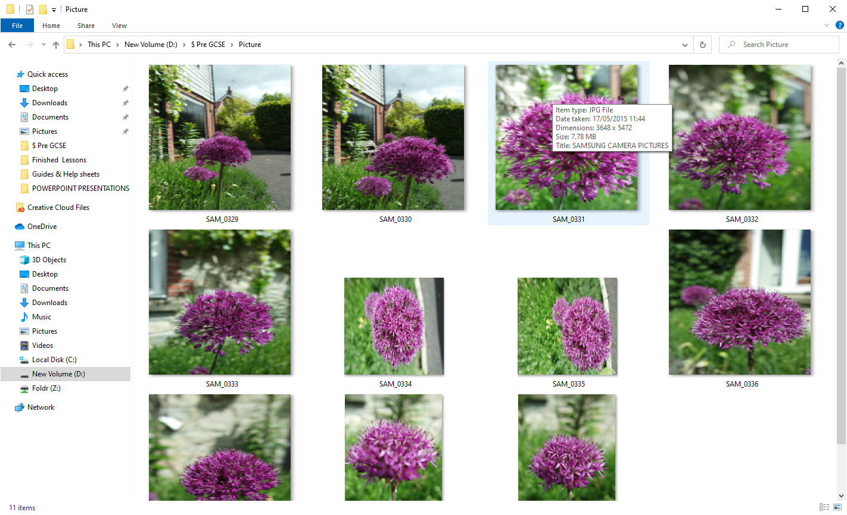

1. **Press the print screen button “PrtScn” (Some where on the top right of your keyboard)**
2. **Nothing will happen (actually it will capture the screen and save a copy to the clipboard)**
3. **Navigate to your power point and right click and “Paste”**

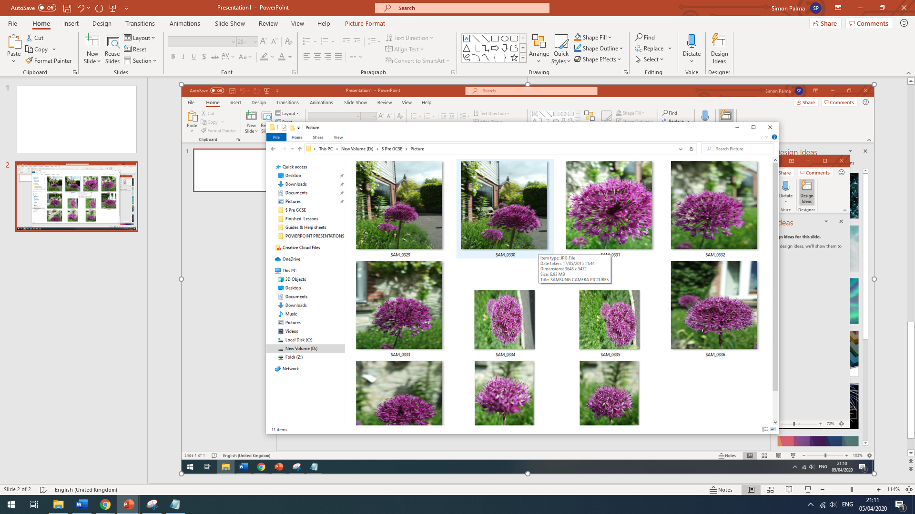

**You should now have a copy of the whole screen.**

**Select the picture “format menu” and then click “Crop”**

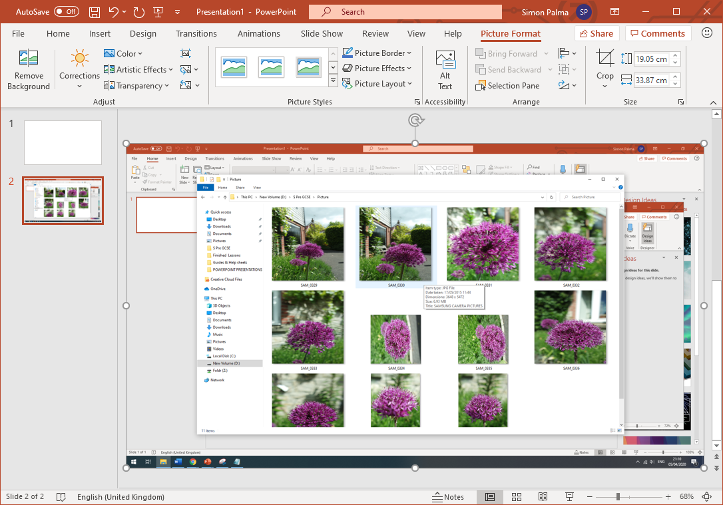

**You can now get rid of the unwanted edges of the screen.**

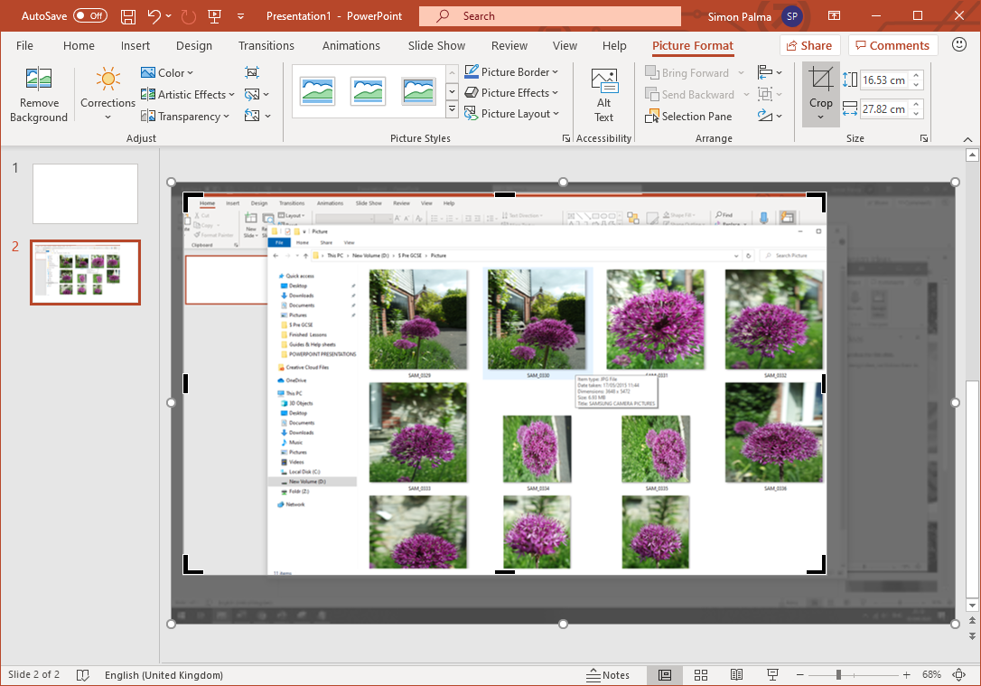

**You should then have this nice clean record of your images ready for you to add notes too.**

