**10 Facts About Cells**

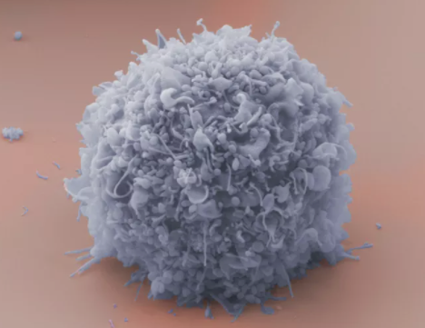

 Human breast cancer cell. Cultura Science / Rolf Ritter / Oxford Scientific / Getty Images

By

[Regina Bailey](https://www.thoughtco.com/regina-bailey-372397)

Updated October 08, 2019

[Cells](https://www.thoughtco.com/what-are-cells-373361) are the fundamental units of life. Whether they be unicellular or multicellular life forms, all living organisms are composed of and depend on cells to function normally. Scientists estimate that our bodies contain anywhere from 75 to 100 trillion cells. In addition, there are hundreds of [different types of cells](https://www.thoughtco.com/types-of-cells-in-the-body-373388) in the body. Cells do everything from providing structure and stability to providing energy and a means of reproduction for an organism. The following 10 facts about cells will provide you with well known and perhaps little known tidbits of information about cells.

**Key Takeaways**

* Cells are the basic units of life and are very small in size, ranging from approximately 1 to 100 micrometers. Advanced microscopes allow scientists to be able to see such small entities.
* There are two major types of cells: eukaryotic and prokaryotic. Eukaryotic cells have a membrane bound nucleus while prokaryotic cells do not have a nucleus that is membrane bound.
* A cell's nucleoid region or nucleus contains the cell's DNA (deoxyribonucleic acid) which contains the cell's encoded genetic information.
* Cells reproduce by different methods. Most prokaryotic cells reproduce by binary fission while eukaryotic cells can reproduce asexually or sexually.

Cells are too Small to be Seen Without Magnification

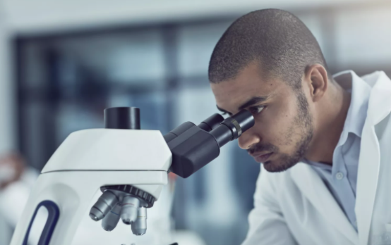

 Biologists are able to obtain detailed observations of cells with microscopes. PeopleImages / E+ / Getty Images

Cells range in size from 1 to 100 micrometers. The study of cells, also called [cell biology](https://www.thoughtco.com/cell-biology-373371), would not have been possible without the invention of the [microscope](https://www.thoughtco.com/microscopes-timeline-1992147). With the advanced microscopes of today, such as the Scanning Electron Microscope and Transmission Electron Microscope, cell biologists are able to obtain detailed images of the smallest of cell structures.

Primary Types of Cells

[Eukaryotic and prokaryotic cells](https://www.thoughtco.com/what-are-cells-373361) are the two main types of cells. Eukaryotic cells are called so because they have a true [nucleus](https://www.thoughtco.com/the-cell-nucleus-373362) that is enclosed within a membrane. [Animals](https://www.thoughtco.com/all-about-animal-cells-373379), [plants](https://www.thoughtco.com/what-is-a-plant-cell-373384), [fungi](https://www.thoughtco.com/interesting-facts-about-fungi-373407), and [protists](https://www.thoughtco.com/protista-kingdom-of-life-4120782) are examples of organisms that contain eukaryotic cells. [Prokaryotic organisms](https://www.thoughtco.com/prokaryotes-meaning-373369) include bacteria and archaeans. The prokaryotic cell nucleus is not enclosed within a membrane.

Prokaryotic Single-Celled Organisms were the Earliest and Most Primitive Forms of Life on Earth

Prokaryotes can live in environments that would be deadly to most other organisms. These [extremophiles](https://www.thoughtco.com/extremophiles-extreme-organisms-373905) are able to live and thrive in various extreme habitats. [Archaeans](https://www.thoughtco.com/archaea-373417) for example, live in areas such as hydrothermal vents, hot springs, swamps, wetlands, and even animal intestines.

There are More Bacterial Cells in the Body than Human Cells

Scientists have estimated that about 95% of all the cells in the body are [bacteria](https://www.thoughtco.com/bacteria-friend-or-foe-372431). The vast majority of these microbes can be found within the [digetive tract](https://www.thoughtco.com/digestive-system-373572). Billions of [bacteria also live on the skin](https://www.thoughtco.com/bacteria-that-live-on-your-skin-373528).

Cells Contain Genetic Material

Cells contain [DNA](https://www.thoughtco.com/dna-373454) (deoxyribonucleic acid) and [RNA](https://www.thoughtco.com/rna-373565) (ribonucleic acid), the genetic information necessary for directing cellular activities. DNA and RNA are molecules known as [nucleic acids](https://www.thoughtco.com/nucleic-acids-373552). In prokaryotic cells, the single bacterial DNA molecule is not separated from the rest of the cell but coiled up in a region of the [cytoplasm](https://www.thoughtco.com/cytoplasm-defined-373301) called the nucleoid region. In eukaryotic cells, DNA molecules are located within the cell's [nucleus](https://www.thoughtco.com/the-cell-nucleus-373362). DNA and [proteins](https://www.thoughtco.com/proteins-373564) are the major components of [chromosomes](https://www.thoughtco.com/chromosome-373462). Human cells contain 23 pairs of chromosomes (for a total of 46). There are 22 pairs of autosomes (non-sex chromosomes) and one pair of [sex chromosomes](https://www.thoughtco.com/how-chromosomes-determine-sex-373288). The X and Y sex chromosomes determine sex.

Organelles Which Carry Out Specific Functions

[Organelles](https://www.thoughtco.com/organelles-meaning-373368) have a wide range of responsibilities within a cell that include everything from providing energy to producing hormones and enzymes. Eukaryotic cells contain several types of organelles, while prokaryotic cells contain a few organelles ([ribosomes](https://www.thoughtco.com/ribosomes-meaning-373363)) and none that are bound by a membrane. There are also differences between the kinds of organelles found within [different eukaryotic cell](https://www.thoughtco.com/animal-cells-vs-plant-cells-373375) types. [Plant cells](https://www.thoughtco.com/what-is-a-plant-cell-373384) for example, contain structures such as a [cell wall](https://www.thoughtco.com/cell-wall-373613) and [chloroplasts](https://www.thoughtco.com/chloroplast-373614) that are not found in [animal cells](https://www.thoughtco.com/all-about-animal-cells-373379). Other examples of organelles include:

* [Nucleus](https://www.thoughtco.com/the-cell-nucleus-373362)- controls cell growth and reproduction.
* [Mitochondria](https://www.thoughtco.com/mitochondria-defined-373367)- provide energy for the cell.
* [Endoplasmic Reticulum](https://www.thoughtco.com/endoplasmic-reticulum-373365)- synthesizes carbohydrates and lipids.
* [Golgi Complex](https://www.thoughtco.com/golgi-apparatus-meaning-373366)- manufactures, stores, and ships certain cellular products.
* [Ribosomes](https://www.thoughtco.com/ribosomes-meaning-373363)- involved in protein synthesis.
* [Lysosomes](https://www.thoughtco.com/lysosomes-cell-organelles-373357) - digest cellular macromolecules.

Reproduce Through Different Methods

Most prokaryotic cells replicate by a process called [binary fission](https://www.thoughtco.com/prokaryotes-meaning-373369). This is a type of cloning process in which two identical cells are derived from a single cell. Eukaryotic organisms are also capable of [reproducing asexually](https://www.thoughtco.com/asexual-reproduction-373441) through [mitosis](https://www.thoughtco.com/stages-of-mitosis-373534). In addition, some eukaryotes are capable of [sexual reproduction](https://www.thoughtco.com/sexual-reproduction-373284). This involves the fusion of [sex cells](https://www.thoughtco.com/sex-cells-meaning-373386) or gametes. [Gametes](https://www.thoughtco.com/gametes-373465) are produced by a process called [meiosis](https://www.thoughtco.com/stages-of-meiosis-373512).

Groups of Similar Cells Form Tissues

Tissues are groups of cells with both a shared structure and function. Cells that make up animal tissues are sometimes woven together with extracellular fibers and are occasionally held together by a sticky substance that coats the cells. Different types of tissues can also be arranged together to form organs. Groups of organs can in turn form [organ systems](https://www.thoughtco.com/organ-systems-373571).

Varying Life Spans

Cells within the human body have different life spans based on the type and function of the cell. They can live anywhere from a few days to a year. Certain cells of the [digestive tract](https://www.thoughtco.com/digestive-system-373572) live for only a few days, while some [immune system](https://www.thoughtco.com/immune-system-372421) cells can live for up to six weeks. [Pancreatic cells](https://www.thoughtco.com/pancreas-meaning-373184) can live for as long as a year.

Cells Commit Suicide

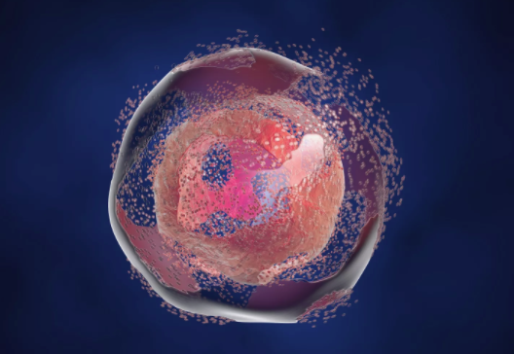

Cell Apoptosis. Dr_Microbe / iStock / Getty Images Plus

When a cell becomes damaged or undergoes some type of infection, it will self destruct by a process called [apoptosis](https://www.thoughtco.com/apoptosis-372446). Apoptosis works to ensure proper development and to keep the body's natural process of mitosis in check. A cell's inability to undergo apoptosis can result in the development of [cancer](https://www.thoughtco.com/normal-cells-versus-cancer-cells-373383).

Sources

* Reece, Jane B., and Neil A. Campbell. *Campbell Biology*. Benjamin Cummings, 2011.

Bailey, Regina. "10 Facts About Cells." ThoughtCo, Aug. 28, 2020, thoughtco.com/facts-about-cells-373372.