Name: Class: Mark:

1. A student designs the triangular shape, shown below, that they wish to cut from acrylic sheet to make a mountain themed wall clock for their climbing club.

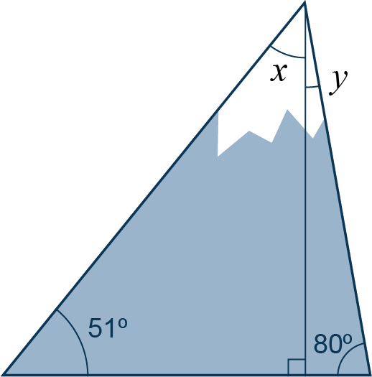

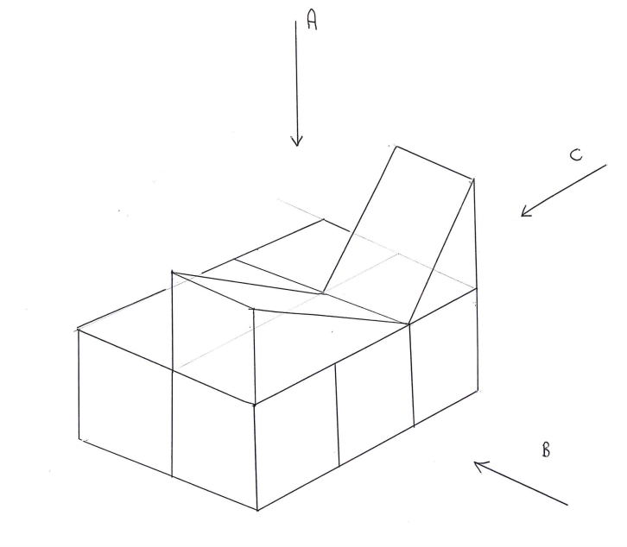(a) Work out the angles *x* and *y* in the diagram. [4]

(b) Given that the base length of the triangular shape is 240 mm and its   
vertical height is 200 mm, work out the area of the shape in i) mm2 and ii) cm2. [3]

2. The 3D shape below has been designed to be made from folded card as a point of sale stand for a school project.

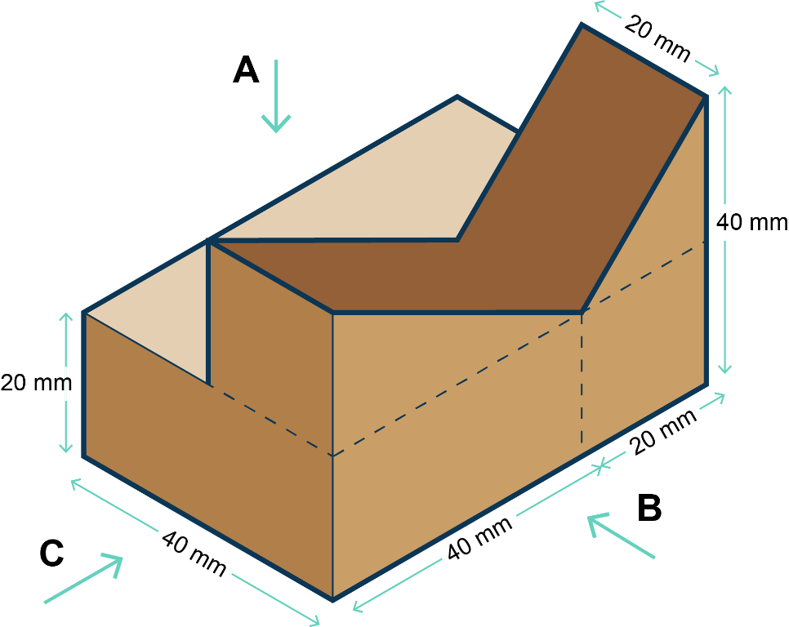

(a) In 3rd angle orthographic projection, draw the three views that would be seen along each of the arrows A, B and C. Used the grip paper below. [4]

****

(b) Work out the volume of point of sale stand. [5]

3. An eco-conscious designer wants to work out how much carbon offsetting they need to purchase in order for their deliveries to be considered carbon neutral.

They have a diesel delivery van that produces 250 g of carbon dioxide for every km travelled when delivering goods. On average the van does 65 km every day for 6 days of every week.

(a) Calculate the mass of carbon dioxide, in kg, produced each week by the van. [4]

(b) The van operates every week except for 1 week between Christmas and New Year. Calculate the annual CO2 emissions for the van.

Write your answer in standard form to 2 decimal places. [2]

[Total 22 marks]