**Microscopes**

___________ microscopes are the ones you get in school. Universities have ___________ microscopes which are ________ powerful. Light microscopes and electron microscopes have allowed biologists to see cell structures with more ________ and ________ than in the past. This has increased our understanding of the role of sub-cellular structures (for example of ____________________).

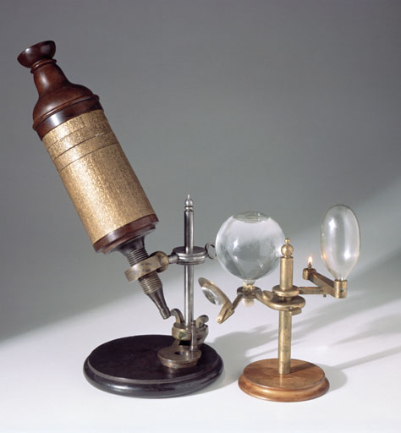 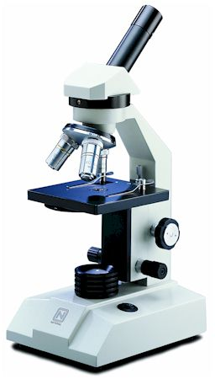 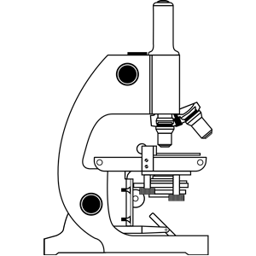

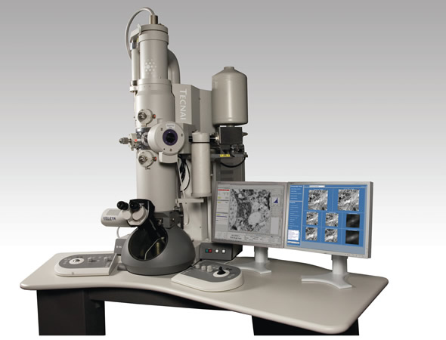

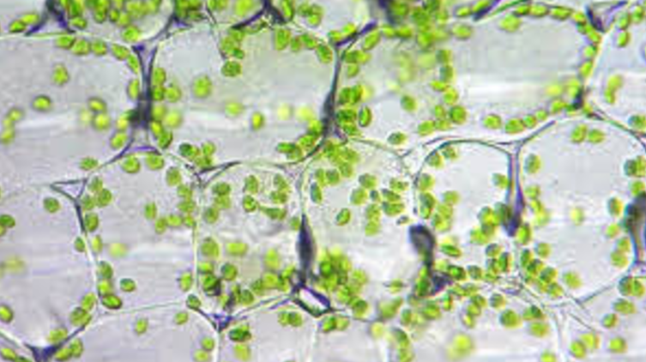

Light microscopy: chloroplasts in lily cells.

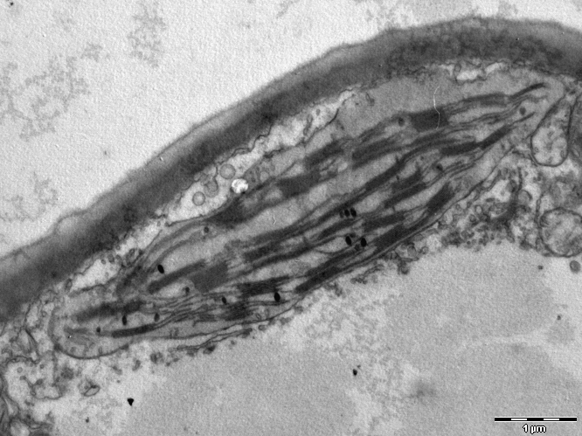

Electron Microscopy: chloroplasts