# Answers

Task 1

A stained-glass window designer is creating a new window design. To assist with the construction of the window, work out the values of angles a to i in the component shapes below.

|  |  |
| --- | --- |
| A screenshot of a cell phone  Description generated with high confidence |  |
| (*a*) = 20° (*b*) = 160° (*c*) = 160° | (*d*) = 60° |
| A close up of text on a white background  Description generated with high confidence | A close up of a logo  Description generated with very high confidence |
| (*e*) = 54° | (*f*) = 52° |
| A close up of a sign  Description generated with very high confidence |  |
| (*g*) = 73.5° (h) = 73.5° | (*i*) = 120° |

Task 2

Work out the surface area of each the laser cut acrylic component below.

|  |  |
| --- | --- |
| A close up of a sign  Description generated with very high confidence | A screenshot of a computer  Description generated with very high confidence |
| (a) Area = 64 cm2 | (b) Area = 135 cm2 |
| A screenshot of a video game  Description generated with high confidence | A close up of a logo  Description generated with very high confidence |
| (c) Area = 49 cm2 | (d) Area = 1,256 cm2 |
|  | |
| (e) Area = **40 cm2** | |

Task 3

Work out the volume of the following shapes.

|  |
| --- |
| A picture containing text  Description generated with high confidence |
| (a) Volume = 264 m3 |
|  |
| (b) A cube of side 6cm Volume = 216 cm3 |
| A picture containing text  Description generated with high confidence |
| (c) Volume = **38,500 mm3** |

Task 4

These cardboard tubes have an internal diameter of 11 cm and an external diameter of 13 cm. They have a length of 15 cm.

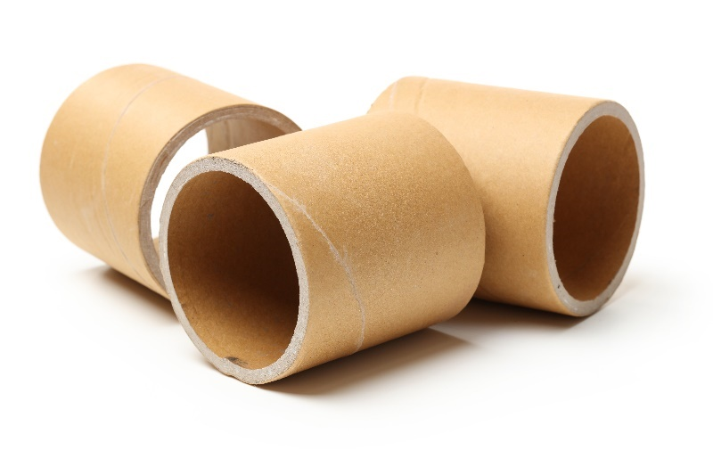

(a) Work out the external volume of one of these tubes.   
1,989.975 cm3

(b) Work out the internal volume of one of these tubes.   
1,424.775 cm3

(c) Use your answer to part a) and part b) to work out the volume of cardboard in   
one of the tubes.   
1,989.975 cm3 – 1424.775 cm3 = **565.2 cm3**