Name: Class:

Task 1

When an architect designs a house, their design doesn’t include everything needed to make a real house.

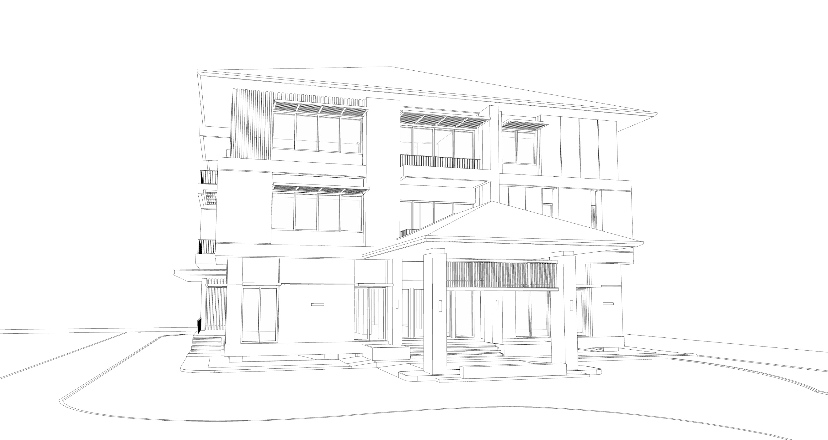

Complete the table below to show items that are either ignored or included in the architect’s computer aided design. The first row has been completed for you.

|  |  |  |  |
| --- | --- | --- | --- |
| **Detail** | **Tick to ignore this** | **Tick to include this** | **Justification** |
| Windows |  | ✓ | The space for windows needs to be given as this affects the design of the house and the walls. |
|  |  |  |  |
|  |  |  |  |
|  |  |  |  |
|  |  |  |  |

Task 2

(a) The table below shows three abstractions of York city. For each abstraction state which features have been included and which have been ignored.

|  |  |  |
| --- | --- | --- |
| **Abstraction** | **Included features** | **Ignored or hidden features** |
| **Standard** |  |  |
| **Cycle Map** |  |  |
| **Transport Map** |  |  |

(b) If you have access to a computer, go to <https://www.openstreetmap.org/>. Turn on layers and investigate the different views in the area you live. Add more features that are lost or included in the abstractions.

Task 3

(a) Look at the maze below. Mark numbers on it for each of the following:

* The entrance
* All points where a decision is made where to turn
* All dead ends
* The exit

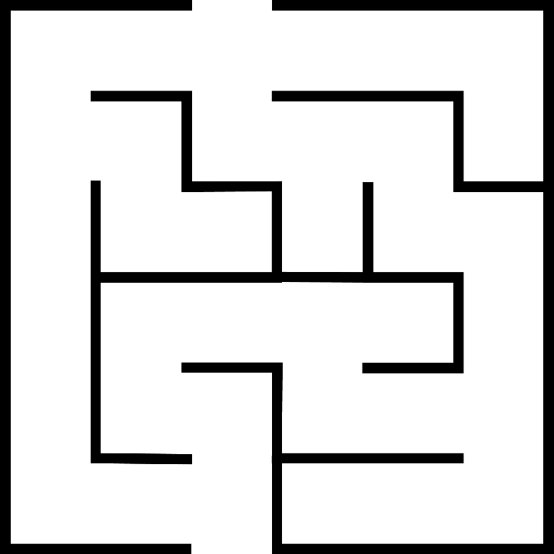

(b) If you have access to a computer, go to:  
<https://csacademy.com/app/graph_editor/>

Enter the connections (edges) for the network (graph) in the Graph Data section on the left. For example, a connection between node 1 and 2 is entered as “1 2”. Paste the network in the box below.

If you don’t have access to a computer, create a network (graph) in the box below by hand like the example in the slideshow.



(c) Use arrows to show the solution through the network from the start to the finish. Check that this solves the original maze.