Answers

Task 1

A student wishes to make a cone from polypropylene to project sound.

The shape is based on a sector of a circle with radius 30 cm.

The angle marked on the diagram is 120°.

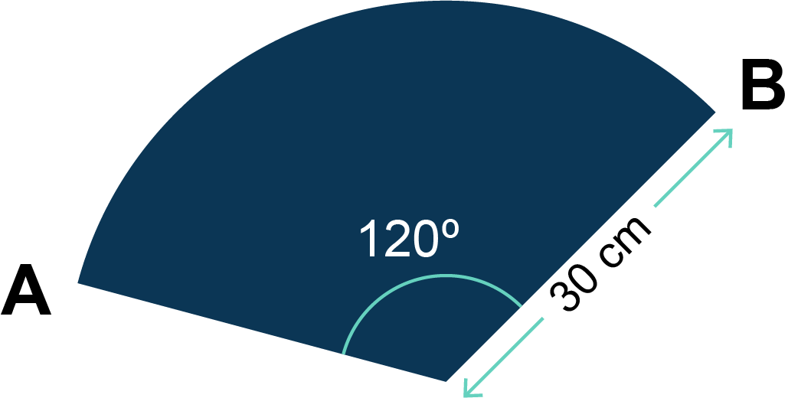

The circumference of a circle is given by *C* = *d* = 2*r*, where *d* is the diameter of the circle, *r* is the radius. Take  as 3.14.

Give all answers to 1 decimal place.

(a) Calculate the area of the polypropylene sector.

Area = × 3.14 × 302 = 9421.99985 cm2

942.0 cm2 (to 1 d.p.)

(b) Calculate the length of the arc of the sector, that is, the length of the curved part.

Length of arc = × 2 × 3.14 × 30 = 62.7937 cm

62.8 cm (to 1 d.p.)

(c) Calculate the total perimeter of the sector, that is, the total length of the outside of the shape.

The total perimeter = (2 × radius) + length of arc

(2 x 30) + 62.8 =

122.8 cm (to 1 d.p.)

Task 2

A student draws two parallel lines on the lid of their project so they can accurately place a self-adhesive vinyl logo.

Work out the sizes of angles *a*, *b* and *c*.

Angle *a* = 180° − 50° = 130°

Angle *b* = 50°

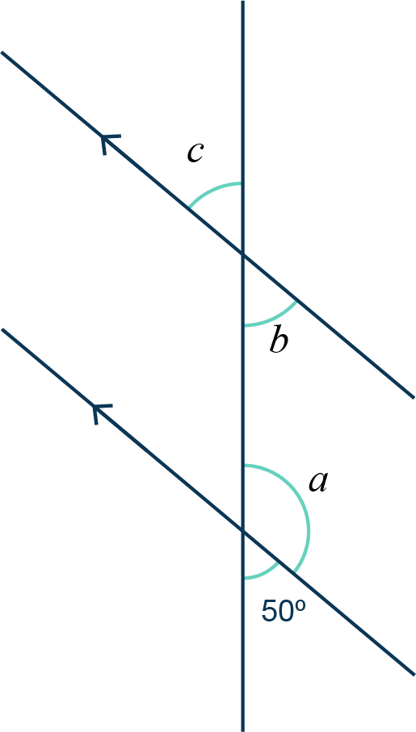Angle *c* = 50°