**Top Chemistry books to read**

[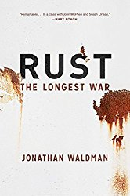](http://www.amazon.com/gp/product/1451691599/ref=as_li_tl?ie=UTF8&camp=1789&creative=390957&creativeASIN=1451691599&linkCode=as2&tag=growitsciblo-20&linkId=FTZ7VZZWKNDVN42M)

**Finalist for the *Los Angeles Times* Book Prize ** A *Wall Street Journal* Best Book of the Year**  
  
It has been called “the great destroyer” and “the evil.” The Pentagon refers to it as “the pervasive menace.” It destroys cars, fells bridges, sinks ships, sparks house fires, and nearly brought down the Statue of Liberty. Rust costs America more than $400 billion per year—more than all other natural disasters combined.  
  
In a thrilling drama of man versus nature, journalist Jonathan Waldman travels from Key West, Florida, to Prudhoe Bay, Alaska, to meet the colourful and often reclusive people who are fighting our mightiest and unlikeliest enemy. He sneaks into an abandoned steelworks with a brave artist, and then he nearly gets kicked out of Ball Corporation’s Can School. Across the Arctic, he follows a massive high-tech robot that hunts for rust in the Alaska pipeline. On a Florida film set he meets the Defence Department’s rust ambassador, who reveals that the navy’s number one foe isn’t a foreign country but oxidation itself. At Home Depot’s mother ship in Atlanta, he hunts unsuccessfully for rust products with the store’s rust-products buyer—and then tracks down some snake-oil salesmen whose potions are not for sale at the Rust Store. Along the way, Waldman encounters flying pigs, Trekkies, decapitations, exploding Coke cans, rust boogers, and nerdy superheroes.  
  
The result is a fresh and often funny account of an overlooked engineering endeavour that is as compelling as it is grand, illuminating a hidden phenomenon that shapes the modern world. Rust affects everything from the design of our currency to the composition of our tap water, and it will determine the legacy we leave on this planet. This exploration of corrosion, and the incredible lengths we go to fight it, is narrative nonfiction at its very best — a fascinating and important subject, delivered with energy and wit.

[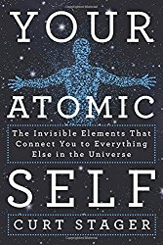](http://www.amazon.com/gp/product/1250018846/ref=as_li_tl?ie=UTF8&camp=1789&creative=390957&creativeASIN=1250018846&linkCode=as2&tag=growitsciblo-20&linkId=PXVFYGHZFLP7LYZN)

Although all matter in the universe is made up of atoms, Dr. Stager has chosen to use the human body as his point of reference, which provides general readers with both a way to relate to the information and a sense of scale.

Rather than an in-depth exploration of human biology, however, it is more like a wandering walk using our basic knowledge of ourselves as a trail marker for exploring the world of elements. The “walk” covers topics from why the sky is blue to how the nitrogen atoms from salmon end up in spruce trees in the Pacific Northwest. The text is roughly organized by sections on the most common elements:  carbon, nitrogen, oxygen, hydrogen, etc.

(Note:  The book does contain references to what happens to bodies after death, which may not be appropriate for some younger teens.)

[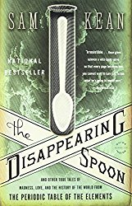](http://www.amazon.com/gp/product/0316051632/ref=as_li_tl?ie=UTF8&camp=1789&creative=390957&creativeASIN=0316051632&linkCode=as2&tag=growitsciblo-20&linkId=VRCSYQ2W26GQ4EFT)

This title is also about elements, but is covers the groups in the periodic table as units. How was an element discovered and who discovered it? Why is it useful and what properties does it have? Interesting tidbits, such as the use of gallium by practical jokers to create “disappearing spoons,” keeps the reader engaged and enthralled.

[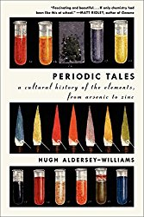](http://www.amazon.com/gp/product/0061824739/ref=as_li_tl?ie=UTF8&camp=1789&creative=390957&creativeASIN=0061824739&linkCode=as2&tag=growitsciblo-20&linkId=T4STFK7P6RLIVU5N)

As suggested by the title, this book is not so much scientific as a cultural history of how we humans have discovered and use the chemical elements.

[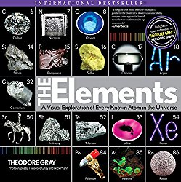](http://www.amazon.com/gp/product/1579128955/ref=as_li_ss_il?ie=UTF8&camp=1789&creative=390957&creativeASIN=1579128955&linkCode=as2&tag=growitsciblo-20)

Really a photographic wonder, this book is a series of two-page spreads for each of the first 100 elements. The author has found concrete examples of every element in its pure form, giving the reader a visual understanding of their properties. It is intriguing, unique and entirely appropriate for children.

To get an idea what the book and cards below are like, Theodore Gray has his periodic table of element photographs at [http://periodictable.com](http://periodictable.com/). To look at each element, click on the photograph.

[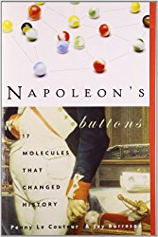](http://www.amazon.com/gp/product/1585423319/ref=as_li_ss_il?ie=UTF8&camp=1789&creative=390957&creativeASIN=1585423319&linkCode=as2&tag=growitsciblo-20)

This title probably contains the most “adult” themes of any in this list, but it also differs from the others because it concentrates on molecules rather than elements. The 17 molecules were chosen for their historical importance.

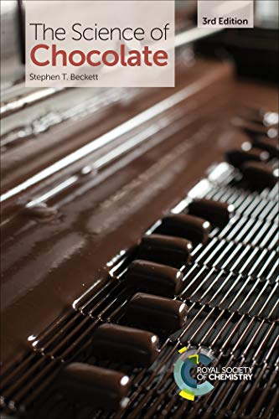

The Science of Chocolate leads the reader to an understanding of the complete chocolate making process and includes the ways in which basic science plays a vital role in its manufacture, testing and consumption. Originally based upon a talk to encourage school children to study science, the book is now widely used within industry and academia.

The third edition of this international best seller has been fully revised and updated. The author has now included methods of sensory evaluation, designing and modifying chocolate flavour to suit the product and the history and manufacture of some well-known confectionery products. Fat, calorie and sugar reduction are also covered including a review of patents in this area. In addition, the section on why chocolate might be good for you has been updated to include some more recent research results. Three new experiments have been added, so there are now twenty of them, which use simple materials and apparatus to demonstrate the scientific and mathematical principles found in the rest of the book. Most are easily adapted to suit different student abilities.

This book will appeal to those with a fascination for chocolate and will be of specialist interest to those studying food sciences and working in the confectionery industry.

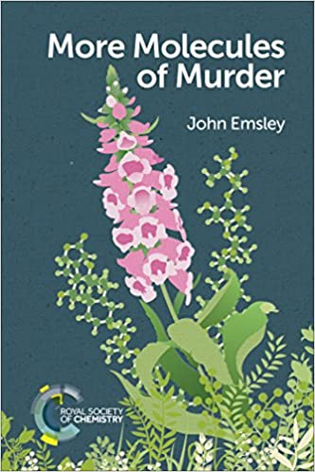

How can a plant as beautiful as the foxglove be so deadly and yet for more than a century be used to treat heart disease? The same is true of other naturally occurring molecules as will be revealed in this current book by award-winning author and chemist, John Emsley.

*More Molecules of Murder* follows on from his highly-acclaimed earlier book *Molecules of Murder,*and again it deals with 14 potential poisons; seven of which are man-made and seven of which are natural. It investigates the crimes committed with them, not from the point of view of the murderers, their victims, or the detectives, but from the poison used. In so doing it throws new light on how these crimes were carried out and ultimately how the perpetrators were uncovered and brought to justice.

Each chapter starts by looking at the target molecule itself, its discovery, its chemistry, its often-surprising use in medicine, its effects on the human body, and its toxicology. The rest of the chapter is devoted to murders and attempted murders in which it has been used. But, be reassured that murder by poison is not the threat it once was, thanks to laws which restrict access to such materials and to the skills of analytical chemists in detecting their presence in incredibly tiny amounts.

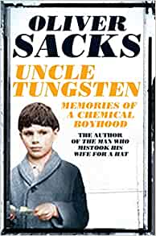

Long before Oliver Sacks became a distinguished neurologist and best-selling writer, he was a small English boy fascinated by metals - also by chemical reactions (the louder and smellier the better), photography, squids and cuttlefish, H.G. Wells, and the periodic table.

In this endlessly charming and eloquent memoir, the author of *The Man Who Mistook His Wife for a Hat* and *Awakenings* chronicles his love affair with science and the magnificently odd and sometimes harrowing childhood in which that love affair unfolded.

In *Uncle Tungsten* we meet Sacks' extraordinary family, from his surgeon mother (who introduces the 14-year-old Oliver to the art of human dissection) and his father, a family doctor who imbues in his son an early enthusiasm for house calls, to his "Uncle Tungsten", whose factory produces tungsten-filament lightbulbs. We follow the young Oliver as he is exiled at the age of six to a grim, sadistic boarding school to escape the London Blitz, and later watch as he sets about passionately reliving the exploits of his "chemical heroes" in his own home laboratory.

*Uncle Tungsten* is a crystalline view of a brilliant young mind springing to life, a story of growing up which is by turns elegiac, comic, and wistful, full of the electrifying joy of discovery.

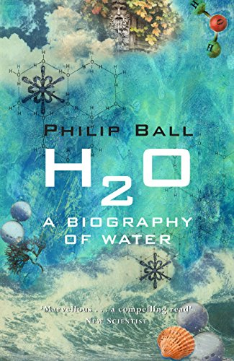

**The brilliantly told and gripping story of the most familiar - yet, amazingly, still poorly understood - substance in the universe: Water.**

The extent to which water remains a scientific mystery is extraordinary, despite its prevalence and central importance on Earth. Whether one considers its role in biology, its place in the physical world (where it refuses to obey the usual rules of liquids) or its deceptively simple structure, there is still no complete answer to the question: what is water? Philip Ball's book explains what, exactly, we do and do not know about the strange character of this most essential and ubiquitous of substances.

H20 begins by transporting its readers back to the Big Bang and the formation of galaxies to witness the birth of water's constituent elements: hydrogen and oxygen. It then explains how the primeval oceans were formed four billion years ago; where water is to be found on other planets; why ice floats when most solids sink; why, despite being highly corrosive, water is good for us; why there are at least fifteen kinds of ice and perhaps two kinds of liquid water; how scientists have consistently misunderstood water for centuries; and why wars have been waged over it.

Philip Ball's gloriously offbeat and intelligent book conducts us on a journey through the history of science, folklore, the wilder scientific fringes, cutting-edge physics, biology and ecology, to give a fascinating new perspective on life and the substance that sustains it. After reading this book, drinking a glass of water will never be the same again.

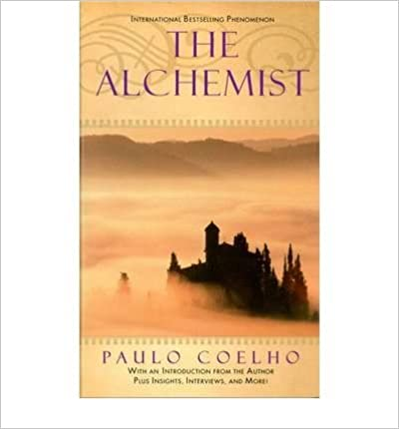

Paulo Coelho's enchanting novel has inspired a devoted following around the world. This story, dazzling in its simplicity and wisdom, is about an Andalusian shepherd boy named Santiago who travels from his homeland in Spain to the Egyptian desert in search of treasure buried in the Pyramids. Along the way he meets a Gypsy woman, a man who calls himself king, and an Alchemist, all of whom point Santiago in the direction of his quest. No one knows what the treasure is, or if Santiago will be able to surmount the obstacles along the way But what starts out as a journey to find worldly goods turns into a meditation on the treasures found within. Lush, evocative, and deeply humane, the story of Santiago is art eternal testament to the transforming power of our dreams and the importance of listening to our hearts.

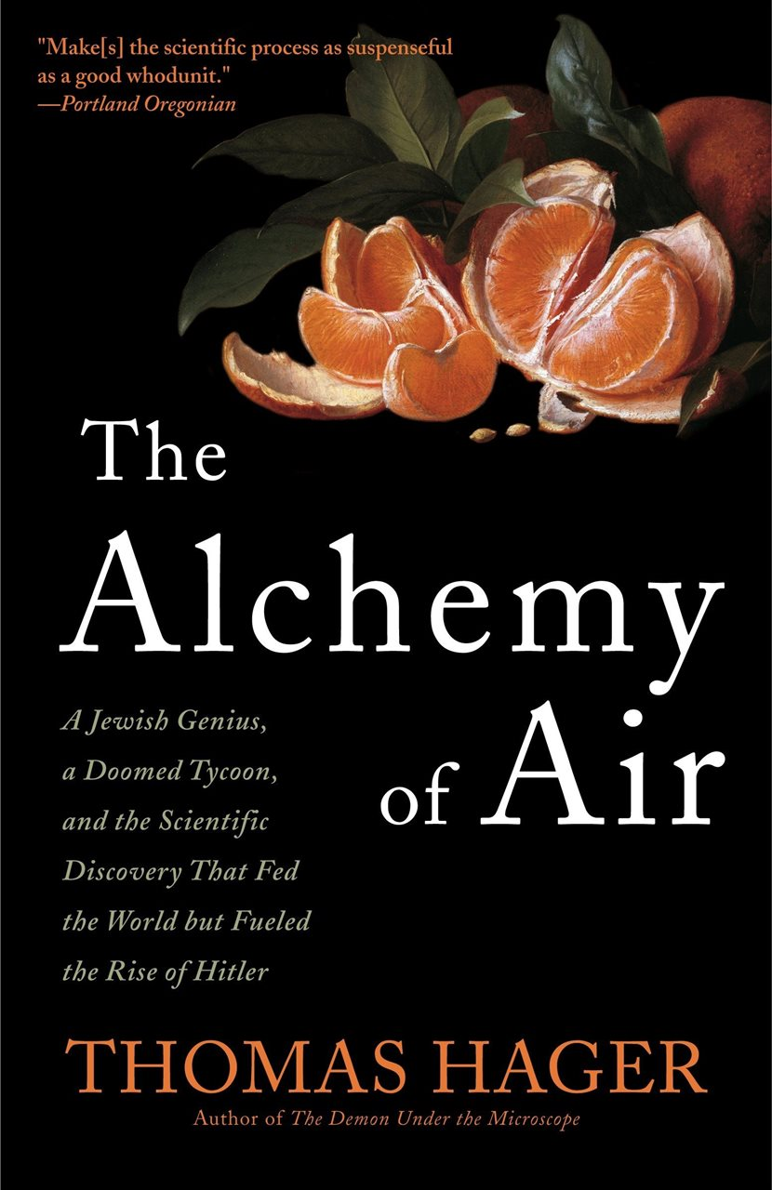

A sweeping history of tragic genius, cutting-edge science, and the discovery that changed billions of lives - including your own.

At the dawn of the 20th century, humanity was facing global disaster. Mass starvation, long predicted for the fast-growing population, was about to become a reality. A call went out to the world's scientists to find a solution. This is the story of the two enormously gifted, fatally flawed men who found it: the brilliant, self-important Fritz Haber and the reclusive, alcoholic Carl Bosch.

Together they discovered a way to make bread out of air, built city-sized factories, controlled world markets, and saved millions of lives. Their invention continues to feed us today; without it, more than two billion people would starve.

But their epochal triumph came at a price we are still paying. The Haber-Bosch process was also used to make the gunpowder and high explosives that killed millions during the two world wars. Both men were vilified during their lives; both, disillusioned and disgraced, died tragically. Today we face the other unintended consequences of their discovery - massive nitrogen pollution and a growing pandemic of obesity.

*The Alchemy of Air* is the extraordinary, previously untold story of two master scientists who saved the world only to lose everything and of the unforeseen results of a discovery that continue to shape our lives in the most fundamental and dramatic of ways.

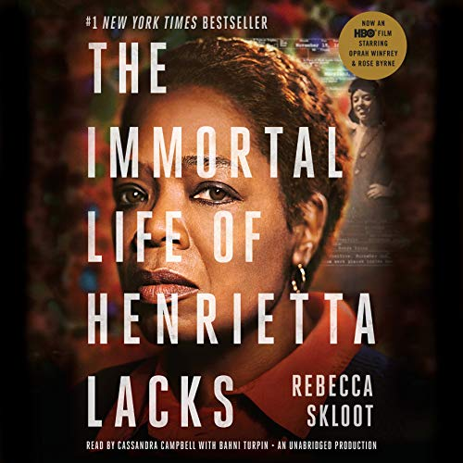

Her name was Henrietta Lacks, but scientists know her as HeLa. She was a poor Southern tobacco farmer who worked the same land as her slave ancestors, yet her cells, taken without her knowledge, became one of the most important tools in medicine. The first immortal human cells grown in culture, they are still alive today, though she has been dead for more than 60 years.

If you could pile all HeLa cells ever grown onto a scale, they'd weigh more than 50 million metric tons - as much as a hundred Empire State Buildings.

HeLa cells were vital for developing the polio vaccine; uncovered secrets of cancer, viruses, and the atom bombs effects; helped lead to important advances like in vitro fertilization, cloning, and gene mapping; and have been bought and sold by the billions. Yet Henrietta Lacks remains virtually unknown, buried in an unmarked grave.

Now, Rebecca Skloot takes us on an extraordinary journey, from the coloured ward of Johns Hopkins Hospital in the 1950s to stark white laboratories with freezers full of HeLa cells; from Henrietta’s small, dying hometown of Clover, Virginia, a land of wooden slave quarters, faith healings, and voodoo, to East Baltimore today, where her children and grandchildren live and struggle with the legacy of her cells.

Henrietta's family did not learn of her immortality until more than 20 years after her death, when scientists investigating HeLa began using her husband and children in research without informed consent. And though the cells had launched a multimillion-dollar industry that sells human biological materials, her family never saw any of the profits. As Rebecca Skloot so brilliantly shows, the story of the Lacks family, past and present, is inextricably connected to the dark history of experimentation on African Americans, the birth of bioethics, and the legal battles over whether we control the stuff we are made of.

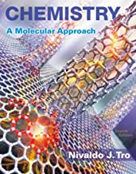

**Actively engage students to become expert problem solvers and critical thinkers**

Nivaldo Tro’s ***Chemistry: A Molecular Approach***presents chemistry visually through multi-level images—macroscopic, molecular, and symbolic representations—to help students see the connections between the world they see around them, the atoms and molecules that compose the world, and the formulas they write down on paper. Interactive, digital versions of select worked examples instruct students how to break down problems using Tro’s unique “Sort, Strategize, Solve, and Check” technique and then complete a step in the example. To build conceptual understanding, Dr. Tro employs an active learning approach through interactive media that requires students to pause during videos to ensure they understand before continuing.

 The **5th Edition** pairs digital, pedagogical innovation with insights from learning design and educational research to create an **active, integrated,**and**easy-to-use**framework. The new edition introduces a fully integrated book and media package that streamlines course set up, actively engages students in becoming expert problem solvers, and makes it possible for professors to teach the general chemistry course easily and effectively.

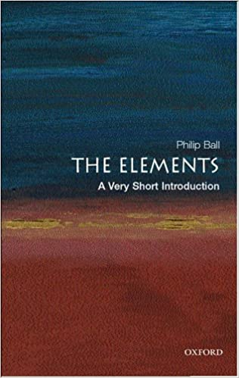

This Very Short Introduction traces the history and cultural impact of the elements on humankind, and examines why people have long sought to identify the substances around them. Looking beyond the Periodic Table, the author examines our relationship with matter, from the uncomplicated vision of the Greek philosophers, who believed there were four elements - earth, air, fire, and water - to the work of modern-day scientists in creating elements such as Hassium and Meitnerium. Packed with anecdotes, The Elements is a highly engaging and entertaining exploration of the fundamental question: what is the world made from?  
  
ABOUT THE SERIES: The Very Short Introductions series from Oxford University Press contains hundreds of titles in almost every subject area. These pocket-sized books are the perfect way to get ahead in a new subject quickly. Our expert authors combine facts, analysis, perspective, new ideas, and enthusiasm to make interesting and challenging topics highly readable.

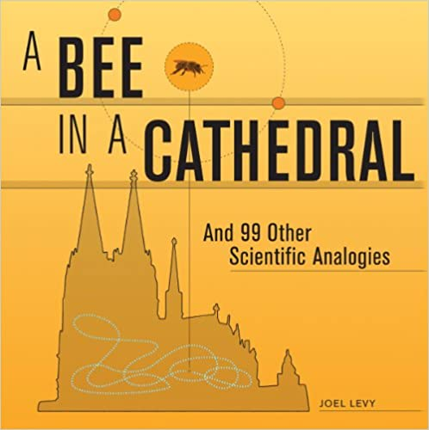

***100 scientific truths and principles clearly explained using the power of analogy.***

The well-known "a bee in a cathedral" analogy describes the size of an atom and its nucleus in understandable terms. The analogy goes that if an atom were expanded to the size of a cathedral, the nucleus would be only about the size of a bee.

***A Bee in a Cathedral*** uses analogies to demonstrate 100 basic scientific truths and principles in new and exciting ways, describing the unbelievably massive, the inconceivably tiny and the unfathomably complex in everyday terms. Readers will be drawn to the book by its combination of intuitive reasoning and a highly visual presentation style.

Each analogy is explained in direct terms and clearly illustrated. A range of facts and figures -- presented in uniquely accessible "infographics" -- complements the analogies. The book covers a wide array of scientific topics: physics, chemistry, astronomy, biology, earth sciences, anatomy and technology. The analogies include:

* If an atomic nucleus expanded to the size of a marble, it would weigh about 100 million tons, or roughly the equivalent of 16 Great Pyramids of Egypt.
* It would take a human heart less than 18 days to fill an Olympic-sized swimming pool.
* The volcanic blast of Mount St. Helens released thermal energy 1,600 times the size of Hiroshima. Krakatoa's 1883 eruption was roughly 13,000 times as powerful as that same bomb.

Informative and engaging, ***A Bee in a Cathedral*** gives readers a deeper appreciation of the forces and facts that govern the universe and everything in it.

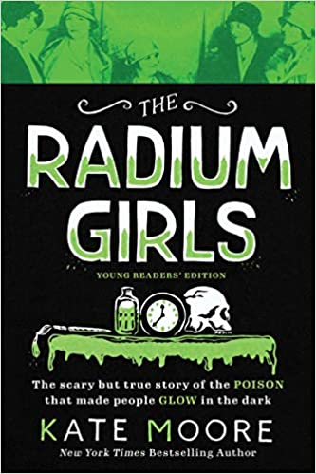

**The acclaimed national bestseller about America's glowing girls and their brave fight for justice, now adapted for young readers**

Amidst the excitement of the early twentieth century, hundreds of young women spend their days hard at work painting watch dials for troops overseas using glow-in-the-dark paint made with radium. They are well paid and consider themselves lucky―until they begin to fall mysteriously ill. As the corporations try to cover up a shocking secret, these determined shining girls suddenly find themselves at the centre of a historic and deadly scandal.

Written with a captivating voice and galloping pace, *The Radium Girls* illuminates the courage and tenacity of these incredible women, whose determination to fight back led to life-changing regulation, advanced nuclear research, and ultimately saved countless lives.

This enthralling and accessible young readers' edition of the *New York Times* and *USA Today* bestseller includes all-new material including a glossary, timeline, dozens of bonus photos, and more.

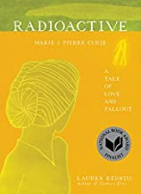

**SOON TO BE A MAJOR MOTION PICTURE directed by Marjane Sartrapi, starring Rosamund Pike and Sam Riley.**

**NATIONAL BOOK AWARD FINALIST**

**“Vivid and ethereal” *–New York Times***

**“Radioactive is quite unlike any book I have ever read—part history, part love story, part art work and all parts sheer imaginative genius.”  
   — Malcolm Gladwell**

*Radioactive* is the mesmerizing, landmark illustrated biography of Marie Curie, by acclaimed author and artist Lauren Redniss. Through brilliant visual storytelling, Redniss walks us through Curie’s life, which was marked by extraordinary scientific discovery and dramatic personal trauma-- from her complex working and romantic relationship with Pierre Curie, to their discovery of two new scientific elements, to Pierre’s tragic death, to Marie’s two Nobel Prizes. *A*haunting and wondrous portrait of one of history's most intriguing figures, *Radioactive*combines archival photos, images, and clippings with dazzling line drawings and a compelling narrative to tell Curie’s story. Far more than an art book or a graphic novel,*Radioactive* is a stunning visual biography and a true work of art.

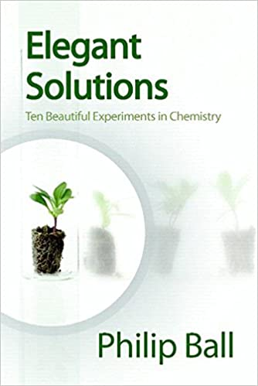

Devising and performing a scientific experiment is an art, and it is common to hear scientists talk about the 'beauty' of an experiment. What does this mean in chemistry, the experimental science par excellence? And what are the most beautiful chemical experiments of all time? This book offers ten suggestions for where beauty might reside in experimental chemistry. In some cases the beauty lies in the clarity of conception; sometimes it is a feature of the instrumental design. But for chemistry, there can also be a unique beauty in the way atoms are put together to make new molecules, substances not known in nature. The ten experiments described here offer a window into the way that chemists think and work, and how what they do affects the rest of science and the wider world. This book aims to stimulate the reader to think anew about some of the relationships and differences between science and art, and to challenge some of the common notions about particular 'famous experiments'. Elegant Solutions: Ten Beautiful Experiments in Chemistry is accessible to all readers, including those without a scientific background and can provide an unusual point of entry into some of the basic concepts of chemistry. Phillip Ball is a renowned, prolific, award winning science writer.

[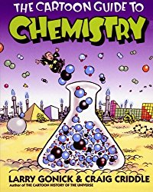](http://www.amazon.com/gp/product/0060936770/ref=as_li_ss_il?ie=UTF8&camp=1789&creative=390957&creativeASIN=0060936770&linkCode=as2&tag=growitsciblo-20)

Cartoon guides like this one are a great way for visual learners to grasp complicated material. Might also draw in older reluctant readers who are intimidated by textbooks.

[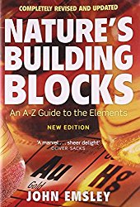](http://www.amazon.com/gp/product/0199605637/ref=as_li_tl?ie=UTF8&camp=1789&creative=390957&creativeASIN=0199605637&linkCode=as2&tag=growitsciblo-20&linkId=IB5V53NPQ6KIZPUQ)

John Emsley takes us on a tour of the periodic table, highlighting the history, uses and biological and chemical roles of each of the elements in the periodic table.

The serious chemistry student may enjoy reading this book from cover to cover, but it also serves as an excellent handy reference to the elements.

John Emsley's *Nature's Building Bocks* was published in paperback in 2003. In this readable, informative, and fascinating guide to the elements are entries on each of the 110+ chemical elements, arranged alphabetically from actinium to zirconium. Each entry comprises an explanation of where the element's name comes from, followed by Body element (the role it plays in living things), Element of history (how and when it was discovered), Economic element (what it is used for), Environmental element (where it occurs, how much), Chemical element (facts, figures, and narrative), and Element of surprise (an amazing, little-known fact).   
  
Fully revised and updated, this browsable compendium holds a wealth of useful information.

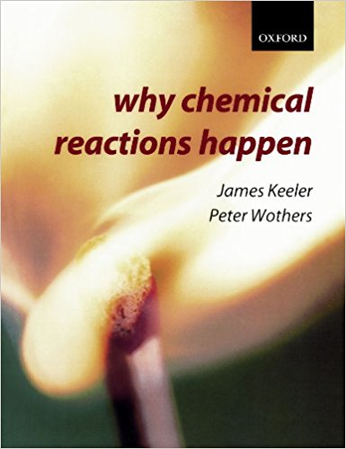

This very good book takes a unified approach to understanding chemical processes, pulling together what we know about bonding in molecules, how molecules interact, and what the outcome will be.

By tackling the most central ideas in chemistry, Why Chemical Reactions Happen provides the reader with all the tools and concepts needed to think like a chemist. The text takes a unified approach to the subject, aiming to help the reader develop a real overview of chemical processes, by avoiding the traditional divisions of physical, inorganic and organic chemistry. To understand how chemical reactions happen we need to know about the bonding in molecules, how molecules interact, what determines whether an interaction is favourable or not, and what the outcome will be. Answering these questions requires an understanding of topics from quantum mechanics, through thermodynamics, to "curly arrows". In this book all of these topics are presented in a coherent and coordinated fashion, showing how each leads to a deeper understanding of chemical reactions.

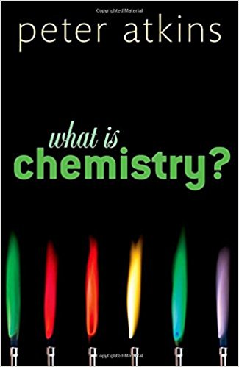

In this book, Peter Atkins discusses the contribution of chemistry to society, some of the major historical achievements of Chemistry, and explores the fundamental concepts of chemistry in a way that is very accessible to chemists and non-chemists alike. He encourages us to look at chemistry through a chemist's eyes, to understand its central concepts and to see how it contributes not only towards our material comfort, but also to human culture. Dr Atkins shows how chemistry provides the infrastructure of our world, through the chemical industry, the fuels of heating, power generation, and transport, as well as the fabrics of our clothing and furnishings.   
  
By considering the remarkable achievements that chemistry has made, and examining its place between both physics and biology, Dr Atkins presents a fascinating, clear, and rigorous exploration of the world of chemistry - its structure, core concepts, and exciting contributions to new cutting-edge technologies.