Name: Class: Mark:

1. Work out the areas of the following table top configurations:

(a) The plan view of two tables. [3]

**A screenshot of a cell phone

Description generated with high confidence**

(b) The plan view of an office desk. [2]

A screenshot of a cell phone

Description generated with very high confidence

2. Work out the area of the following weed suppressant matting plans for a garden designer.   
Let  = 3.14. [2]

(a) Work out the area of matting required for the triangular shaped part of the garden.

A close up of a sign

Description generated with high confidence

(b) Work out the area of matting needed for a composite shaped flower bed. [4]

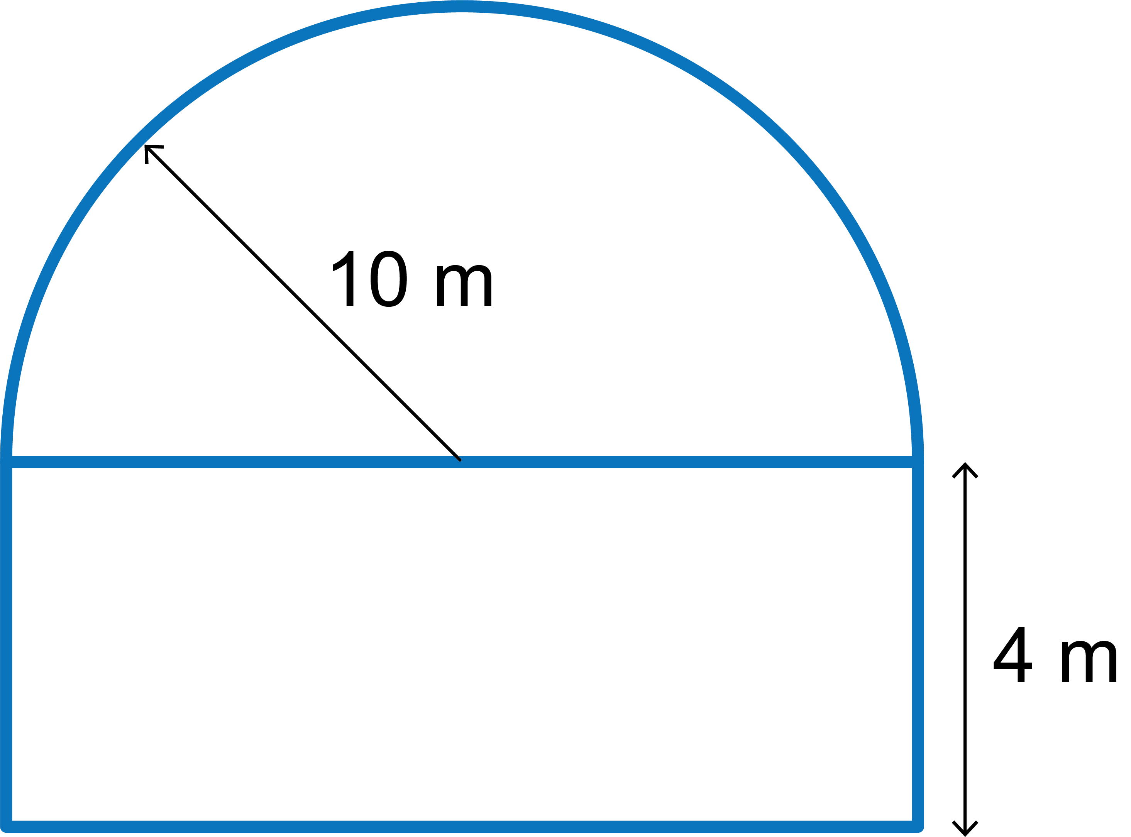

(c) Work out the area of matting needed to go around a large circular garden sculpture. [4]

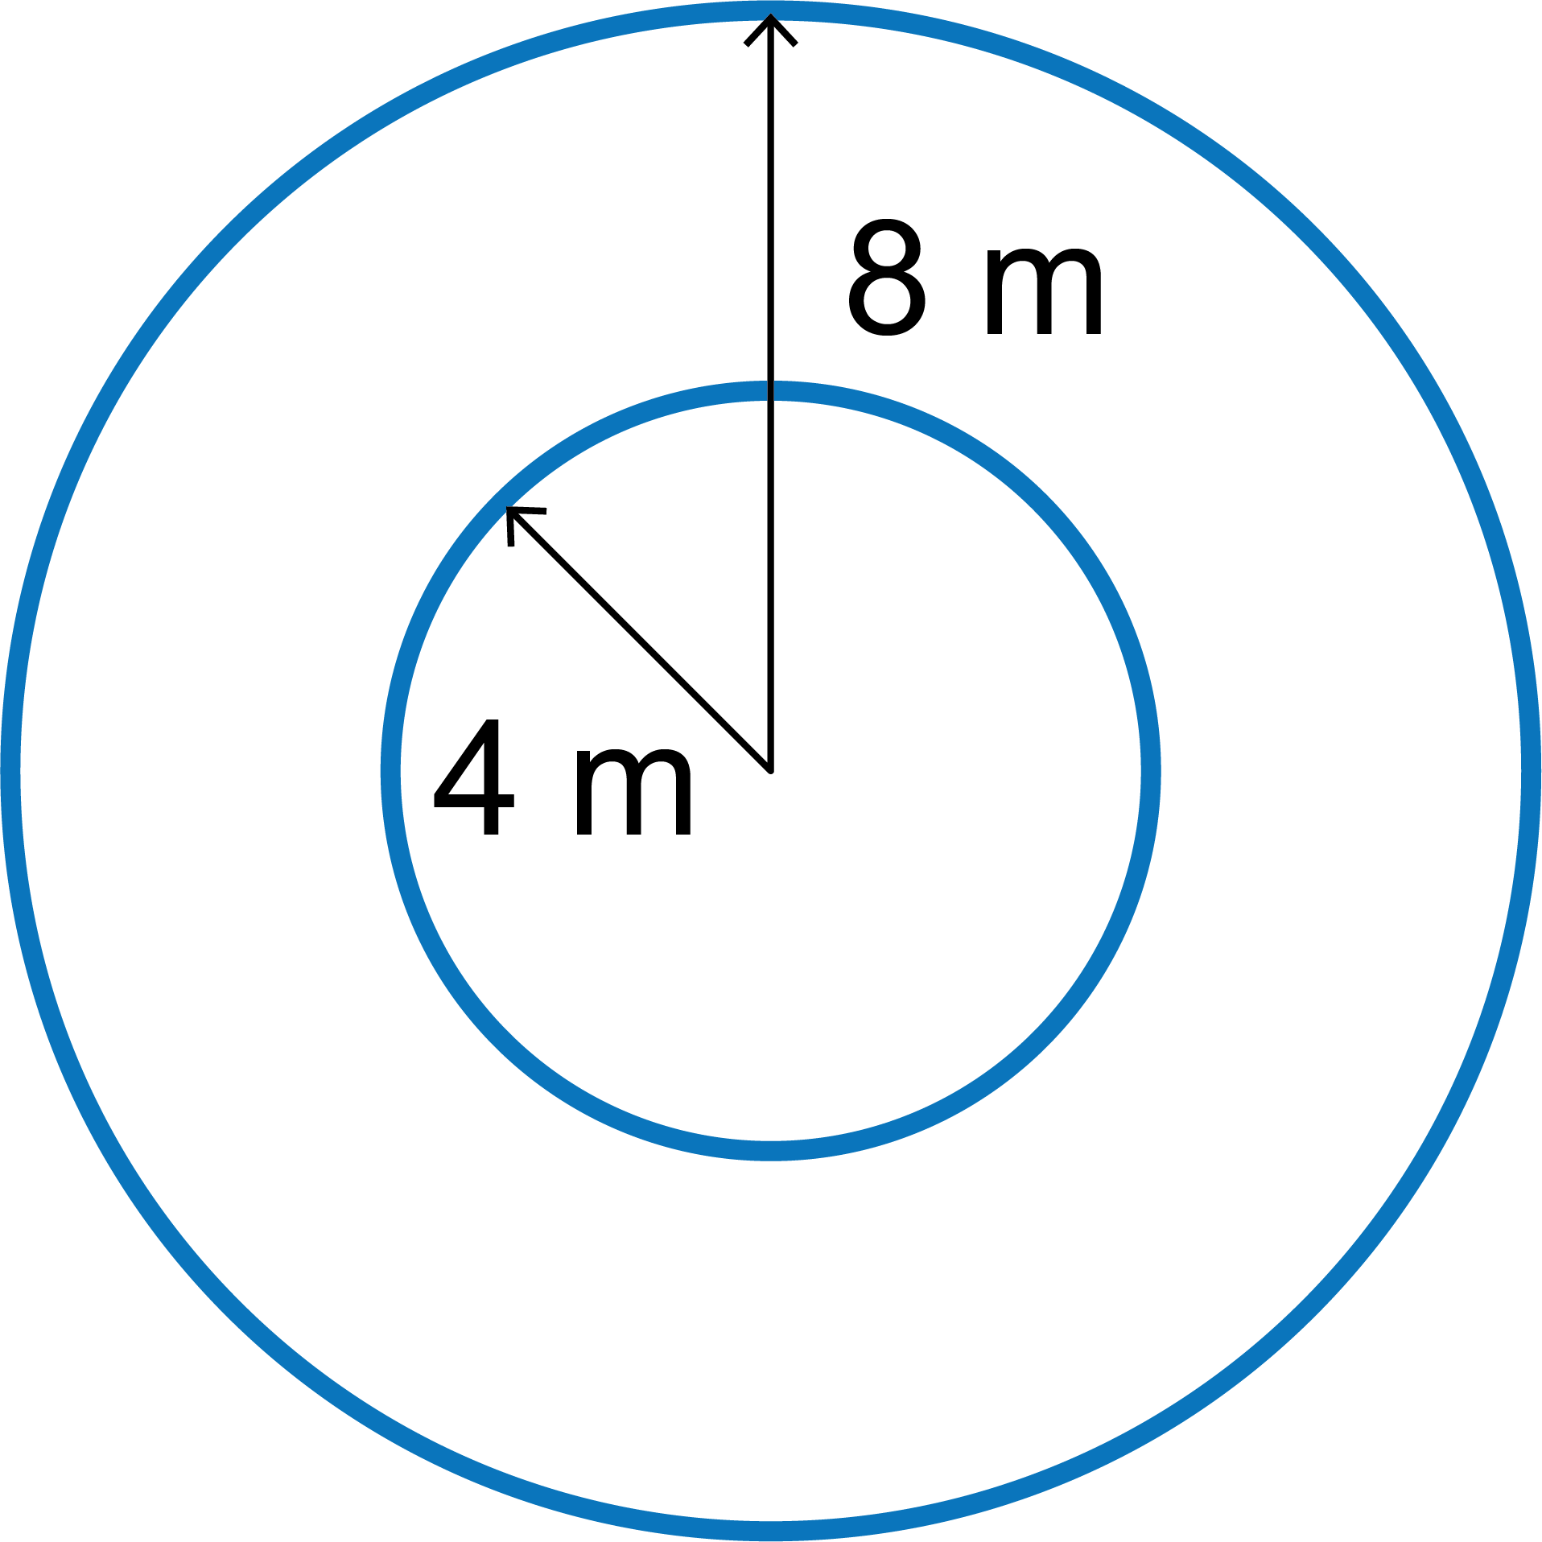

3. Work out the i) surface areas and ii) volumes of the following wooden cubes and cuboids.

|  |  |
| --- | --- |
| (a) Dimensions = 2 cm × 2 cm × 8 cm [2] | A close up of a box  Description generated with high confidence |
| (b) Dimensions = 9 mm × 9 mm × 9 mm [2] | A close up of a box  Description generated with high confidence |
| (c) Dimensions = 1.5 m × 3 m × 0.3 m [2] | A close up of a box  Description generated with high confidence |

4. A student designs the following prism made out of modelling board.

A picture containing text

Description generated with very high confidence

(a) Work out the surface area of the shape. Let  = 3.14. [12]  
Show the steps in your working clearly.

**Note:** The circumference of a circle =  × diameter, or 2 ×  × radius

[Total 33 marks]