Answers

Task 1

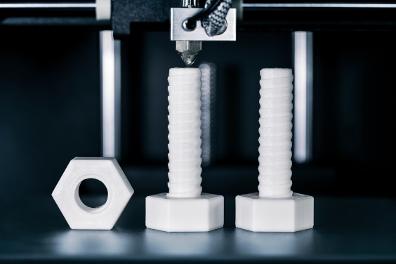1. The picture shows nylon filament being 3D printed in to nuts and bolts.

Nylon has a density of 1.15 g cm3. A cube of 2 cm length is needed for each nut and bolt.

(a) Calculate the volume of the cube, in m3. Give your answer in standard form.

Volume in cm3 = (2.00 × 2.00 × 2.00) = 8.00 cm3

1.00 m3 = (100 cm)3 = 106 cm3

So, 8.00 cm3 = m3= **8.00 x 10-6 m3**

(b) Calculate the mass of the cube in grams.

Density (in g cm3) =

Mass (in g) = density (in g cm3) × volume (in cm3) = 1.15 × 8 = **9.2 g**

(c) Calculate the mass of the cube in kg. Give your answer in standard form.

1,000 g = 1 kg, so 9.2 g = kg = **9.2 × 10-3 kg**

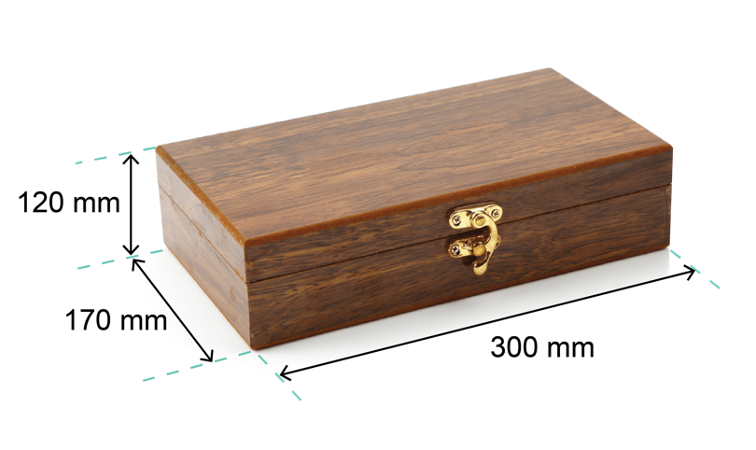Task 2

The picture shows a wooden jewellery box that a student has made.

The actual dimensions of the box are given.

(a) Calculate the surface area of the box.

Surface area = (120 × 170 × 2) + (300 × 120 × 2) + (300 × 170 × 2)   
= 40,800 + 72,000 + 102,000 mm2 = 214,800 mm2

(b) Calculate the volume of the box.

Volume of box = 120 × 170 × 300 = **6,120,000 mm3**

A student produces an accurate drawing of the jewellery box using a scale of 1 : 5.

(c) Calculate the dimensions of the box in the scale drawing.

Dimensions are **24 mm x 34 mm x 60 mm**

(d) Calculate the surface area of the box of the scale drawing.

Surface area = (24 × 34 × 2) + (34 × 60 × 2) + (60 × 24 × 2) =   
1,632 mm2 + 4,080 mm2 + 2,880 mm2 = **8,592 mm2**

(e) Calculate the ratio of the areas of the scale drawing to the actual box.  
Give your answer in the simplest whole number ratio.

Ratio of areas is 8,592 : 214,800 or **1 : 25**

(f) What observations can be made about the answer to part (e) given the scale ratio   
is 1 : 5?

Side lengths are in the ratio of 1 : 5, so areas will be in the ratio of the squares of the lengths, so 12 : 52, or **1 : 25**

(g) Using the answer to part (f), deduce the ratio of the volumes of the scale box to the actual box.

The ratio of the volumes will be according to the cubes of the lengths,   
so 13 : 53, or **1 : 125**

(h) The student discovers that the volume of the original box it too small for its desired use.  
He would like to increase the volume of the actual box by 50%.  
Calculate the new dimensions of the box. Give the new dimensions to 1 d.p.

If the volume is to increase by 50%, then the volume ratio will be 1 : 1.5

So, working backwards, the ratio of the lengths will be : or 1 : 1.144..

Multiplying the original side lengths by a factor of 1.144.. gives:

(120 × 1.144..) by (170 × 1.144..) × (300 × 1.144..)

= **137.4 mm × 194.6 mm × 343.4 mm**

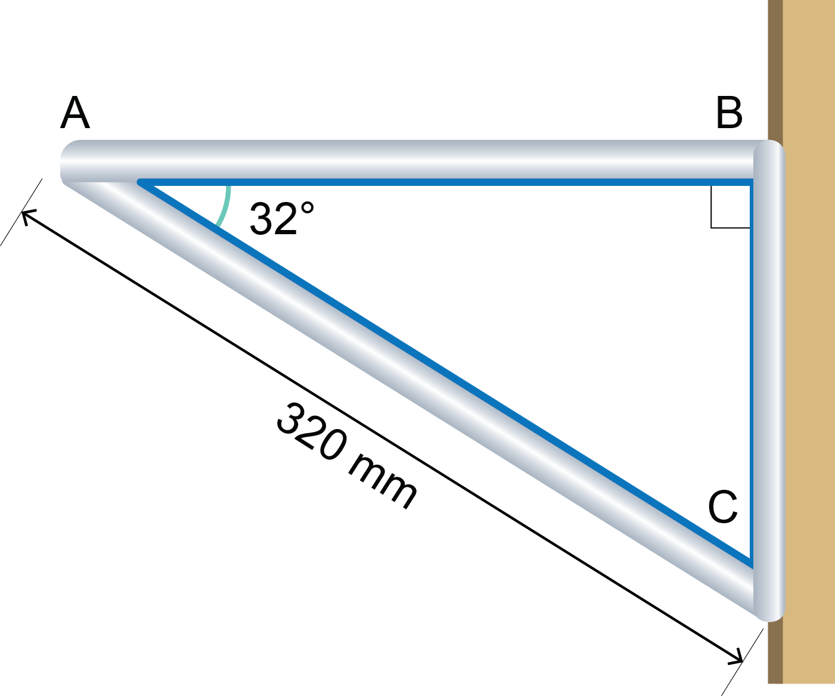Task 3

The picture shows a shelf bracket fixed to a vertical wall.

The bracket is made of solid aluminium tubing of diameter 16 mm.

(a) Calculate, using trigonometry:

C

i) Length AB. Give your answer to 1 d.p.

cos 32° =

AB = 320 × cos 32° =

**271.4 mm**

ii) Length BC. Give your answer to 1 d.p.

sin 32° =

BC = 320 × sin 32° =

**169.6 mm**

(b) Work out the total length of all three sides of the bracket.

Total length of tubing = 169.6 + 271.4 + 320 = **761 mm**

(c) The density of aluminium is 2.70 g cm3.

Work out the mass of aluminium tubing needed to make the bracket if all three sides were made from the same material.

Give your answer to 1 d.p.

The aluminium tubing is diameter 16 mm = 1.6 cm, or 0.8 cm radius.

The length of tubing = 761 mm = 76.1 cm

The volume of aluminium =  × (0.8)2 × 76.1 = 153.00.. cm3

Mass = density x volume

The mass of aluminium = 2.70 × 153.00.. = 413.1 g

Task 4

1. The bar graph gives the mass of plastic pollution produced by different manufacturing   
sectors in 2017.

(a) Use the bar graph to calculate the percentage of plastic waste produced by the following industrial sectors:

Give all answers to 2 d.p.

i) electronics

Percentage = × 100 = **4.42%**

ii) packaging

Percentage = × 100 = **35.87%**

(b) Use the data in the bar graph to construct a pie chart.

Work out the percentage that each makes towards the total.

To calculate the angle for each category in the pie chart, multiply the percentage by 360

For example, the packaging industry will be:

× 360 = 129.1

All angles are calculated, then used to construct a pie chart.

2. Clothing designers and manufacturers need to know relevant anthropometric data when designing specific items of clothing.

This table shows some anthropometric data for a sample of 900 people used by a company making gloves, socks and shoes.

|  |  |  |  |
| --- | --- | --- | --- |
| **Parameter** | **Percentile** | | |
| **5th** | **50th** | **95th** |
| **Age (years)** | 20.2 | 25.2 | 29.6 |
| **Foot breadth (cm)** | 7.6 | 8.6 | 9.4 |
| **Foot length (cm)** | 23.9 | 26.3 | 27.8 |
| **Foot height (cm)** | 5.1 | 5.8 | 6.6 |
| **Hand breadth (cm)** | 8.7 | 9.5 | 10.1 |
| **Hand length (cm)** | 18.4 | 19.4 | 20.2 |
| **Hand thickness (cm)** | 2.9 | 3.3 | 4.1 |

(a) Give the median age of the sample.

**25.2 years**

(b) Calculate the number of people who have a foot breadth greater than 9.4 cm.

5% of people have a foot breadth greater than this value,

5% × 900 people = **45 people**

(c) Calculate the number of people that have an age of less than 29.6 years.

This is the 95th percentile, so 95% of 900 will be **855 people**.

(d) Give the probability of a person having a foot length of greater than 27.8.

This is the 95th percentile, so 5% of people have a foot length greater than 27.8, or **0.05**.

(e) Calculate the probability of choosing two consecutive people having an age greater than 29.6. Assume the first person chosen is then placed back into the sample.

The probability of a person having an age greater than 29.6 = 0.05 or

The probability of two consecutive people having this age = × = or **0.0025**

(f) A designer wishes to create a hand grip for a tool based on the hand breadth data in the table. They want the grip to fit between the 5th and 95th percentile of hand breadth data.

How many people will be able to use the grip comfortably?

90% of the sample will fit the proposed dimensions, so 90% of 900 is **810 people**.