Please write clearly, in block capitals

Centre number Candidate number

Surname

Forenames(s)

Candidate’s signature

GCSE Design and Technology

Date of Exam Time allowed: 1½ hours

Materials

For this paper you must have:

* normal writing and drawing instruments
* a calculator
* a protractor

Instructions

* Use black ink or black ball-point pen. Use pencil only for drawing
* Fill in the information at the top of this page
* Answer all questions
* You must answer the questions in the spaces provided. Do not write on blank pages
* Do all rough work in this paper. Cross through any work that you do not want to   
  be marked

Information

* The marks for questions are shown in brackets
* The maximum mark for this paper is 80
* There are 20 marks for Section A, 26 marks for Section B and 34 marks for Section C

SECTION A - Core Technical Principles

Questions 1-10 are multiple choice questions. For multiple choice questions you should shade in one lozenge. If you make a mistake, cross through the incorrect answer and shade the correct response.

# 1: A designer has created a road safety system for children. It alerts other road users of their presence through a visual stimulus. What is the output in this system? [1 mark]

⬨ Beeping sound

⬨ Flashing lights

⬨ Vibrating alert

⬨ Waterproof audio device

# 2: Figure 1 shows a pair of scissors.

# 

# Figure 1

# Which class of lever is the pair of scissors? [1 mark]

⬨ Class 1 lever

⬨ Class 2 lever

⬨ Class 3 lever

⬨ Class 4 lever

# 3: Which one of the following best describes a materials ability to be shaped or flattened into a thin sheet without cracking, tearing or snapping? [1 mark]

⬨ Brittleness

⬨ Hardness

⬨ Malleability

⬨ Toughness

# 4: Which one of the following is the stimulus needed for thermochromic pigment to change colour? [1 mark]

⬨ Electricity

⬨ Heat

⬨ Pressure

⬨ Ultraviolet light

# 5: Which one of the following statements is true? [1 mark]

⬨ Balsa is from a softwood tree

⬨ Corrugated card is used as protective packaging

⬨ Silk is a synthetic fibre

⬨ Zinc is an alloy

# 6: Which one of the following fibres can be made into an entirely natural textile? [1 mark]

⬨ Elastane

⬨ Polyamide

⬨ Polyester

⬨ Wool

# 7: Which one of the following is an alloy? [1 mark]

⬨ Aluminium

⬨ Brass

⬨ Copper

⬨ Zinc

# 8: Which one of the following statements is false? [1 mark]

⬨ A buzzer is an output component

⬨ A light emitting diode is an input component

⬨ A microcontroller is a process component

⬨ A speaker emits sound

# 9: Which sentence best describes a technical textile? [1 mark]

⬨ A fabric that allows water to pass through it easily

⬨ A very tough and heavyweight fabric

⬨ Fibres are spun, blended and/or layered to make enhanced fabrics

⬨ A very quick drying fabric

# 10: What is duplex board commonly used for? [1 mark]

⬨ Packaging boxes

⬨ High-quality watercolour paintings

⬨ Takeaway container lids

⬨ Tracing a design

11: State **two** properties that make technical fibres such as Kevlar, suitable for   
use in clothing for the emergency services. [2 marks]

Property 1.

Property 2.

12: State **two** reasons why chipboard is commonly used for flooring. [2 marks]

1.

2.

13.1: Composite materials are used when two or more different materials are combined to create a new material with improved properties and functionality.

1. Name **one** composite material. [1 mark]

1. For your chosen composite material, name **two** of the materials that   
   have been combined? [2 marks]

Material 1:

Material 2:

13.2: Many composite materials are not considered to be environmentally friendly at the end of life.

Give **one** reason why this is the case. [1 mark]

13.3: A designer has chosen to use a composite material for the construction of a child’s toy instead of the usual material.

The usual material costs £2.60 per square metre.

The composite material costs 25% more.

1. How much does 1 square metre of the composite material cost? [1 mark]

1. The client wants to produce 150 toys. Three toys can be made from 1 square metre of the composite material.

How much is the total cost of the composite material for all 150 toys? [1 mark]

SECTION B - Specialist Technical Principles

**Specialist processing**

|  |  |  |  |  |  |
| --- | --- | --- | --- | --- | --- |
| Laminating | Embossing | Extrusion | Laser cutting | Pleating | Anodising |

Specialist processing techniques include:

14.1: Choose **one** specialist processing technique from the list below.

Name of chosen specialist process

Give **two** reasons why the named process is used. [2 marks]

1.

2.

14.2: In the box below, use notes and sketches to explain how your chosen process   
from **14.1** is performed using an appropriate material of your choice. [4 marks]

15.1: Choose **one** product in **Figure 2** and describe **two** features that make it suitable for one-off production.

|  |  |  |
| --- | --- | --- |
|  |  |  |
| Tailored suit | Wedding ring | Fibreglass sculpture |
|  |  |  |
| Wooden bureau | Architectural model | Personalised wheelchair |

**Figure 2**

Name of chosen product

Feature 1: [2 marks]

Feature 2: [2 marks]

15.2: Choose **one** process that requires an element of hand tool skills or finishing. This could be one of the processes used on your chosen product in **16.1**.

Name of chosen specialist process

In the box below, use notes and sketches to explain the process in detail. [4 marks]

16: Circle **one** of the following and give **two** reasons why its physical properties are suitable for the intended use.

* **Acrylic** – for a moulded bath
* **Carton board** – for a point of sales display stand
* **Cast iron** – for a metalwork vice
* **Ash** – for a baseball bat
* **Elastane** – for a pair of cycle shorts
* **Microcontroller** – for use in an electronic snooker scoreboard

1. [2 marks]

2. [2 marks]

17: Designers sometimes choose to use recycled materials for manufacturing their products rather than using virgin material.

Examples include: clothing, trainers, car parts, packaging, bottles, paper products.

Evaluate how the use of recycled materials in a product can be beneficial   
for the manufacturer, the consumer and the environment. [8 marks]

SECTION C – Designing and Making Principles

**Figure 3** shows a hearing aid worn by an adult to assist with loss of hearing.

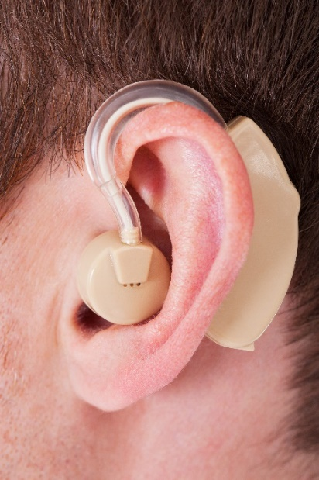

**Figure 3**

**Specification**

* Very lightweight
* Comfortable to wear
* Low power consumption
* Easy to replace the batteries
* Adjustable volume control and an on/off switch

Evaluate the hearing aid in terms of the following points.

18.1: Suitability for the user [4 marks]

18.2: Aesthetic qualities [4 marks]

18.3: Ergonomics [4 marks]

19.1: Explain what is meant by the term ‘tolerance’ in relation to quality checking   
and how designers and manufacturers use it to ensure repetitive accuracy. [4 marks]

19.2: Describe **two** quality checks that might be carried out on the hearing aid pictured, that would involve checking a tolerance and explain why each would be used.

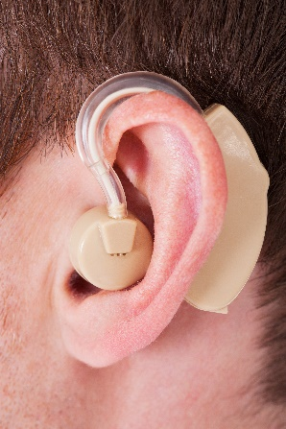

Check 1: [2 marks]

Check 2: [2 marks]

20.1: The data in the table, **figure 4,** shows the views of 120 business professionals who are hearing aid users. They were asked to rank the features in the table to find out which were the most important to them.

The table shows how many users ranked each point as the most important.

Complete the table by calculating the **two** missing Number of users for 1 mark   
and **two** percentages for 1 mark. [2 marks]

|  |  |  |
| --- | --- | --- |
| **Most important feature** | **Number of users** | **Percentage of total** |
| Ultra-small size |  |  |
| Very long battery life | 6 | 5% |
| Cost under £700 each | 6 |  |
| Rechargeable batteries |  | 10% |
| Almost invisible to sense when worn | 66 | 55% |
| Total | 120 | 100% |

**Figure 4**

*Use this space for your working out:*

20.2: Using the information in table **figure 4**, complete the bar chart below. [2 marks]

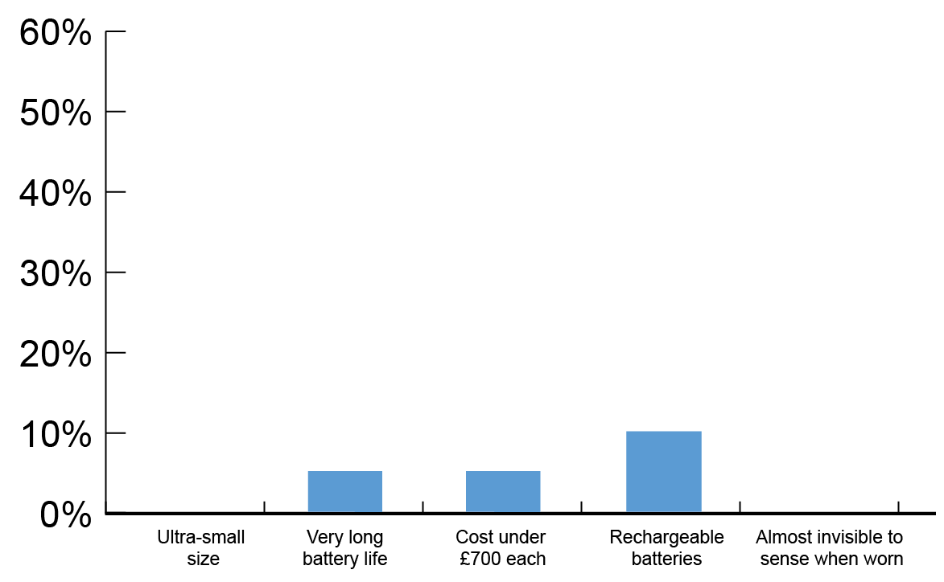

Percentage of users choosing most   
important features

20.3: Explain how this data may influence the design of a newer version of the   
hearing aid. [3 marks]

21.1: Market research is used by designers to find out important information that may influence the design of a product.

Name **two** different ways that designers could gather information that would help them decide how to design a product. The information could come from primary and/or secondary sources. In your answer explain how each source might influence a design.

1. [2 marks]

2. [2 marks]

21.2: Explain why designers ask potential customers to use and review   
prototypes of their products before finalising their designs. [3 marks]