**Homework 3: “What if” scenarios**

1. Here is a spreadsheet showing class marks for three tests.

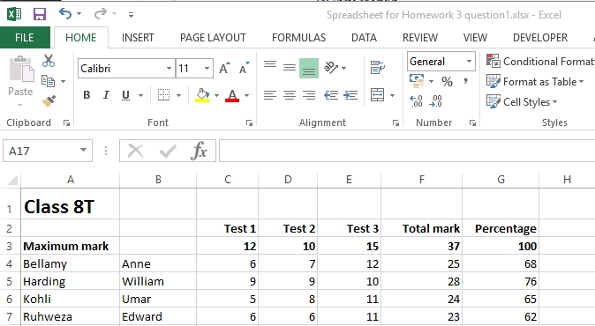

(a) Name four different ways in which formatting has been applied to the   
spreadsheet. [4]

(b) How can you display the formulae in the spreadsheet? [1]

(c) Write a formula for the maximum percentage mark achieved by any student. [1]

(d) Which option from the menu bar will you select in order to sort the data in descending order of percentage? [1]

Amend the default entries in the dialog box below to to sort the data in   
descending order of percentage. [2]

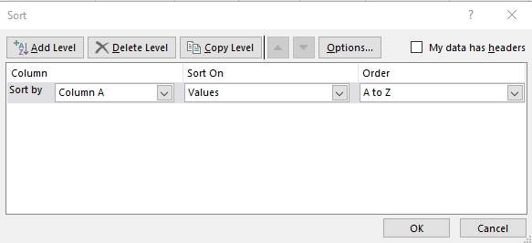

(e) Show how you would complete the Function Arguments in the box below,   
in order to insert the word “Distinction” in column H beside any percentage   
greater than or equal to 75. [3]

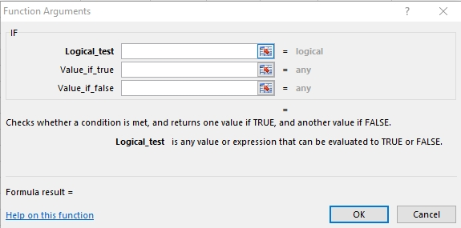

[Total 12 marks]