# Homework 5 Logic Gates

1. Draw a logic circuit representing the Boolean expression

Q = NOT(A OR B) AND NOT(C AND D) [2]

2. Figure 1 shows a logic circuit.

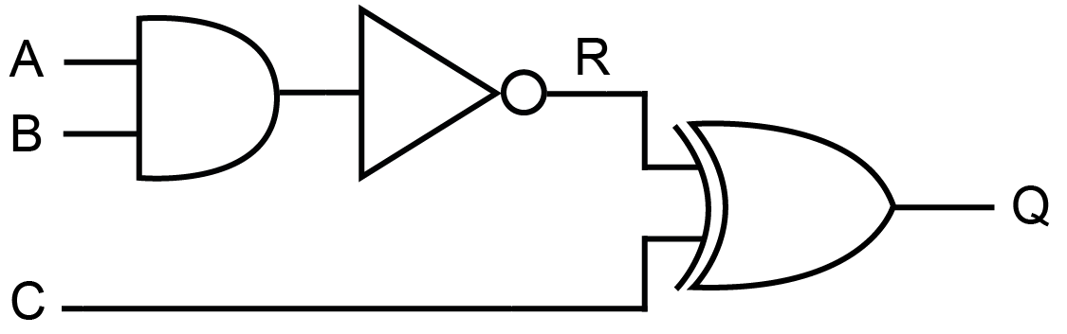

**Figure 1**

(a) Complete the truth table below for the logic circuit shown in Figure 1. Write the correct value of the output Q for each of the listed sets of inputs. [4]

|  |  |  |  |  |
| --- | --- | --- | --- | --- |
| **Input A** | **Input B** | **Input C** | **R** | **Output Q** |
| 0 | 0 | 0 | 1 |  |
| 0 | 1 | 1 | 1 |  |
| 1 | 0 | 0 | 1 |  |
| 1 | 1 | 1 | 0 |  |

(b) Two of the gates in the circuit shown in Figure 1 could be replaced by a single gate.

(i) Which two gates could be replaced? [1]

(ii) What single gate would be used instead? [1]

(c) Give **two** reasons why it might be an advantage to use as few gates as possible in a logic circuit. [2]

3. (a) Why is the NAND gate known as a “universal gate”? [1]

(b) By completing the truth tables below, show that the following circuit is equivalent to an OR gate. [4]

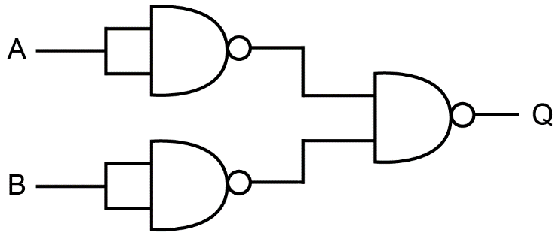

Truth table for OR gate:

|  |  |  |
| --- | --- | --- |
| **Input A** | **Input B** | **Output Q** |
| 0 | 0 |  |
| 0 | 1 |  |
| 1 | 0 |  |
| 1 | 1 |  |

Truth table for given circuit:

|  |  |  |  |  |
| --- | --- | --- | --- | --- |
| **Input A** | **Input B** | **P = NOT (A AND A)** | **Q = NOT (B AND B)** | **Q = NOT (P AND Q)** |
|  |  |  |  |  |
|  |  |  |  |  |
|  |  |  |  |  |
|  |  |  |  |  |

[Total 15 marks]