Worksheet 1: Zebra crossing

This is a Zebra Crossing. This crossing is on a wide road and has an island in the middle.

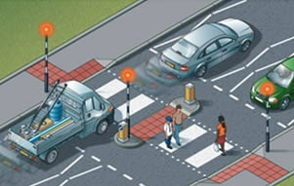

Correctly order the instructions below to help pedestrians to use this crossing safely.

|  |  |
| --- | --- |
| **Instruction** | **Order** |
| Walk to the island looking both ways and listening |  |
| Step onto the second half of the zebra crossing |  |
| Stop at the island |  |
| Step onto the first half of the zebra crossing |  |
| Stop at the side of the road looking to the other side of the Zebra crossing |  |
| Look right |  |
| Look left |  |
| Wait until traffic from the right has stopped or the road is clear |  |
| Walk to the other side of the road looking both ways and listening |  |
| Stay on the island until traffic from the left has stopped or the road is clear |  |